(U)RANS pool thermal Hydraulics
Lilla Koloszar, Vincent Moreau
Von Karman Institute for Fluid Dynamic VKI
koloszar@vki.ac.be
Centre for Advanced Studies, Research and Development in Sardinia CRS4
Department of Energy & Environment
moreau@crs4.it

Contents
Nomenclature 2
1 introduction 3
1.1 Identification of the relevant physics 3
1.2 Building a numerical model 4
2 historical overview of pool loops CFD modelling: the CRS4 experience and viewpoint 5
2.1 A window type spallation target for the “Energy Amplifier” (CRS4, 2000) 6
2.2 EADF: “Energy Amplifier Demonstration Facility” down-comer (2000, CRS4) 8
2.3 EFIT: “European Facility for Industrial Transmutation” (2005-2010); 10
2.3.1 EFIT hot plenum 10
2.3.2 EFIT core bottom 11
2.3.3 EFIT Outer plenum 12
2.3.4 EFIT outcome 13
2.4 XT-ADS: “eXperimeTal ADS” 13
2.5 FASTEF: “Fast-Spectrum Transmutation Experimental Facility” 15
3 CFD Models of MYRRHA 16
3.1 SEARCH: ”Safe ExploitAtion Related Chemistry for HLM reactors” (2011-2015) 16
3.2 The MYRRHA CFD model by CRS4 17
3.3 The MYRRHA CFD model by VKI 19
3.3.1 Approach for pump simulation 20
3.3.2 Porous media approach in the core 21
3.3.3 Barrel and above core structure simulation 23
3.3.4 Porous media approach in the primary heat exchangers 24
3.3.5 In Vessel Fuel Storage simulation 25
3.3.6 Computational mesh 26
4 (U)RANS MYRRHA model for what? 27
4.1 Looking at the flow and the thermal field under design nominal condition 27
4.1.1 Looking at the flow field 27
4.1.2 Looking at the thermal field 28
4.2 Looking at the system and sub-systems characteristic times 29
4.2.1 Local residence time 29
4.2.2 Pollutant emission 30
4.2.3 Lagrangian particulate 31
4.3 Beyond simple illustrations 32
5 Numerical developments toward transient simulations 32
5.1 General flow field 32
5.2 Verification of the porous core approach 34
5.3 Unsteady features 36
6 What next (conclusion) 40
7 References 41

Nomenclature
Symbols
C_{p} isobaric specific heat
R hydraulic resistance
T temperature
u velocity

Greek
ρ density
τ characteristic time

Subscript
(.)₀ reference or target value
(.)_{l} linear
(.)_{q} quadratic

Abbreviations
ACS Above Core Structure
CAD Computer-Aided Design
CFD Computational Fluid Dynamics
CR Control Rod
EoS Equation of State
FA Fuel Assembly
HX Heat eXchanger
IPS In Pile Section
IVFH In Vessel Fuel Handling
IVFS In Vessel Fuel Storage
LBE Lead-Bismuth Eutectic
LES Large Eddy Simulation
MYRRHA Multi-purpose hYbrid Research Reactor for High-tech Applications
NS Navier-Stokes
PP Primary Pump
RANS Reynolds Averaged Navier-Stokes
URANS Un-stationary Reynolds Averaged Navier-Stokes
VoF Volume of Fluid

introduction
Numerical simulation of a reactor pool is still a very challenging problem despite the ever increasing computational power and available numerical techniques. The main difficulty in the application of CFD codes to such problems are due to:
- The complex multi-physical environment coexisting in such applications and the lack of general knowledge of their modelling in an economic way.
- The difficulties arising while building the numerical model, including the definition of the conditions to be simulated.

Identification of the relevant physics

To demonstrate the complexity and the process of analysis of the relevant physics in a pool type configuration, the MYHRRA [1] reactor will be used as demonstrator. A picture of the MYRRHA reactor and the relevant physical aspects from the thermo-hydraulic point of view is proposed in Figure 1. The numerical simulation considered for this thought experiment aims to reproduce the primary coolant flow and heat transfer patterns.
Due to the low velocities considered and the nature of the cooling liquid – a liquid metal – the flow field can be considered as incompressible. This assumption removes the direct link between the temperature, the density and the pressure. The primary coolant of the reactor is Lead Bismuth Eutectic, LBE, a heavy liquid metal with low Prandtl number. Its material properties are highly dependent on temperature; known correlations could be taken from the LBE Handbook [6]. Above the LBE in the reactor Argon gas is placed and free surfaces are formed. The need to represent the free surface in the simulations depends on the operating conditions investigated.
With that, we can consider to solve the incompressible Reynolds-Averaged Navier-Stokes equations, complemented with the energy equation. In general, the incompressible thermal equation is decoupled from the momentum, but in the MYRRHA reactor case, due to the high temperature variation the buoyancy effects are expected to contribute significantly to the flow field, so that a force term should be included in the momentum equation, rebuilding the coupling between velocity and temperature. Conjugate heat transfer plays a significant role due to the high temperature gradients, so its effect might need to be considered, as well.

. 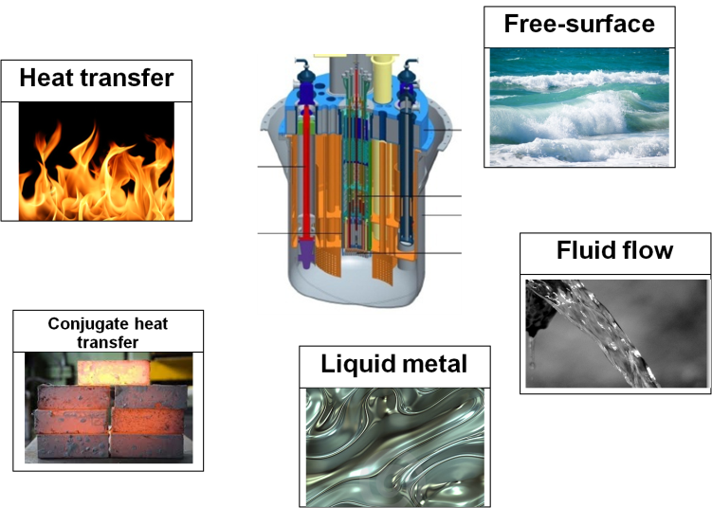
Figure 1: The MYRRHA reactor and physical considerations

Between the reactor cover and the LBE, Argon gas is placed to moderate oxidation at the free surface. The representation of this free surface should depend on the conditions we wish to simulate. If the free-surface is moving, its tracking is inevitable.

Building a numerical model
After identifying the domain of interest, the next step is to generate its discrete representation. The technique used should be conformal of the numerical discretization used later on and it should be able to deal with the complexity and the expanse of the geometry to be modelled: the vessels together with all their internal structures, resulting usually in a large number of mesh parts. The difficulty in building the mesh is mainly due to the quite different scales in the domain (from a few centimetres to several metres).
Once the computational mesh is available, we can turn our attention to the computational solver. It has to have validated models, especially models of turbulence, to estimate mixing and stratification, since the direct simulation of all the scales of the flow is still out of reach. Moreover, it is not even reasonable, if one is only interested on the general, average fields and integral quantities. Indeed, the simplification of the given problem should proceed till their effect does not contaminate the solution beyond usability. The final challenge to apply CFD for pool type problems lies in the need to perform transient calculations if transient problems are considered.

historical overview of pool loops CFD modelling: the CRS4 experience and viewpoint
In the context of Heavy Liquid Metal (HLM) cooled reactors, the first CFD simulation dealing with an entire thermal loop was performed at CRS4 in year 2000, using the STAR CD® software commercial code. It was the CFD simulation of a window spallation target loop [2].
The loop was 7m high, driven by buoyancy, heated by a proton beam near the bottom and cooled near the top by a heat exchanger with oil as secondary coolant. While only a 2D (axial-symmetrical) steady-state loop, it already contained several features of the present argument:
- A closed thermal loop.
- Heat source from Neutronic calculation.
- Oil secondary coolant part of the model with thermal exchange on local basis.
- Solid structures modelled and thermally coupled with the fluid.
Modelling the primary coolant loop of a reactor in pool configuration has been then performed in several steps, all referred to some old precursor of MYRRHA or ALFRED with “fancy” names.
- EADF: “Energy Amplifier Demonstration Facility”; ¼ of the external part of the loop with one of the four immersed HXs (Sept. 2000) [3].
- EFIT: “European Facility for Industrial Transmutation; (i) hot plenum (1/4), (ii) bottom plenum (1/12) and (iii) outer plenum (1/8) with ½ pump, 1 HX and ½ DHR… FP6 EUROTRANS IP framework (2005-2010) presented at ICONE-17 (2009) [4].
- XT-ADS: “eXperimenTal-ADS”; ½ of the entire pool loop including the nuclear core also EUROTRANS IP framework presented at ICONE-17 (2009).
- FASTEF: “Fast-Spectrum Transmutation Experimental Facility”; ½ of an entire isothermal fake loop to simulate with VoF an HX tube rupture. CDT FP7 European project (2009-2012) [5].
With all the CFD features experienced in this list of simulations, and taking profit of the always increasing computer power, it began to be clear that a sound CFD modelling of the entire primary coolant loop of a HLM reactor, including all the main relevant physical features, was becoming effectively realizable.
And indeed, the effective realization was performed in the framework of the SEARCH FP7 European project (2011-2015), as pre-requisite of a fuel dispersion study. That is, it took approximately 12 years to complete the jump from 2D to 3D CFD models of thermal loops in pool configuration.
We now give a closer look at what are now historical studies and we will take the occasion to see spontaneously appear and introduce many of the delicate features involved in the pool loop CFD.

A window type spallation target for the “Energy Amplifier” (CRS4, 2000)
The Energy Amplifier concept was introduced to CRS4 by Carlo Rubbia in 1997. At this occasion, a research group on this topic has been formed at CRS4.
The basic idea is to couple a proton beam to a subcritical nuclear reactor. The beam is produced by a dedicated particle accelerator and must be guided inside the core under deep vacuum. The beam enters the core region from the top through a solid thin interface called the target window, and interacts with the material behind to create a first generation of neutrons. The interaction region is called the spallation target and must be at the centre of the nuclear core. The first generation of neutrons diffuses through the core active region and produces a sub-critical chain reaction. The system must be designed such that any initial nuclear reaction should produce directly between 0.95 and 0.98 other nuclear reaction. The material chosen for the spallation target and also for the primary coolant is molten Lead or molten Lead-Bismuth Eutectic (LBE).
At this time, the spallation target was thought as a system independent of the core system and whose characteristic dimensions are 7 m high for 55 cm diameter. A sketch of the system is shown in Figure 2, together with the mesh and the heat deposition in the spallation region. In Figure 3, we show the temperature field below the target on the left and, at the heat exchanger level, from left to right the temperature of the rising LBE, of the down-coming LBE, of the rising oil and of the down-coming oil (bayonet tubes).

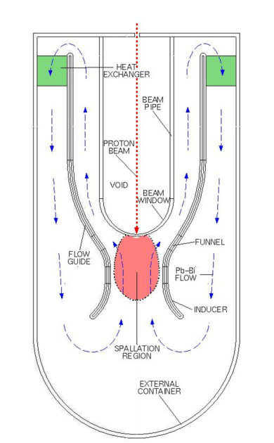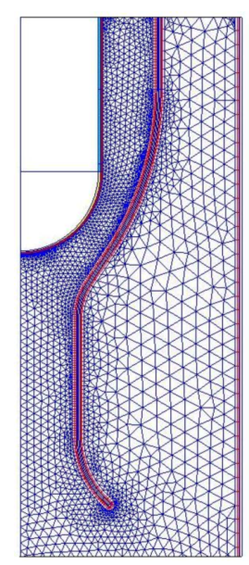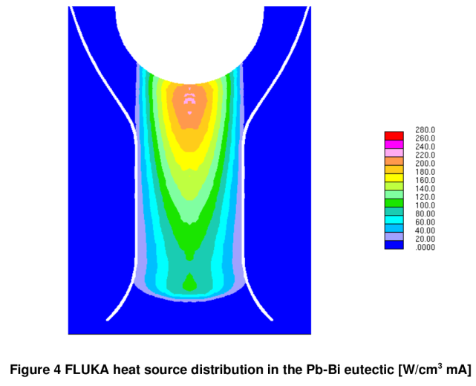
Figure 2: from left to right, sketch of the spallation target system, mesh and heat source.
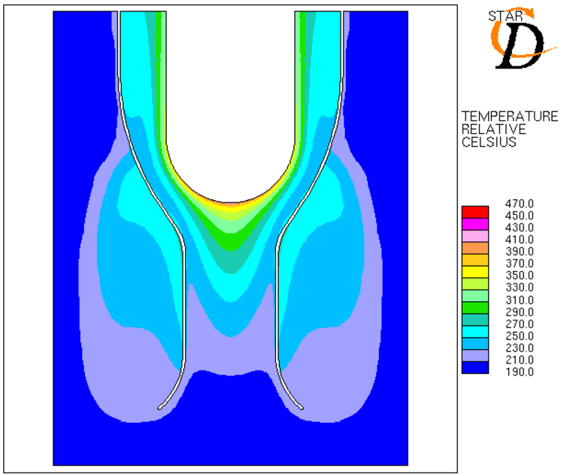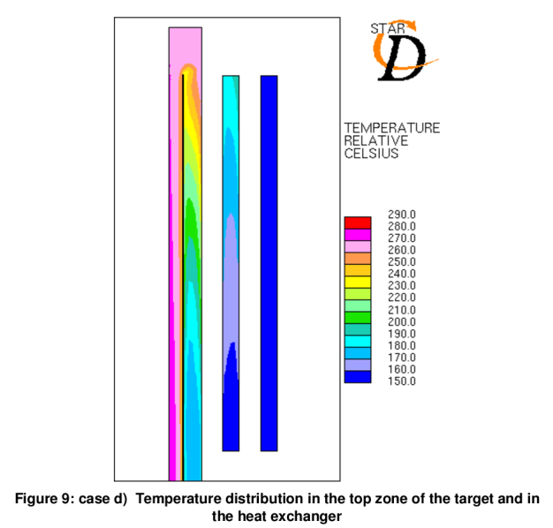
Figure 3: spallation target model. Left: volumetric heat source from FLUKA calculation. Right: top of the CFD model with from left to right, the temperature of the (i) rising LBE, (ii)down-coming LBE.
Besides the approximations imposed by the axial-symmetrical constraint, this simulation already exhibits features that are recurrent in pool loop modelling:
- The target thermal coupling with the spallation beam comes from a separate calculation from the neutronic code FLUKA, performed with its own standard of rules and on a different computational grid. With high concentration gradients, it is very easy to bring consistent errors from grid to grid interpolation, even leading to a noticeable discrepancy in the total heat source.
- The temperature below the window but outside the central funnel is due to the combination of three factors: (i) heat conduction through the walls, (ii) heat deposition by spallation and (iii) an almost still flow recirculation zone. The heat deposition is quite low, too low to be seen on a linear scale but still accumulating. The fact is that in condition of very small or lacking convection, then conduction and/or slight volumetric heat sources can lead to unexpected local high temperatures.
- The modelling of the heat exchangers is still an on-going process. It must be relevant to the case under study. It was already clear at this time that a simple volumetric heat sink was not suitable, as it may create artificial cold zones. In this case, a very simple representation of the secondary coolant has been modelled with the inlet of the rising leg thermally coupled to the outlet of the down-coming leg. Thermal exchange is performed between the two oil legs and between the rising oil leg and the down-coming LBE on a cell by cell basis considering the same height and a constant lateral offset. It was not possible at that time to place two legs at the same place as it is now in CFX/Fluent and also recently in Starccm+, within the porous media setting.

EADF: “Energy Amplifier Demonstration Facility” down-comer (2000, CRS4)
The EADF reflect the ADS concept as proposed by C. Rubbia and at the origin of the CRS4 related research group in 1997. Besides the Window Target System, the group studied the EADF vessel down-comer under the direct supervision of Ansaldo (see sketch in Figure 4). The down-comer is made of several parts. First, the flow enters the outer plenum rising through a series of vertical pipes. An HX is immersed in the plenum and the LBE flow is expected to enter by the top and exit at the bottom, driven by natural convection. The bottom of the outer plenum is then separated from a volume below the core by a bottom grid, delimiting the outlet of the computational domain.
- Passing from a 2D CFD analysis to a 3D one was quite a challenge and as the computational power was the same as for the target, something had to be paid for:
- Operating a slight regularisation of the design, only ¼ of the physical domain was simulated. Reduction to 1/8 was considered excessive. In the quarter considered, there are 6 rising tubes and one entire HX, as shown in Figure 4.
- The structural parts are represented by impermeable 2D membranes, called shells or baffles.
- The domain outlet consists in several disconnected holes. These holes have been merged in a single horizontal layer; see also Figure 5, right.
- The mesh is almost entirely structured by parts in a series of vertical layers, trying to keep the minimum acceptable number of cells.
- Mesh conformity could not be enforced with the curved bottom part of the domain and with the structure supporting the pipes.

These shortcuts are very common still in 2017. Non-conform mesh where however quite new at that time and under active development. Another interesting feature regards the discretisation of the pipes, Figure 5 centre. The leading idea is the following: when discretisation constraints are such that the discretisation will not respect the geometry by a large amount (typically a circle with very few cells), it can be preferable to slightly modify the geometry to make it easier to mesh. This allows you to choose your prime geometrical characteristic to preserve. In this case, it was the internal cross section of the pipes, controlling the pipe exit flow speed at a given mass flow rate.
The model has been run in steady-state, see Figure 6 left for the temperature field. The existence of a plot with the temperature field on a section of the HX oil side (Figure 6, right) indicates that the thermal coupling used for the 2D target system could be extended to the 3D context.
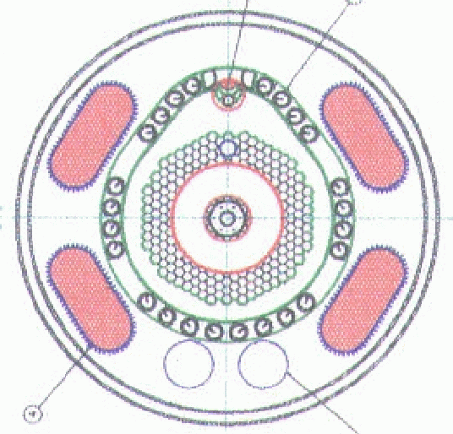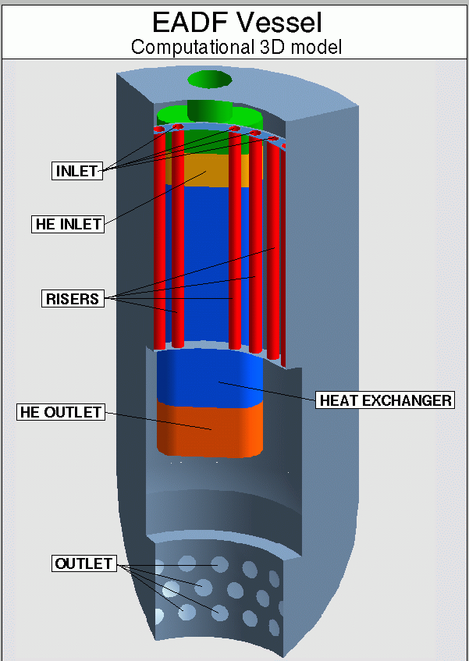
Figure 4: Left, sketch of the EADF. Right, preliminary geometry of the computational domain.
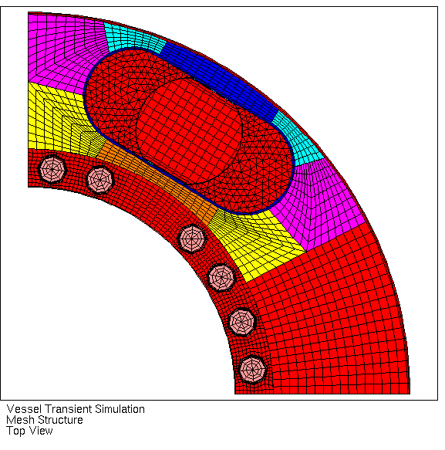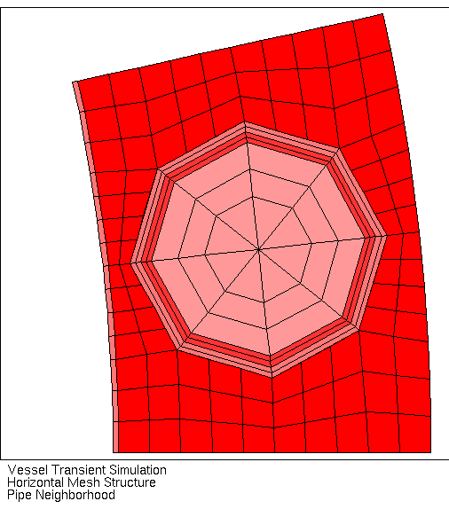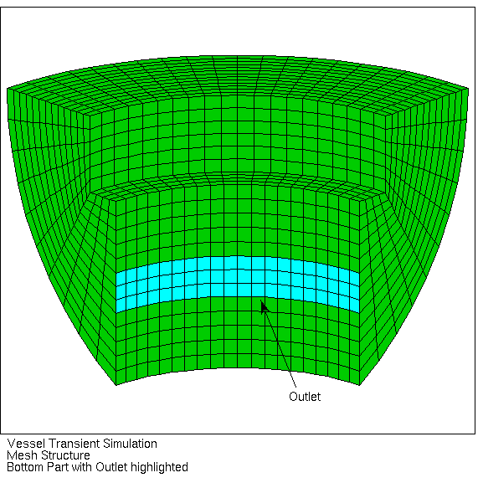
Figure 5: EADF computational grid. From left to right: horizontal layer, detail of a riser pipe and curved bottom.
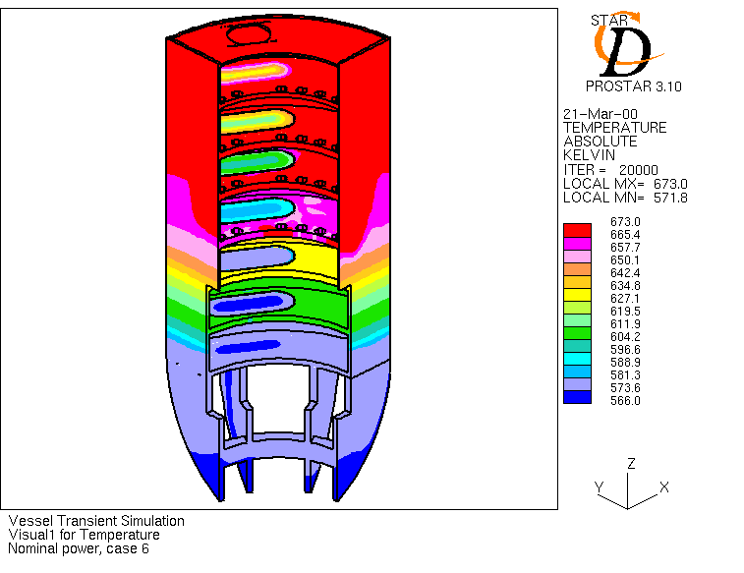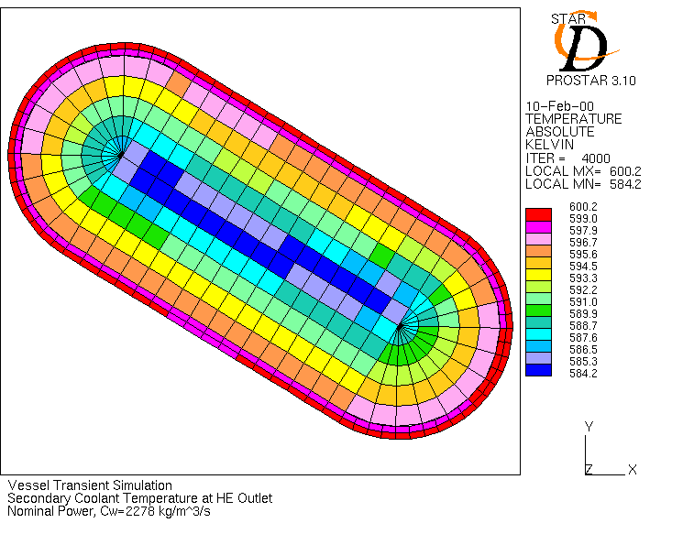
Figure 6: EADF model. steady-state thermal field: left, in LBE, right in HX oil side.

EFIT: “European Facility for Industrial Transmutation” (2005-2010);
The former simulations where performed in a purely Italian context. Then the related activity at CRS4 nearly died and the EADF concept was relegated to history. Because the CFD simulation of pool loops respond to a necessity for the main HLM Gen IV reactors, CRS4 could restart its activity within the European framework, and more precisely thanks to the FP6 IP EUROTRANS (2005-2010).
Three relevant CFD models are shortly presented here, and have been presented at ICONE-17 (2009). These are the EFIT (i) hot plenum (1/4), (ii) bottom plenum (1/12) and (iii) outer plenum (1/8) with ½ pump, 1 HX and ½ DHR.

EFIT hot plenum
The EFIT hot plenum CFD simulation addresses the Above Core Structure (ACS) and the flow redirection to large lateral bended pipes where the pumps are located. In the ACS, an intermediary grid is simulated as a resistive porous media. An attempt of flow optimization has been performed on a simplified geometry aiming at making the flow at the pump inlet the more uniform possible, see Figure 8.
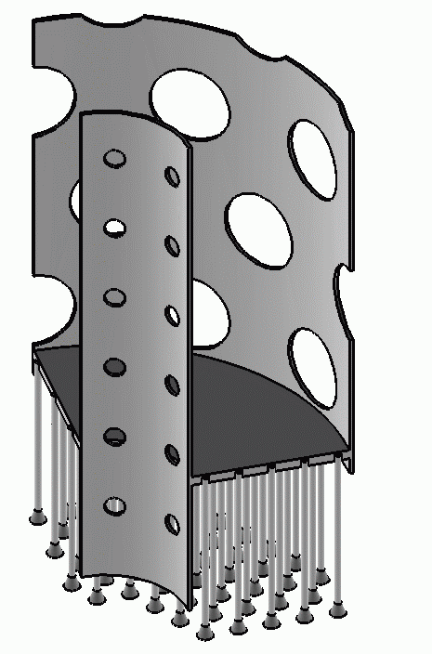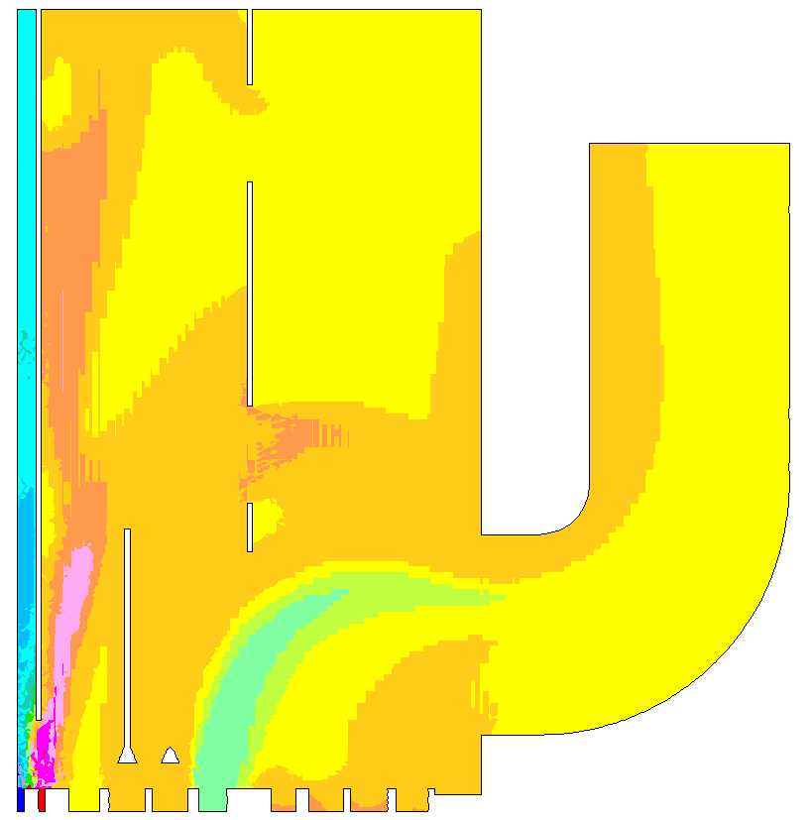
Figure 7: EFIT hot plenum. Left: structures. Right: thermal field.

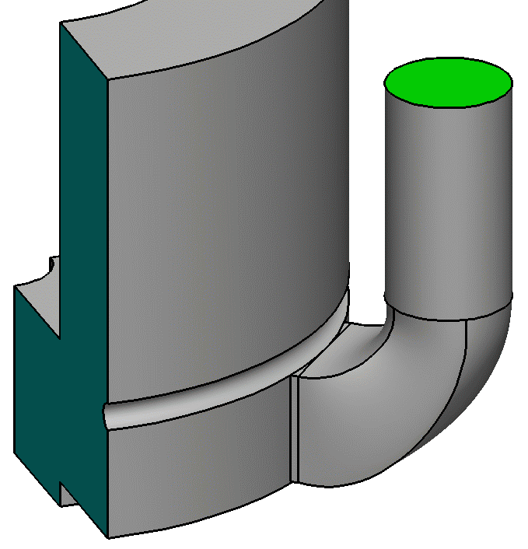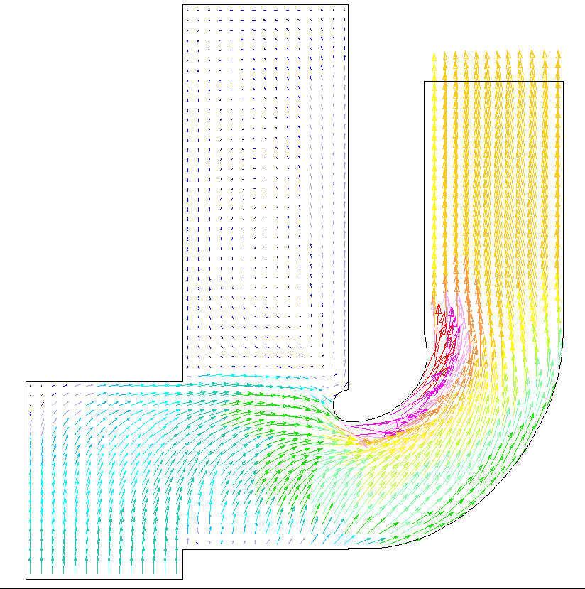
Figure 8: EFIT optimisation study. Left: geometrical variant. Right: flow field.

EFIT core bottom
This simulation was performed to understand whether the flow entering the bottom plenum would nicely be conveyed towards the core bottom and split as expected between the fuel assemblies (FA). In the simulation presented in Figure 9, we check that a variation of the design with the bottom support grid made orthogonal to the vessel effectively eliminates a large recirculation zone that was formerly present at the bottom around the centre axis.

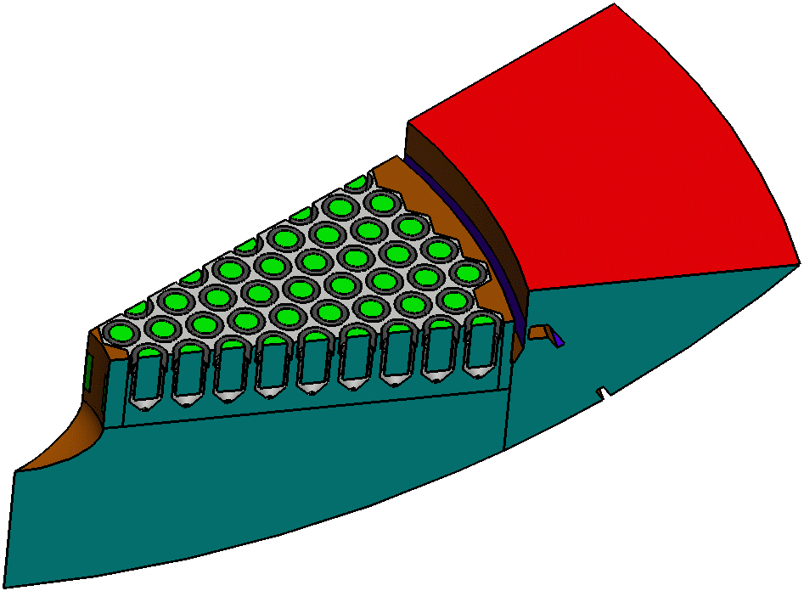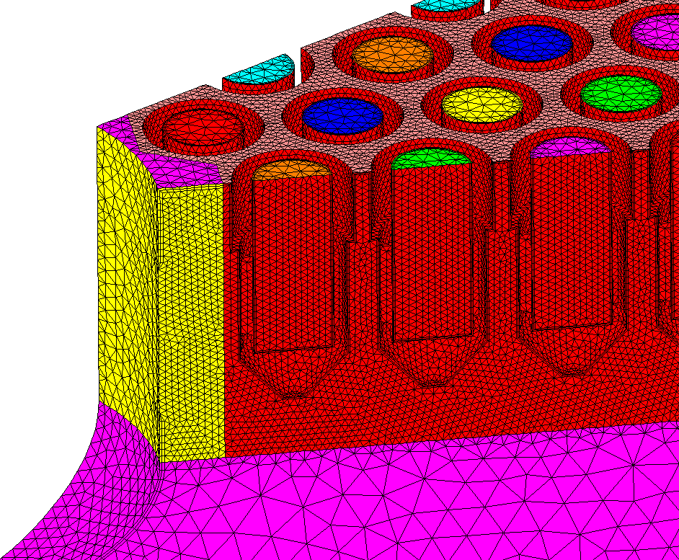
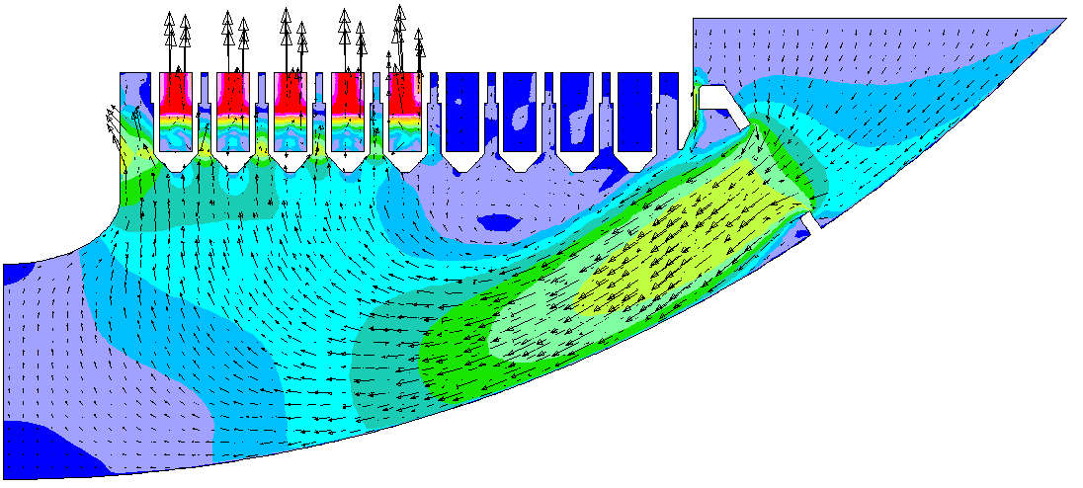
Figure 9: EFIT core bottom. Top left: computational geometry. Top right: mesh detail. Bottom: flow field.

EFIT Outer plenum
The domain of the simulation starts from the pump outlet, with the flow reversing in the HX. The outlet of the HX is connected to the outer plenum, and the outer plenum has a bottom outlet towards the core bottom. A DHR is also immersed in the outer plenum which automatically enters in function when the coolant rise above a given temperature, typically arising in case of HX failure, see Figure 10. The simulation aim was to control the correct behaviour of the DHX. It turns out that the DHX is much more efficient with a slightly longer downward shroud, as seen in Figure 11.

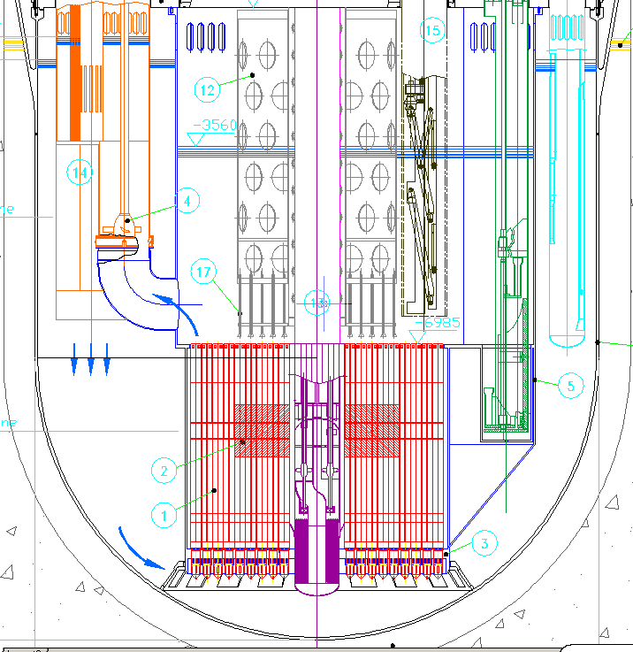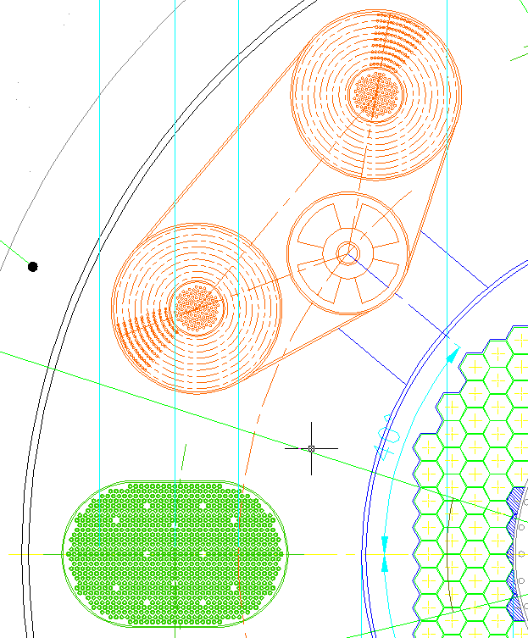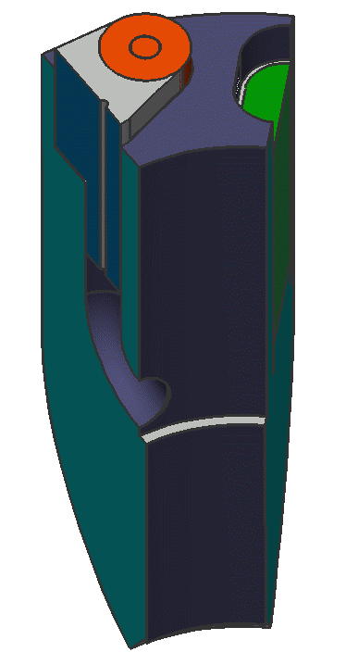
Figure 10: EFIT Outer Plenum. Left and centre: design sketch. Right: computational domain.
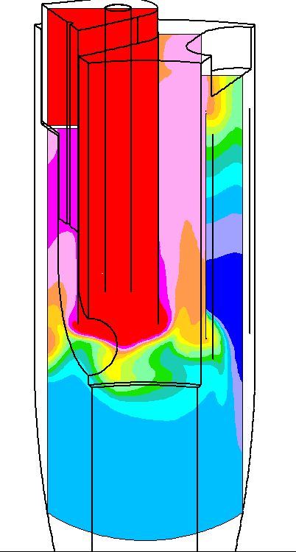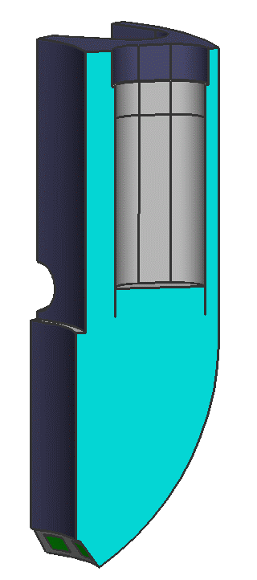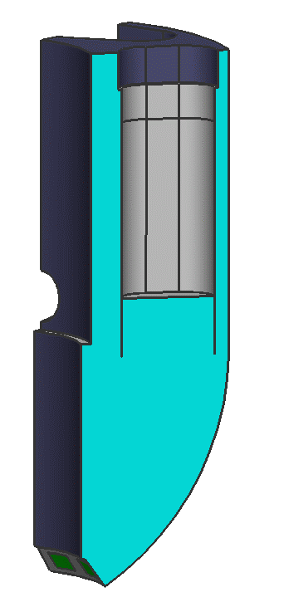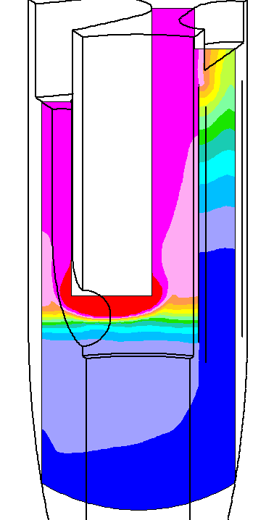
Figure 11: EFIT Outer Plenum. Left: original temperature field and DHR shroud length. Right: Increased DHR shroud length and corresponding temperature field.

EFIT outcome
The simulations of parts of EFIT have been done under the supervision and in close collaboration with Ansaldo Nucleare. The really interesting thing is that the CFD simulations have produced small but relevant changes of the design: (i) shape of the pump pipe inlet, (ii) shape of the bottom grid and (iii) length of the ADS shroud.

XT-ADS: “eXperimeTal ADS”
The XT-ADS numerical model marks a change of paradigm in the CRS4 CFD simulations. First, we swept from STAR CD, a classical CFD mesh based CFD software used until this moment to the STAR CCM+® software, an object-oriented CFD software, rewritten from scratch taken into account 20 years improvement of computer science. In the meantime, we changed from slightly parallel runs, limited to 4 CPUs on a single PC, to definitively heavier parallel simulations, here on 20 CPUs of a PC cluster.
The simulation of the XT-ADS had the goal to understand whether the RVACS is able to maintain the vessel temperature below the limit in case of station blackout with concomitant unavailability of the primary DHR system.
For this, you just have first to build your CFD model and bring it under nominal operation, Figure 13.
In the XT-ADS, the disposition of the sub-systems is such that we had to simulate at least one half of the physical domain. The final mesh that came out had 1.7MCells, see Figure 12.

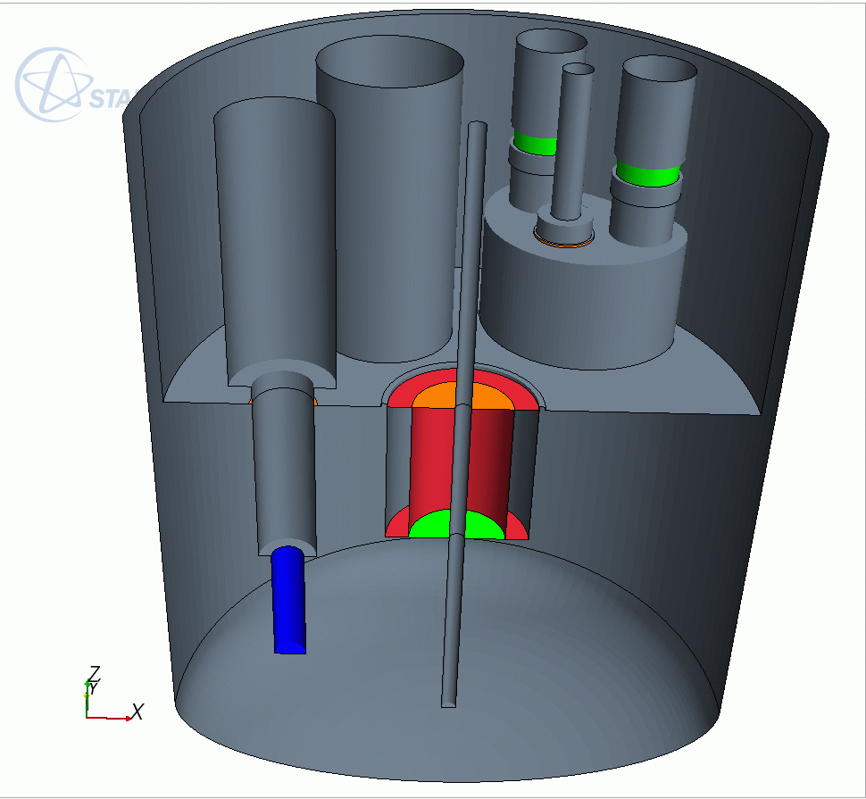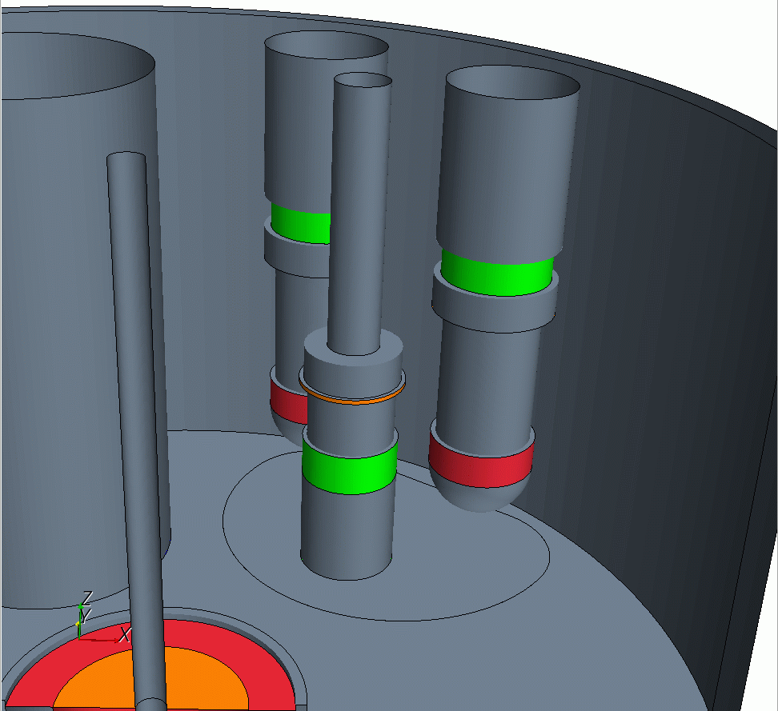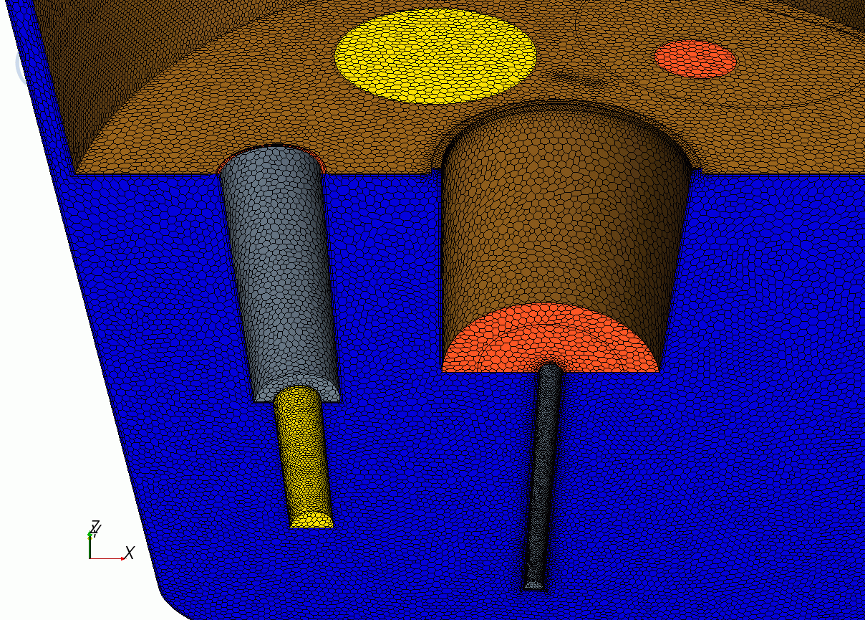
Figure 12XT-ADS computational domain and mesh.
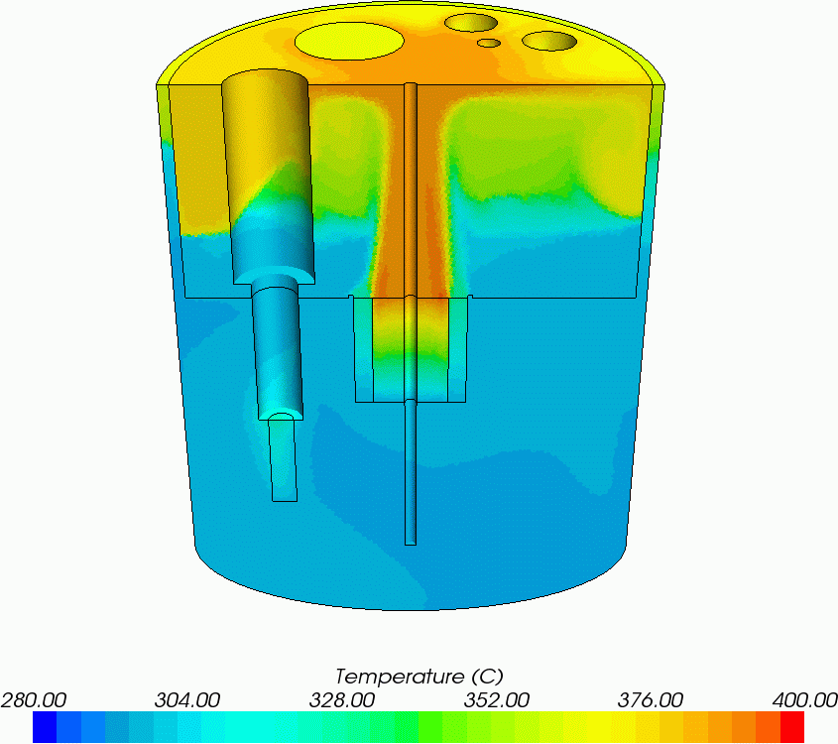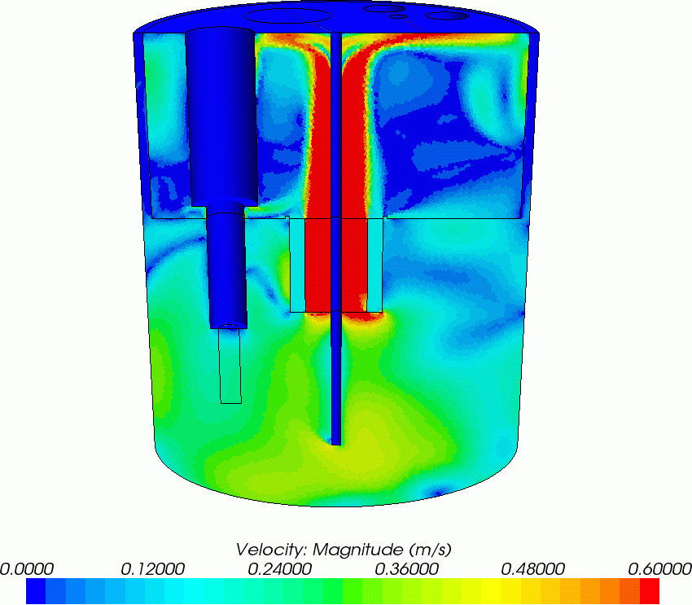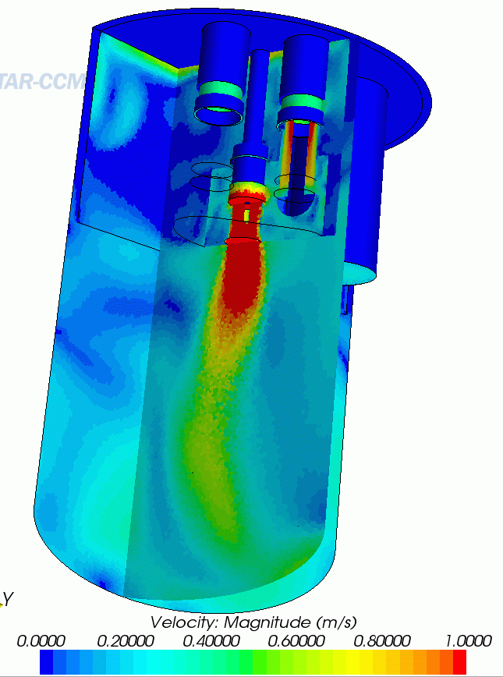
Figure 13: XT-ADS steady state. Left: temperature. Centre and right: velocity magnitude.
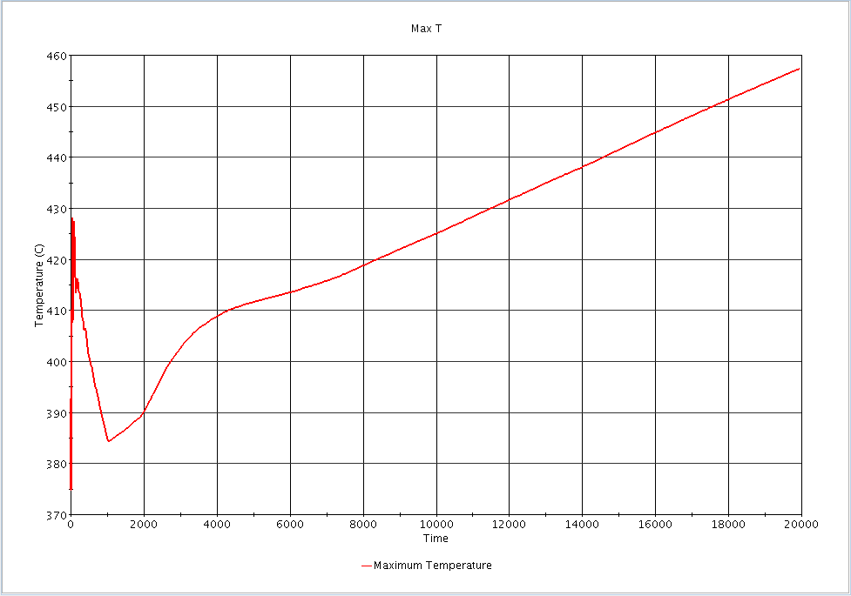
Figure 14: XT-ADS shut down transient. Left: temperature. Center: velocity magnitude. Right: time evolution of maximum temperature.
The simulation domain is an assembly of fluid volumes with the interfaces treated either as internal (free path), porous baffle (local flow resistance) or plain conducting baffle. No structural part is present.
The simulation confirmed two things. First, the flow in outlet of the pump is strong enough so that there is no stagnation region at the bottom of the vessel, see Figure 13 right. Second, as it is and consistently with system code simulations, the RVACS system is not adequate to ensure a sufficiently long grace time, see Figure 14.
From the CFD point of view, this is the first time that we closed a 3D thermal loop.

FASTEF: “Fast-Spectrum Transmutation Experimental Facility”
One of the main drawbacks of the XT-ADS simulation is the inability to take into account the different free-surface levels of the hot and cold plenum respectively and their evolution during transients involving a change of regime of the pumps.
This aspect is addressed in the following simulation, performed in the framework of the CDT FP7 European Project (2009-2012). The aim of the simulation is to understand what could happen in case of tube rupture in an HX of FASTEF. The main concern was whether some vapour would enter the fuel assemblies.
We made a very preliminary evaluation in which a quite large quantity of gas was produced at some place of one HX tube. We could not found ways to restrict the computational domain without taking the risk to strongly affect the physic of the problem. We ended by creating an entire closed loop mimicking the behaviour of the entire FASTEF primary loop, see the geometry in Figure 15, including two free surfaces at different levels, see Figure 16 left.

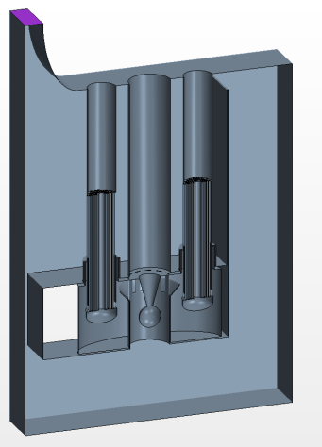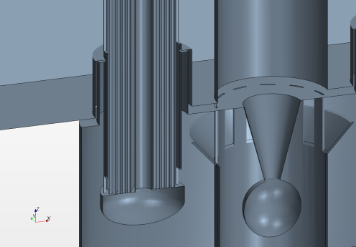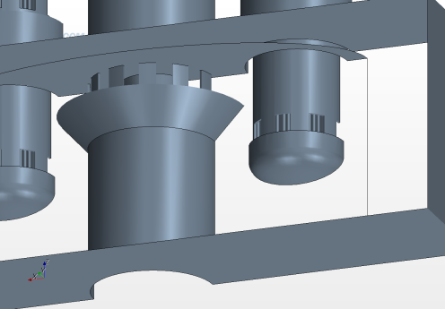
Figure 15: FASTEF tube rupture simulation. Geometry of the computational domain.
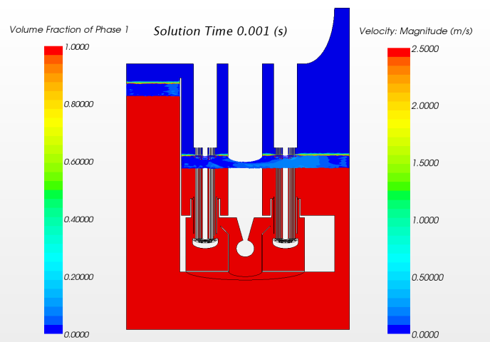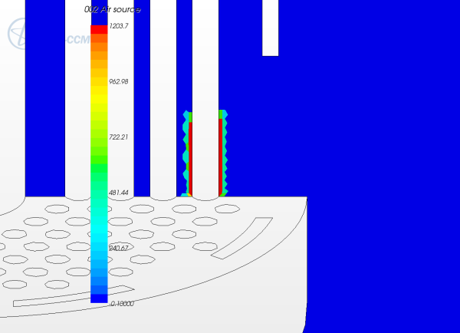
Figure 16: FASTEF tube rupture simulation. Left: steady state free-surface levels. Right: localization of the steam source term.
The pump thrust is modelled with a localised downward volume force and the core resistance by a localised quadratic hydraulic resistance. Being a “cold” simulation, the structural part is not present but has some width. The Volume of Fluid (VoF) setting has been used. The virtual steam is created around the bottom of a tube closest to the pump outlet, as shown in Figure 16 left, by means of a localised light phase volume fraction source.
The use of the VoF setting in a closed loop was not straightforward. The main issue was the slow accumulation and growth of a mixed layer. The control of the sharpness of the free-surface for long time has been acquired by implementing an in-house modelling that was developed and tested in the framework of yet another FP7 project named THINS (2010-2014).
Thanks to the know-how accumulated in these years, it slowly became clear that a versatile CFD model of a large entire closed thermal loop in pool configuration such as the MYRRHA primary coolant system, was at hand. This is the subject of the next chapter.

CFD Models of MYRRHA

SEARCH: ”Safe ExploitAtion Related Chemistry for HLM reactors” (2011-2015)
SEARCH is a FP7 project. The objective of its WP5 was to model a possible fuel dispersion in MYRRHA to evaluate the possibility of some kind of re-criticalisation under incidental conditions.
This requires as pre-requisite at least a consistent modelling of the entire primary coolant loop. And in fact this was the primary objective during the first part of the project.
As we were to deal with nuclear safety issues, we proposed to apply to the project the classical features of nuclear safety issues, that is: redundancy and diversification.
Diversification was first obtained by modelling both with CFD and by Coarse Mesh System codes, SIMMER-III (2D) and SIMMER-IV (3D), so as not to depend on only one type of modelling. The SIMMER approach was performed by KIT, ENEA and UNIPI.
Within the CFD framework, redundancy was obtained by using two different partners to perform essentially the same work:
- CRS4 modelling with the commercial tool Starccm+ and
- VKI modelling both with a commercial tool (Fluent) and with an open source platform (OpenFOAM)
In this way, the know-how would be preserved in case of inability of one partner or of one commercial code. Moreover, it would help understand the pro- the con- or the complementarity of commercial vs. open source software.

The MYRRHA CFD model by CRS4
At the beginning of the project, it seemed feasible that, at least in a first step, only ¼ of the domain could be simulated. And a first model was built, containing most of the foreseen elements, and began to be operated, as shown in Figure 17.
In the meantime, the MYRRHA design had evolved and the numerical model was born already obsolete.
As a consequence, a new model had to be built. It was agreed to fix the design as for the new one for the duration of the project (Gothenburg meeting, May 2012). However, the evolution of the MYRRHA design, the degree of precision and versatility foreseen was such that a last taboo had to be dropped down: no more use of geometrical/functional symmetries. The entire 360 degrees of the system was to be modelled [12], see Figure 17. Now, five years later, this seems banal, but in 2012, it was definitively not. Fortunately, massive parallel CFD computation was becoming quite common.

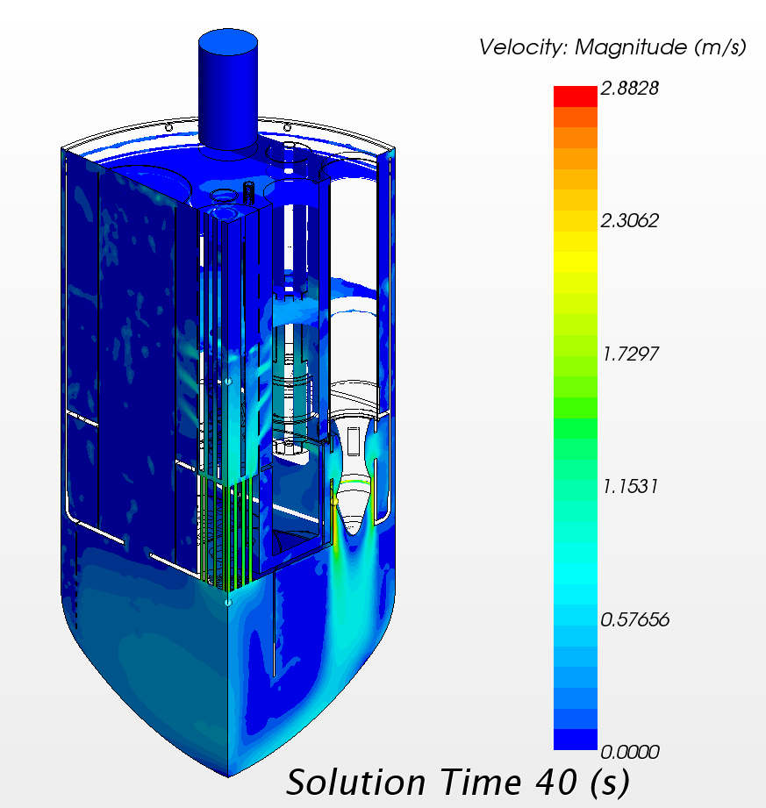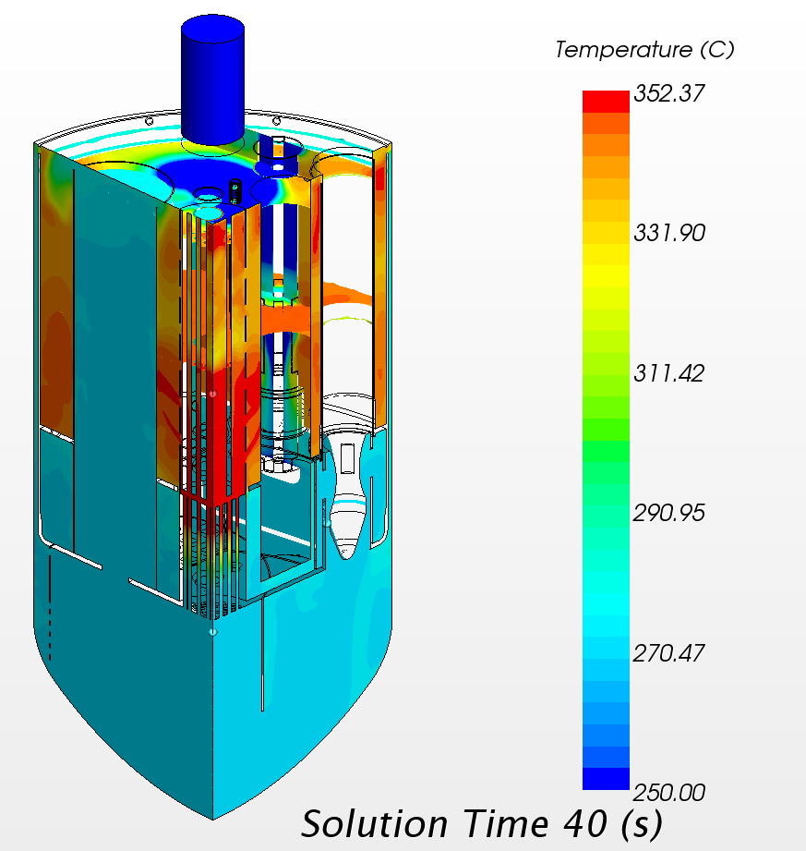
Figure 17: MYRRHA ¼ model. Top left: outline. Top centre: solid structure. Top left: free surface levels. Bottom left: velocity magnitude. Bottom Right: temperature field
The CFD MYRRHA model of CRS4 effectively gathers all the features of the models presented until now, and also new ones, in a single application. Here are the main features:
- No reduction from geometrical/functional symmetries
- VoF two phase flow: LBE (buoyant) and cover gas (constant density).
- Temperature dependence of the LBE physical properties [6]
- Plain structural part with conjugate heat transfer
- Closed (connected) circuit for the LBE
- Core modelling on the single FA basis, with heat source profile from neutronic calculations and distributed hydraulic resistance coefficients.
- Heat Exchanger modelling with porous setting and articulated heat removal law.
- Pump modelling with a localized body force, including a swirl component.
A serious constraint of the CRS4 model is that within the VoF setting in Starccm+, there is no such thing as a specific steady-state simulation mode. Only physical transients are allowed. To alleviate this constraint, an alternative approach is to renounce temporarily to the VoF setting, to settle all the theoretical and technical difficulties of the model not involving large changes of free-surface level, and then re-introduce the VoF setting as a final step, accepting the risk that the VoF setting could enter in conflict with other physical features. This is an equally valid strategy that in fact has been pursued in parallel at VKI, strengthening the redundancy and diversification approach of the WP [13].
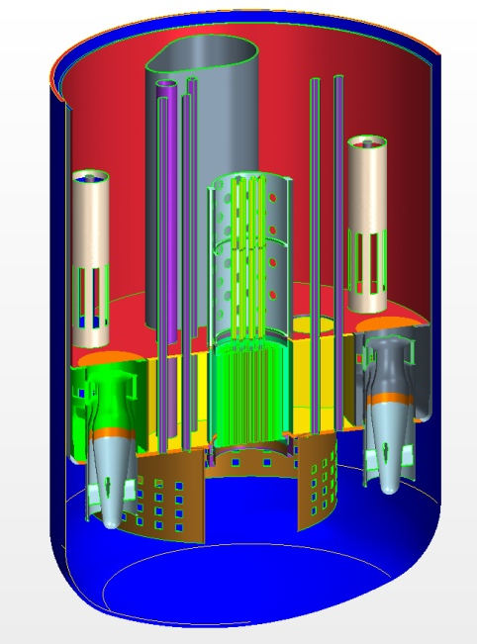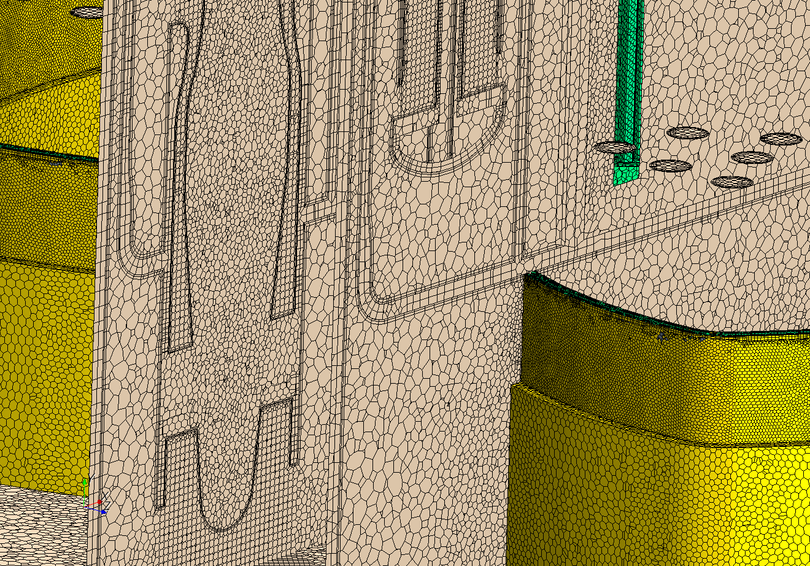
Figure 18: MYRRHA model. Left: solid structure of half model. Right: insight on the mesh density.

The MYRRHA CFD model by VKI
The von Karman Institute joined to the quest of simulating the thermo-hydraulics of the MYRRHA reactor in the SEARCH project. The flow and thermal field in the reactor is very complicated, coupled with a complex geometry and without any previous experience with such problems, the VKI team decided to adopt an incremental approach in the development of the model, keeping in mind the final aim to have a flexible methodology capable following the design modifications in the geometry as well as to construct a model that is representative in term of physics and geometry, but that only contains as much complexity as necessary to provide the quantities of interest in order to be able to simulate transient situations.
In this context the aim of the von Karman Institute was to develop a solver, myrrhaFoam, using the open-source simulation platform OpenFOAM, in such a way not to be restricted by licence costs and to be able to use the computational capacity of the VKI clusters. In this framework, a simplified model was considered and the primary aim was to simulate the operating condition of the reactor.

Approach for pump simulation
The flow field within the reactor is driven by the pumping system. There are two Heat Exchanger/Pump casing, each one consisting of two Heat Exchangers, HX, and one pump. Concerning the pumps, modeling the flow through the rotor would require meshing around the blades and modeling the dynamic behavior of these rotating parts. This level of refinement is not required since we are only interested in respecting the nominal flow conditions of the primary coolant loop. The presence of the rotor was therefore neglected in the CFD model shown in Figure 19.

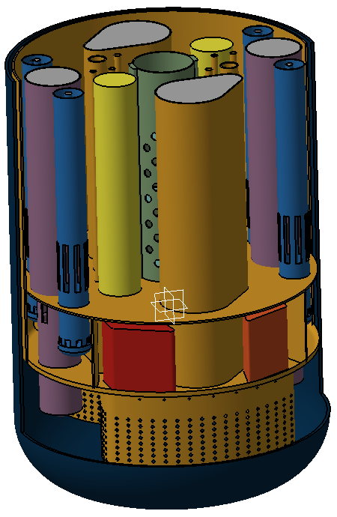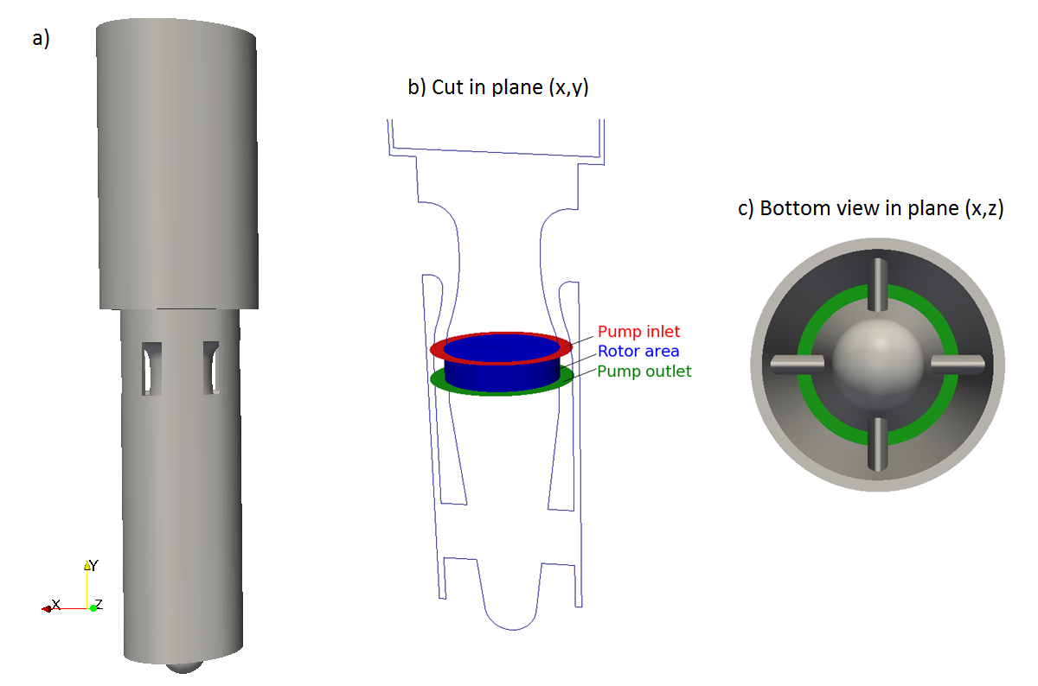
Figure 19: The numerical model of the MYRRHA reactor and the pumps: solid pump component, rotor area and pump inlet/outlet surfaces and bottom view

There are two possible ways of representing the pumps: by having either an open or a closed system. In the first case, the rotor area (annular volume between red and green ring) is removed from the CFD domain and the nominal mass flow rate is imposed at the pumps outlet (green surface), by specifying velocity conditions. Reference pressure is then given at the pumps inlet (red surface). However, in case of transient simulations such as pump failure for instance, a closed-loop is needed. The flow motion is then activated by a momentum source applied to the rotor area, and fixed to balance the desired mass flow rate.

Porous media approach in the core

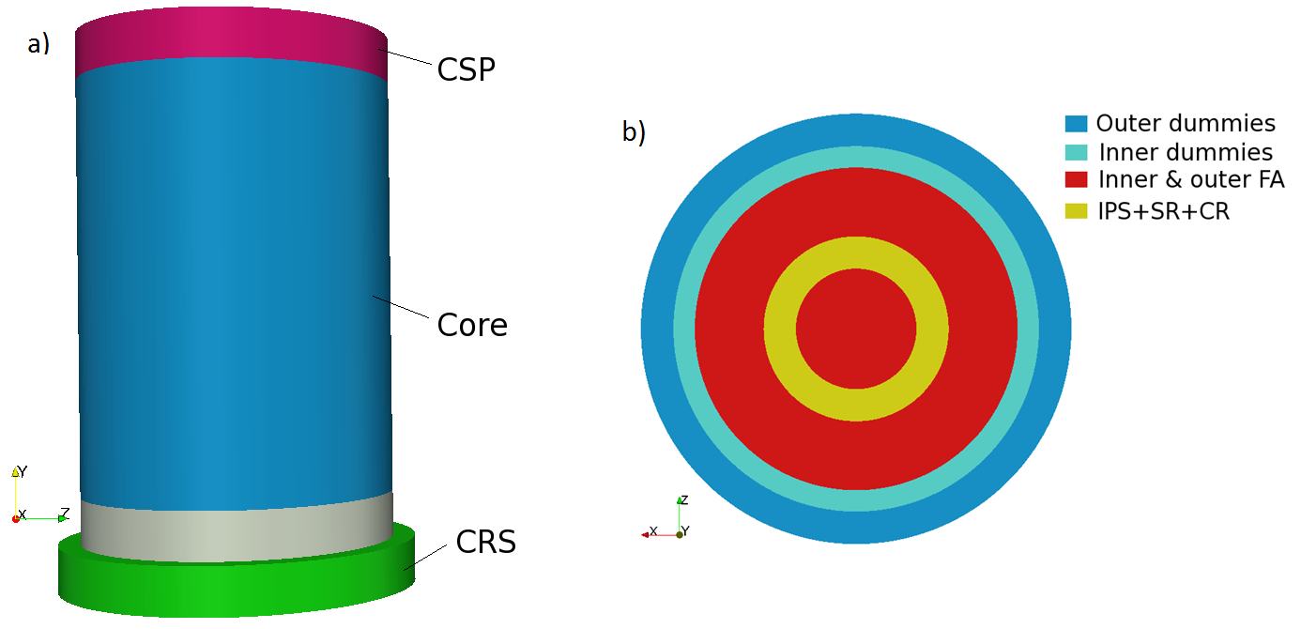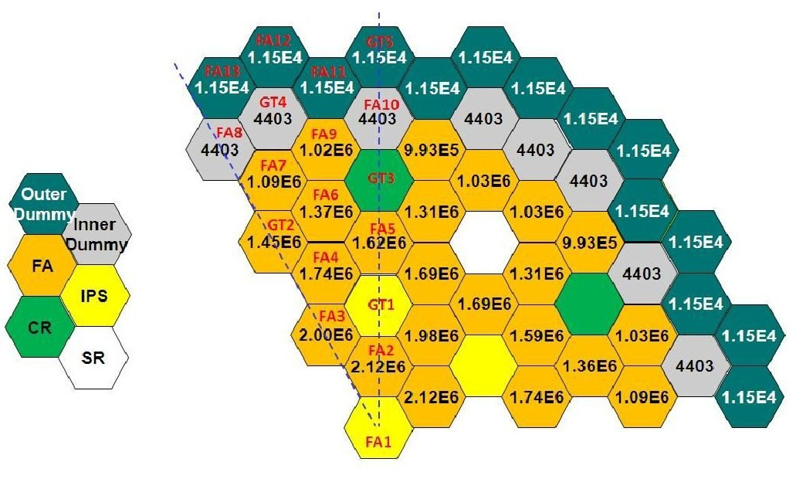
Figure 20: The a) General porous media in the central part of the reactor b) Core layout decomposition c) radial power distribution in the MYRRHA reactor core
The core has been modeled following the homogenization approach with porous modeling. The different zones are separated according to the structures layout, which is governing both porosity and pressure losses. Consequently, the general core layout, shown in Figure 20, is composed in the central core of 5 porous rings, representing from the centre: (i) the inner Fuel Assembly, FA, (ii) the combination of In-Pile Section, Scram Rods, Control Rods (IPS+SR+CR), (iii) the outer Fuel Assembly, (iv) the inner dummies and (v) the outer dummies. The last ring corresponding to the core jacket is a solid component and was therefore subtracted from the flow domain. The area directly below the core, composed of a grid with cones that hold the Fuel Assemblies in place, makes the connection with the core restraint system, CRS. As this intermediate ring is characterized by very little flow blockage from either axial or radial directions, it is approximated as a non-porous zone.
However, it should be noted that in reality the IPS, SR and CR are arranged separately between the Fuel Assemblies, thus approximating this area to a single ring is a non-negligible assumption in terms of momentum and heat transfer. Each of these porous zones is characterized by a certain porosity value γ, defined as the ratio between the volume of fluid and the total volume of the media. From a numerical point of view, these pressure losses due to friction are added to the standard equation as a momentum sink expressed as follows (Darcy-Forchheimer law [14]):
$$\vec{F_{i}}=-\frac{µ}{α}\vec{u_{i}}-\frac{ρ}{2}C_{2}\left|\vec{u}\right|\vec{u_{i}}=∇p_{porous}$$ | (1)
As the parallel channels connect the lower plenum with the upper plenum, the mass flow rate distribution is a result of the different porosities. The pressure drop across the entire core area, from the lower plenum up to the free-surface (including the radial losses through the barrel holes) is estimated to about 2 bars based on fuel assembly correlations. Due to hexagonal wrapper tubes of the fuel assemblies in reality the flow is blocked in the radial direction in the porous media. This condition is imposed numerically by assigning a very high value of the radial resistance coefficients in the core region. The cross sections of the rings are determined with respect to the fractions of core positions taken.
The pressure drop in normal operation is determined by the pressure drop in the Fuel Assembly. These losses are estimated by using the Rehme correlation for a wire wrapped fuel bundle as a function of the local Reynolds number (noted as $f\left(Re\right)$):
$$∆P=f\frac{L_{pin}}{D_{eq}}0.5ρu^{2}$$ | (2)
In the above equation, $u$ is the local flow velocity, $L_{pin}$ corresponds to the pin length, $D_{eq}$ is the equivalent diameter and $f$ is the friction factor given by:
$$f=\left(\frac{64}{Re}F^{0.5}+\frac{0.0816}{{Re}^{0.133}}F^{0.9335}\right)N_{r}π\left(D_{r}+D_{w}\right)\frac{1}{St}$$ | (3)
where $N_{r}$ is equal to the number of pins, $D_{r}$ is the clad outside diameter and $D_{w}$ is the wire diameter. The geometrical factor $F$ is fixed to 1.225. More details are available in [7,8]. The formulas given by equations (4) and (5) are implemented within the numerical model by defining a new porous model class, using the local velocity to calculated $Re$ and $f$. The inner dummies are modeled as the FA rings since they have the same flow rate and pressure drop. The axial resistance coefficient of the two other core rings, IPS+SR+CR and outer dummies, was kept constant and first approximated based on the desired mass flow rate distribution.
The heat in the core is modeled as a volumetric heat source of 100 MW in total and is limited to the inner and outer FA rings, where the nuclear reaction is significant. The foreseen radial power distribution is approximated by a third order polynomial to approach an integrated power of 24.6 MW and 75.4 MW in the inner and outer Fuel Assembly rings. A detailed description of the real and fitted distributions is given in Figure 21/a. As can be seen, the functional source is only active where the fuel elements are placed in the core.
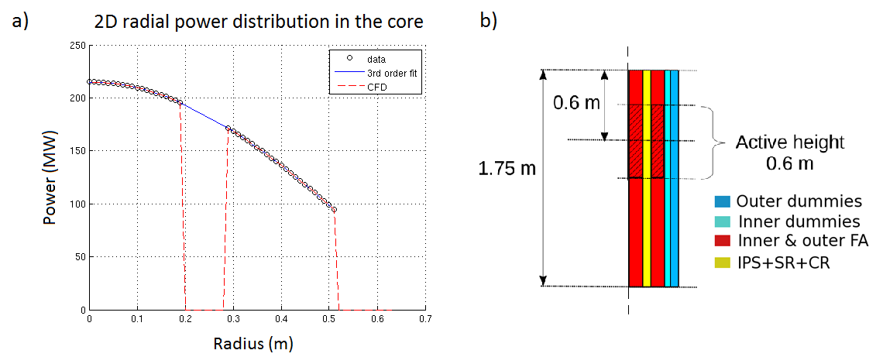
Figure 21: a) Radial heat source distribution b) Axial positioning of the heat source
In the axial direction, the shape is a cosine profile of half a period, reaching a maximum in the active core centre represented in hatching on Figure 21/b. However, the cosine reaches only zero at 1.035 m and power is limited to this active height of 0.6 m. The final expression used to model the core heat source distribution is the following, given in W/m3:
$$Q_{core}\left(r,y\right)=Q_{0}\cos\left[\frac{π}{h}\left(y+h_{0}\right)\right]f\left(r\right)$$ | (4)
Where h is the active fuel length, h0 is the projected initial of the cosine fitting and f(r) represents the radial distribution of the produced heat. This function is a quadratic function of the radius obtained such that the total energy of the core results in the nominal 100 MW.

Barrel and above core structure simulation
The barrel is an integral part of the core support structure, CSS, and is located in the centre of the reactor. It guides the LBE flow from the outlet of the core to the upper (hot) plenum HP through 11 rows of ten 200 mm holes. The barrel surrounds the above core structure, ACS, containing a number of guide tubes and instrumentation tubes. The holes insure the mixing of the LBE as it passes from the core into the Hot Plenum. However, the original CAD has been modified for the single phase simulation to match the numerical domain where the LBE is present, delimited by the free-surface level, positioned in the middle of the 7th row of barrel holes (starting from the bottom). Therefore, the geometry was cut at exactly this level, omitting the upper part, as shown in Figure 22 a).
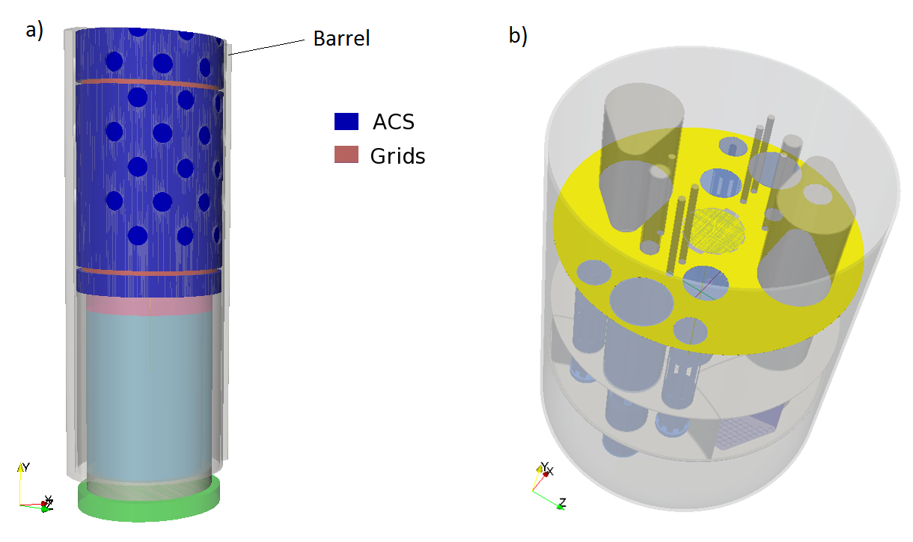
Figure 22: a) Porous media representation of the ACS b) Hot plenum and barrel free-surfaces

Once again the porous media approach is used to model the region inside the barrel. At intermediate positions along the Above Core Structure, two grids guide the In-Pile Section, Control Rod and Scram Rod tubes into the core. They are modeled as separate porous zones through which the axial pressure drop is estimated. However, from the free level of LBE to just above the outlet nozzles of the fuel assemblies, the Above Core Structure is a much more open structure, also modeled as a porous media. Derivation of porous media properties of the Above Core Structure were based on the book: Nuclear Systems by Todreas and Kazimi [9]. By taking into account the presence of all guiding tubes, a porosity of 0.91 is calculated. The LBE free-surface of the HP is highlighted in yellow in Figure 22 b). As introduced previously, in the single phase full power simulation the free surfaces are approximated by a free slip condition since their level is not expected to vary much at steady state. In addition, the hot plenum (HP) and barrel region free-surface levels are approximated to be at the same height, although a slight difference exists in reality.

Porous media approach in the primary heat exchangers
After having collected the heat from the nuclear reaction, the hot LBE in the Hot Plenum is aspirated by the pumps into the four heat exchangers. There, the heat is transferred to the secondary coolant which is a mixture of liquid and steam water like in most nuclear power plants. The type of heat exchanger is a counter-current flow heat exchanger with straight tubes. The Heat Exchanger design is shown in Figure 23 a). The LBE is flowing outside the water tubes downwards, while the two-phase water is flowing upwards. In normal operation, the HX’s have to remove the power generated by the reactor core and all of the other heat sources (e.g. spent fuel, pumps). Therefore, it was designed to extract 110 % of the nominal core power to take all of these into account. The number and dimensions of the water tubes should therefore be sufficient for the Heat Exchanger to extract 27.5 MW. Each Heat Exchanger consists of 684 water tubes with an external diameter of 16 mm. In the CFD model however, the Heat Exchanger is simplified using the porous media approach which avoids having to represent the hundreds of water tubes. Only the feed water pipe in the centre is represented and subtracted from the numerical domain as the secondary circuit is not modeled. Based on the cross-sectional area occupied by the water tubes, the porosity is calculated. As previously, the theoretical average velocity allows us to estimate the pressure losses with Handbook correlations [14], which in turn provide us with the inertial resistance coefficients (Equation 7). As observed in Figure 23 b), the porous media (in blue) occupies all of the interior volume of the Heat Exchanger, except the feed water line, which is taken into account as solid surface (in red). Also here the simulation domain is limited by the height of the LBE free-surface level.
The heat transfer between the primary and secondary coolant is represented in the CFD model by a variable heat sink located in the Heat Exchanger porous zone. The heat transfer correlation derived by Ushakov [10] for liquid metals and recommended for rod bundles in a triangular or hexagonal arrangement is used. The following expression for the Nusselt number $Nu$ is applied:
$$Nu=7.55\frac{P}{D}-20{\left(\frac{P}{D}\right)}^{-3}+\frac{3.67}{90{\left(P/D\right)}^{2}}{Pe}^{\left(0.19\frac{P}{D}+0.56\right)}$$ | (5)
As described by equation (5), the heat transfer that occurs at the water tube boundary will depend on the pitch to diameter ratio $P/D$ and the Peclet number, $Pe$. The latter is related to the Reynolds number $Re$ and the Prandtl number, $Pr$, such that:
$$Pe=Re.Pr, with: Re=\frac{ρu_{magn}D_{H}}{μ} \& Pr=\frac{μC_{P}}{λ}$$ | (6)
In the simulation, the local velocity magnitude $u_{magn}$ is considered to calculate the local heat transfer described by $Nu$. The latter is then used to determine the heat transfer coefficient $h_{e}$ on the LBE side, given by:
$$h_{e}=\frac{Nu.λ}{D_{H}}$$ | (7)
Finally, the total local heat transfer $U$ is determined, considering also the water tube’s heat transfer resistance $R$ and the heat transfer coefficient $h_{i}$ on the water side, as follows:
$$U=1/{\left(\frac{1}{h_{e}}+R+\frac{1}{h_{i}}\right)}$$ | (8)
As for the core, the heat sink $S_{PHX}$is volumetric, therefore it takes into account the water tubes exchange surface $A_{exchange}$, the Heat Exchanger volume $V_{HX}$ and the local temperature difference between the LBE and the water, such that:
$$S_{HX}={UA_{exchange}\left(T-T_{water}\right)}/{V_{HX}×F_{HX}}$$ | (9)

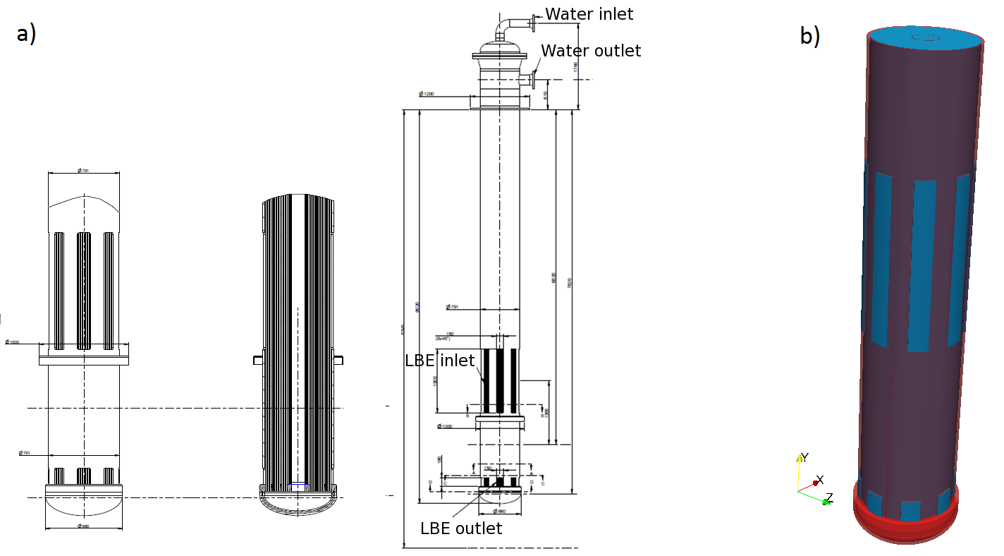
Figure 23: a) HX design b) HX with porous media modeling

The water temperature $T_{water}$ is fixed to 200 °C. An additional factor $F_{HX}$ appears in order to adjust the heat that is removed. The factor $F_{HX}$ was fixed to 0.52 so that approximately 25.5 MW would be removed by each Heat Exchanger when heat losses are neglected.

In Vessel Fuel Storage simulation
The IVFS (In Vessel Fuel Storage) consists in four racks, each capable of storing half a core, with 76 positions where the Fuel Assembly can be placed. Instead of representing individually the different positions, this component is simplified using a porous media that surrounds all the storing positions. This region is defined by considering that the racks are fully occupied by the Fuel Assembly. Consequently, the same parameters are taken for the IVFS porous media than for the Fuel Assembly rings. Finally, in terms of heat modeling the IVFS represent an additional source of energy since the stored Fuel Assembly release some residual heat. Thus, a uniform heat source is added in each of them so that an extra 2 MW is injected in total. It is important to mention that LBE is able to flow within the IVFS to help cool down the Fuel Assembly by natural convection. To allow the coolant circulation, several holes are placed in the cylindrical shell of the inner vessel between the two plates of the IVFS casing.

Computational mesh
Finite Volume codes are more accurate with hexahedral meshes, as the flow is better aligned with the grid. In order to obtain a hexahedral based mesh for the reactor simulations, the mesh generator included in the OpenFOAM package, called snappyHexMesh was used [11]. The snappyHexMesh utility generates 3-dimensional meshes containing hexahedra (hex) and split-hexahedra (split-hex) automatically from triangulated surface geometries in Stereolithography (STL) format. The mesh approximately conforms to the surface by iteratively refining a starting mesh and morphing the resulting split-hex mesh to the surface. The specification of mesh refinement level is very flexible and the surface handling is robust with a pre-specified final mesh quality. The mesh generator is script driven and completely automatic. Geometry modifications therefore can be taken into account easily. It runs in parallel with a load balancing step at each iteration, which makes it very efficient.
First a basic background mesh was generated with a global mesh size of 30cm. This basic mesh is then refined 4 times around the surfaces and edges to get a good representation of the geometry with a refinement ratio 1:2 (cell linear ratio between fine and coarse sections). Three different refinement regions were defined in order to capture the pump jets and the jet below the core. Finally, the refined mesh is snapped to the surfaces to capture correctly the geometric complexity. In order to represent the shear stress on the walls without resolving fully the boundary layers, wall functions have been used. The fluid and the solid mesh are generated together resulting in a fully conformal mesh between the fluid and the solid regions. In addition to the inner vessel, the other major solid parts are meshed so that conjugate heat transfer, CHT, can also be simulated through these structures. The solids located in between LBE regions of high temperature difference appear to be the walls of the in vessel fuel handling machine, IVFHM and the two diaphragm plates. In the CAD created for the CFD model, together with various tubes these two components are included within a single part referred to as main-walls and colored in grey in Figure 24 a). Therefore, all of these components are meshed at once as a single solid domain (grey domain). In addition, the blue region representative of the closed LBE zone surrounding the core is also meshed. The last solid parts added to the simulation are the four Heat Exchanger walls. A zoom to the pump region can be seen in Figure 24 b) to give a view to the mesh structure used throughout this work.

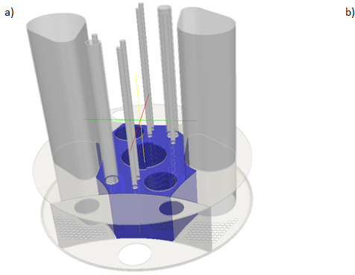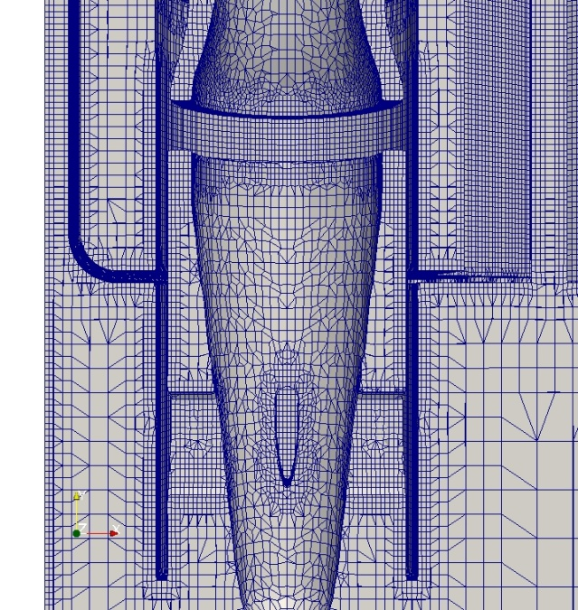
Figure 24: a) ‘Main-walls’ component in grey and closed LBE region in blue b) Mesh of the pump region

(U)RANS MYRRHA model for what?
Taking for granted that we can freely operate our (U)RANS CFD model, a question naturally arises: what to do with it?
Part of the answer lies in looking at what we have done with it.

Looking at the flow and the thermal field under design nominal condition

Looking at the flow field
There are two constraints on the flow field:
- Not too high velocity (less than 2m/s) for erosion/corrosion issues
- Not too low velocity for corrosion/oxygen control issues (less than 1 day residence time)
Visual inspection of the flow velocity throughout the computational domain let us spot a local maximum at the HX outlet, see Figure 25 right, apparently still under 2m/s, but taking into account that the HX is modelled as a porous medium, only the superficial velocity in shown which is quite lower than the local maximum velocity, typically when flowing laterally between 2 tubes of the HX.
On the other hand, while constructing the model, we were faced with the “apparition” (subtracting the internal structures to the fluid domain inside the vessel) of a “dead” LBE volume around the core, hydraulically disconnected from the rest of the LBE inventory. The volume is shown on Figure 25 right.
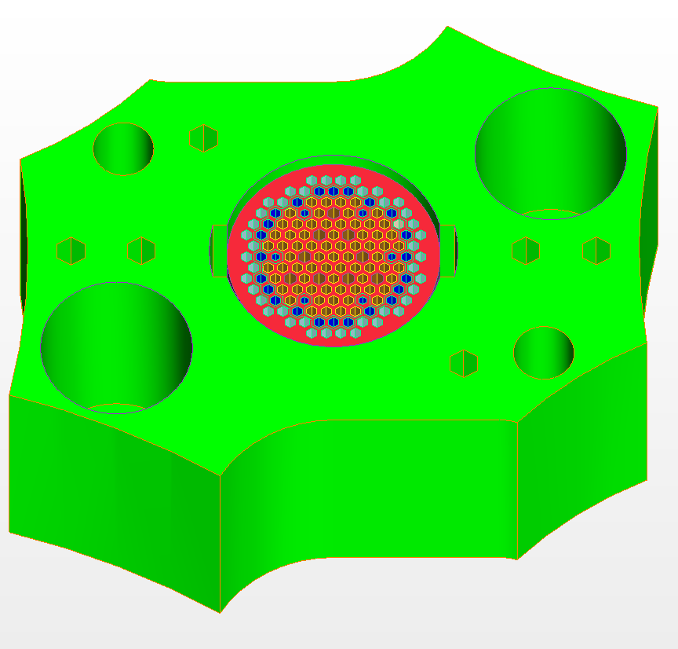
Figure 25: MYRRHA model. Left: velocity across the HX. Right: isolated LBE volume (in green) around the core.

Looking at the thermal field
At a first level, we can look at the thermal field for hot spots or cold spots. At our level of description, the LBE hottest spot is in the hottest central FA as expected and the coldest spot near the axis of the HXs. As the secondary coolant is hotter than the melting temperature, there is no risk of freezing under normal operation. However, the cold spot in the LBE at the top of the HX is a priori unstable and could lead to some thermal fatigue effect, see Figure 26 centre. The temperature field at the free surface controls the rate of evaporation of all the substances dissolved in the plenum, a chemistry related issue. Looking at Figure 26 left, one can guess that some optimisation performed on the ACS could lead to a quite cooler free-surface temperature.
At a second level, by looking at some well-chosen isotherm in the Hot Plenum, see Figure 26 right, one can get insight on whether the Hot Plenum thermal stratification is stable or not. This is again because low frequency instabilities could lead again to thermal fatigue issues.

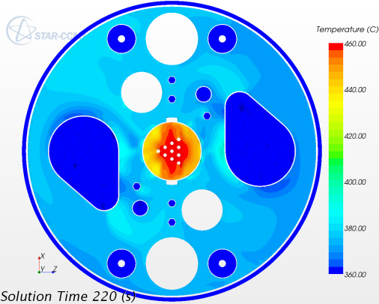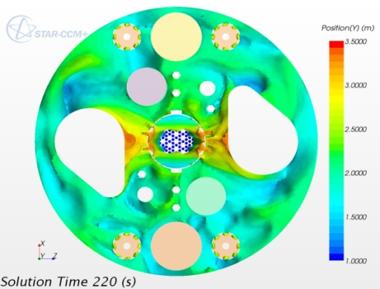
Figure 26: MYRRHA model. Lrft:, free-surface temperature. Center: LBE temperature through the HX. Right: isotherm in the Hot Plenum.

Looking at the system and sub-systems characteristic times
There are several ways to inquire on the system and sub-systems time response. Characteristic times based on the ratio volume to flow rate are not sufficient data because not all the fluid in a pool is necessarily involved at the same level. Let us see this on some example.

Local residence time
Evaluating the residence time of a flow particle entering some fluid volume is easily done using convected passive scalars. You just have to define a passive scalar, initialize it at zero and give it a source term to increment it by one each second. In a closed loop, we must be careful to reset the scalar to zero at some place (really at some flow cross section) in the loop.
The procedure can be applied a posteriori at a relatively low computational cost by freezing all the other equations solver. In completely stagnant regions, the scalar will practically never reach steady state. Once the time of simulation is quite higher than the mean flow residence time, we can easily spot the potentially problematic regions, as seen on Figure 27.

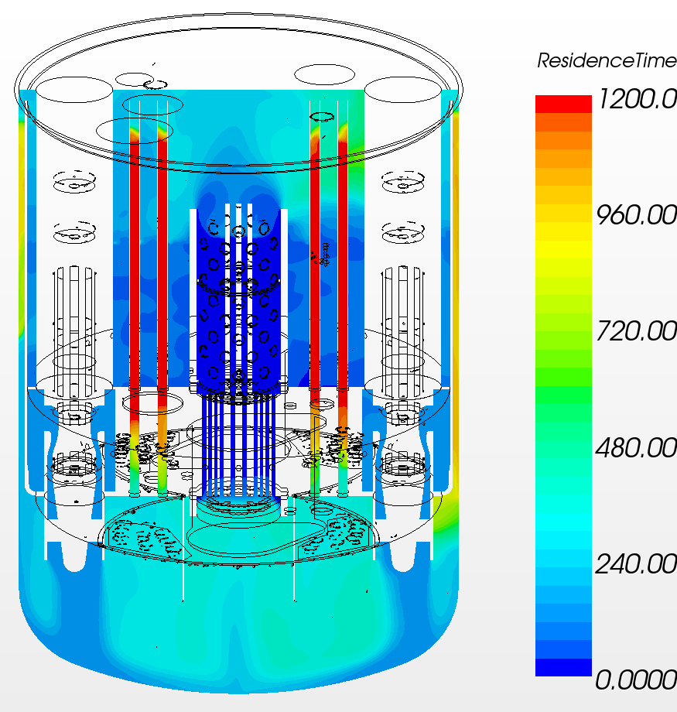
Figure 27: MYRRHA model. Residence time under nominal condition.

Pollutant emission
An emission of arbitrarily small particles can be followed in a similar way with a passive scalar having a localised source which is, in this case, in a specific FA of the first ring. Using a source which is constant in time, one can see on Figure 28 left that the diffusion is strong enough so that all information is lost on the origin of the pollutant when it reaches the core bottom. Instead, if the source is a pulse, that is if the source is also localised in time, we can monitor how and with what delay the scalar passes through different positions such as the HX or the pump inlets, as shown in Figure 28 right.

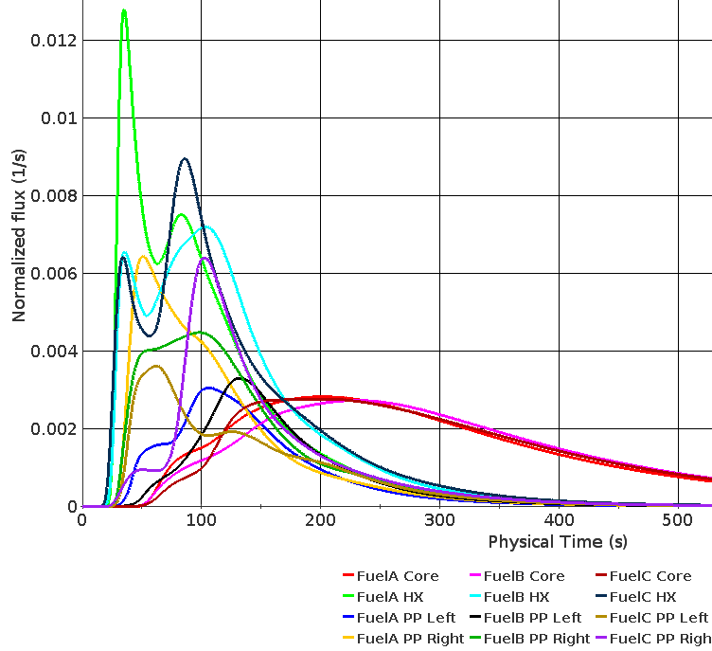
Figure 28: MYRRHA model. Left: dispersion of a passive scalar produced in a central FA. Right: history of a pulse of passive scalar from the core monitoring the flux at different positions.

Lagrangian particulate
The passive scalar tool has strong limitations. The scalar can be convected only by the carrier flow velocity and is also diffused. It cannot have a drift velocity and cannot basically aggregate, limiting the range of physical application. Lagrangian particles instead can have their own density and thus also a buoyancy driven drift velocity. Here again, upon the hypothesis of small volume fractions, the Lagrangian particles are not supposed to influence the background flow and they can be emitted and followed in an otherwise frozen LBE velocity, temperature and turbulence fields.
An example is given in Figure 29 showing the final position of 6000 Lagrangian particles of 2 different densities and 3 different diameters 800s after being emitted from one of the central FAs in a ULOF scenario. The larger and heavier particles tend to precipitate above the diaphragm upper plate, the larger and lighter particles tend to agglomerate on the free-surface and the smaller particles tend to be kept in suspension and to follow the LBE main flow path.

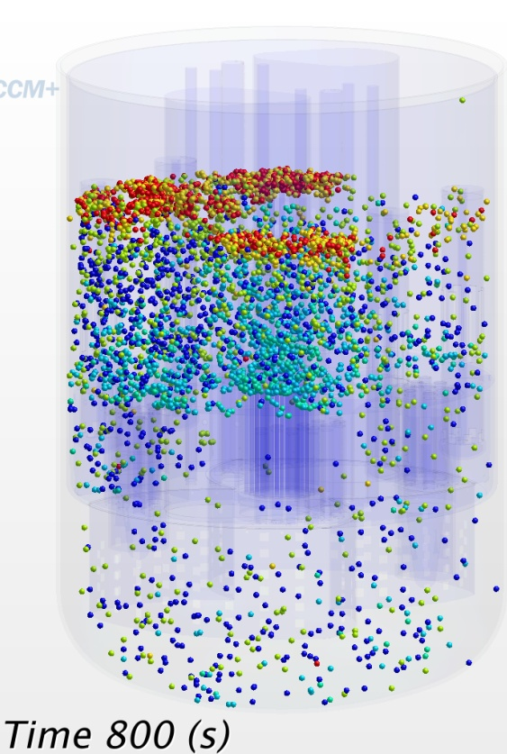
Figure 29: MYRRHA model. Lagrangian particles coloured according to different densities and diameter 800s after emission from one of the central FAs in a ULOF scenario.

Beyond simple illustrations
Most of the applications shown until now are applied under essentially steady state conditions. They can equally easily be applied, with the due precautions, under transient flow conditions. And in fact, all the modelling is predisposed and makes full sense for transient conditions involving changes in the flow regime such as the loss of one or two pumps. With 3 dimensions in space and one in time, it is however a little complex to refer about 4 dimensional problems on very few 2D paper sheets.
In all that has been presented until now, we have implicitly make use of the (U)RANS framework as a simple given tool. Now that we have some idea on what the tool can do, it is time to inquire a little deeper on what is the tool made of and precise somewhat more its range of application.

Numerical developments toward transient simulations

In the following, the reactor in nominal operation is analysed, based on the setup constructed in the von Karman Institute. Since the level of the free surfaces are constant in this scenario, the resolution of the free surface is not strictly needed, so two approaches were taken: a single phase simulation was performed to get insight to the flow and thermal fields of the reactor, then a multiphase solution was considered to initialize later transient simulations with changing positions of the free surface levels, such as primary pump start up and shut down or accident scenarios e.g. primary pump failure.

General flow field
The first objective of the full power simulation is to get an insight on the large flow patterns that develop within the reactor. These ones are essential to get a general understanding of the flow field and to identify possible areas where low LBE refresh rates may occur. Indeed, such stagnant zones need to be avoided since oxygen control has to be kept within narrow limits. The second objective of this simulation is to evaluate the temperature distribution on the different components for stress evaluations.

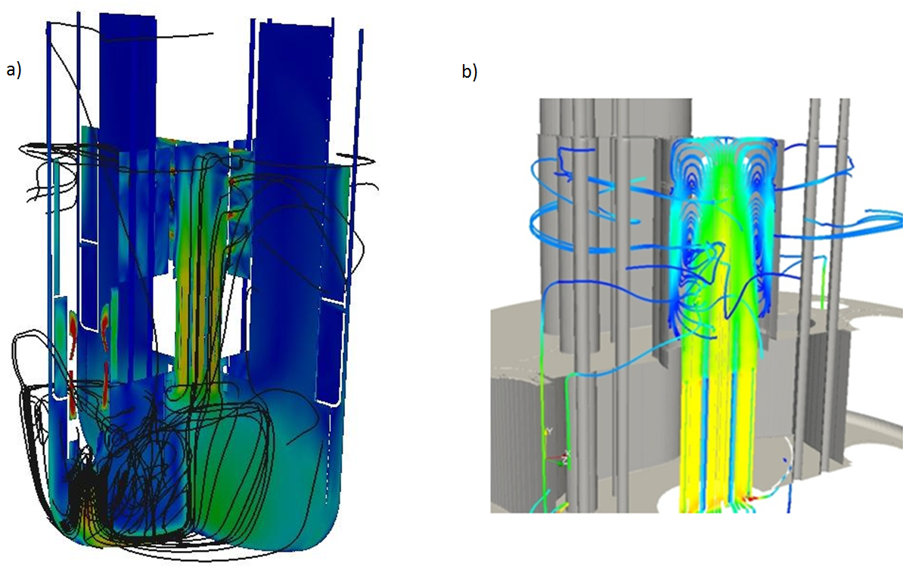
Figure 30: a) Velocity contours and streamlines in the vertical symmetry planes b) Streamlines in the barrel region

The overall pressure drop through the primary coolant loop is 2.57 bars. One of the most important parameters of the reactor is the pressure drop through the core. We recall that a pressure drop of 1.7 bars is expected in the core region while about 2 bars should be obtained between the Cold Plenum and Hot Plenum, respectively. The resulting values from the simulation indicate very small differences of less than 2 % both in the core and between the Cold Plenum and Hot Plenum. The maximum pressure difference over the barrel free surface and over the Hot Plenum free-surface is at most 1.5 kPa. This would be equivalent to a height variation of 1.5 cm, therefore underlying the practically flat aspect of these surfaces. This confirms that modeling the free-surfaces as a zero-shear slip wall is acceptable for this operational condition.
A general description of the flow field can now be proposed based on the flow streamlines shown in Figure 30. The two pump jets first impact the bottom of the vessel before merging in the centre of the lower plenum leading to an upward flow directed towards the core. The flow is distributed as expected through the different core rings. Within the above core structures a central upward plume is formed going up to the free surface level. Once the flow reaches the free-surface, part of it exits through the last row of barrel holes but a large portion goes back down into the barrel before exiting through the other rows of holes down below. Finally, the flow in the upper plenum goes back into the Heat Exchangers. Contours of velocity are given in Figure 31 in the two vertical symmetry planes (indicated on the top view), with levels between 0-1 m/s and saturated above. The nominal mass flow rate leads to a maximum velocity of 2.37 m/s in the pumps.

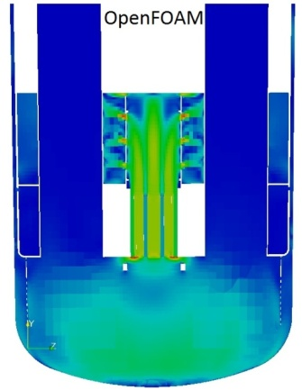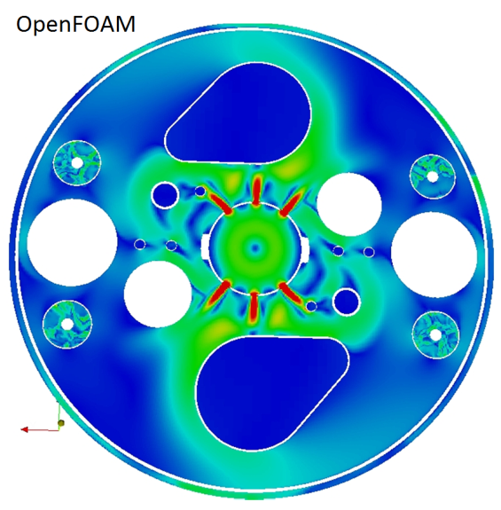
Figure 31: Velocity magnitude contours in the vertical symmetry plane z=0

As for the flow in the symmetry plane cutting the barrel holes, long vertical jets originating from the different core rings appear in the Above Core Structure. Unlike in the perpendicular plane, mixing is limited and the LBE exits progressively through the barrel holes. The jets from the holes facing the IVFHM collide with the chimney structures.

Verification of the porous core approach
One of the important modeling requirements to fulfill is to approach the desired mass flow rate distribution in between the different core rings. A good agreement is obtained with the proposed porosity and resistance settings in the porous media of the core. The relative differences compared to the desired flow rates stay below 5%. These differences remain acceptable and no further adjustment is required.

The various heat sources and sinks used for thermal modeling result in substantial temperature variations throughout the reactor. We recall that 100 MW is injected across the core and an additional total of 2 MW is added in the IVFS, where the used Fuel Assemblies are stored. In steady state, this same amount of heat (102 MW) is extracted by the four Heat Exchangers since thermal losses to the exterior are currently neglected. The water side temperature, 200°C, of the Heat Exchangers acts as a fixed reference temperature. The turbulent Prandtl number was fixed to 2.8 according to the literature in the following study [10]. Static temperature contours in the vertical symmetry planes are shown in Figure 32. One can see that due to mixing, the core heat source located in the inner and outer FA rings heats up the flow coming out from the other rings as the flow rises. A maximum temperature of 471 °C is reached in the core. The mass flow average core inlet and outlet temperatures correspond to 272 °C and 344.5 °C respectively, in agreement with an injected power of 100 MW $\left(P=\dot{m}C_{p}∆T\right)$.

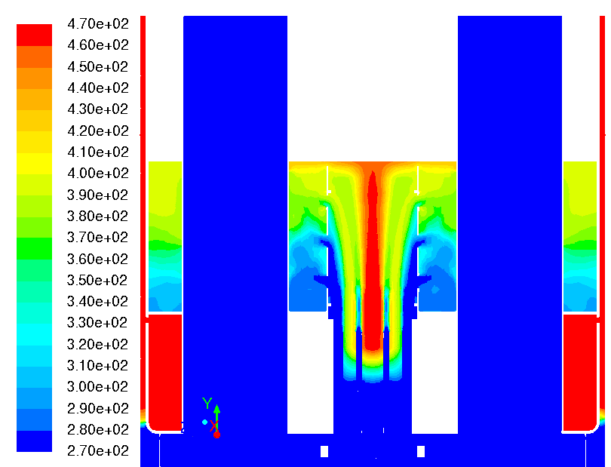

270
320
400
470

Ts (°C)
Figure 32: Effect of conjugate heat transfer (left without, right with CHT)

Figure 32 shows clearly the importance of the conjugate heat transfer. By conduction through the structures the temperature differences between the cold and hot plenum in the upper region of the reactor (annular space and IVFHM) are smoothened. As illustrated in Figure 32, LBE is being ejected through the barrel holes at different temperatures. Considering the lack of flow mixing in this plane, the cold flow from the outside rings tends to exit through the first rows of holes while the central hot jet in the core reaches the free-surface. Average temperatures on the barrel and Hot Plenum free-surfaces are approximately equal to 440 °C and 400 °C respectively. In the Hot Plenum, buoyancy prevails and results in a thermal stratification, as shown in Figure 33, where the vertical temperature profile in the Hot Plenum is plotted along a vertical line (Figure 33).

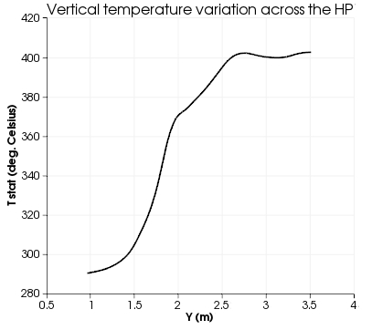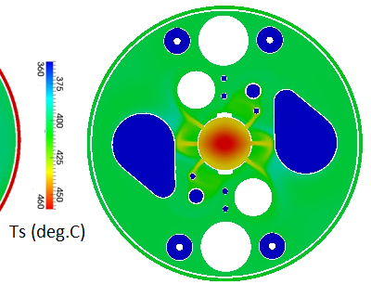
Figure 33: Thermal stratification along a vertical line in the Hot Plenum next to the IVFS and Static temperature contours on the free-stream surface

To assess the thermal stress experienced by the various components of the reactor, static temperature contours on both sides of the parts are shown in Figure 34. In the simulation without conjugate heat transfer, the internal structures experience temperature gradients by being in contact with the LBE in the two parts of the pool (Hot & Cold Plenum). A maximum temperature difference across the wall of around 60 °C appears at the upper diaphragm plate, where the Heat Exchanger outlet region (270 °C) is located on the lower side and the hot flow (320 °C) in the Hot Plenum located on the upper side. Temperatures on the diaphragm and in particular its two horizontal plates are shown in Figure 34/b. As for the top plate, strong gradients exist over its surface but the differences between both sides, of importance for thermal stresses, are limited to similar levels than for the bottom plate.
In the simulations with conjugate heat transfer where the conduction through these plates cools down the hot LBE located in the IVFS area, the temperature gradient between this zone and the Cold Plenum is considerably reduced, which reduces thermal stresses on the lower diaphragm plate (< 30 °C).

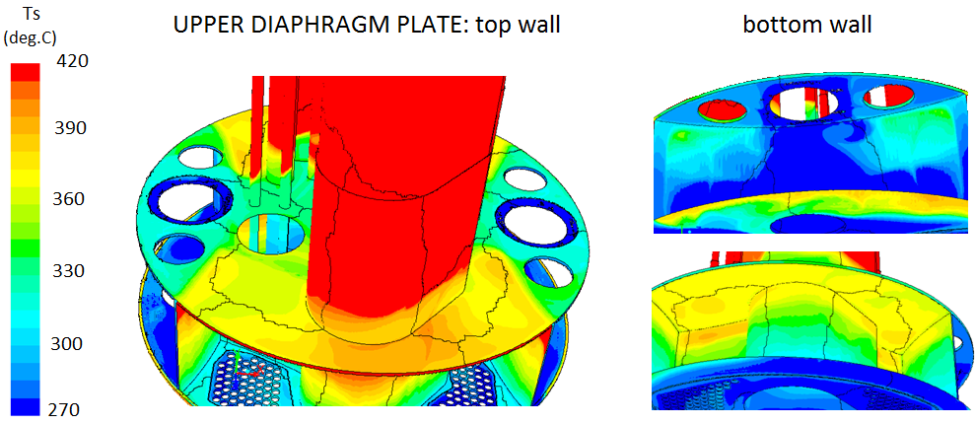
Figure 34: Static temperature contours on the top and bottom sides of the diaphragm plates

Unsteady features
In order to be able to deal later with transient scenarios, a closed loop was considered with multiphase VoF simulation. The region above the LBE is filled with Argon gas. In order to have the same pressure everywhere in the gas region, all the tubes emerging from the upper and lower plenum were truncated such that a 5 cm gap is present between the top cover and the top of the tubes.
As the LBE level was constant at the beginning of the simulation the flow was stagnant, too. The flow field got established:~100 sec of physical time in the simulation corresponding to 12 days of computational time on 128 processors. The obtained flow field with the single phase and multiphase flow solvers can be seen in Figure 31. The general flow field and velocity magnitudes are conformal in the two simulations, though the multiphase solver presents less distinct jets coming from the pumps and going towards the core due to the unsteady nature of the flow. For the steady state simulation we obtain a time averaged flow field, while in the unsteady simulation we can appreciate an instantaneous picture of the flow topology.
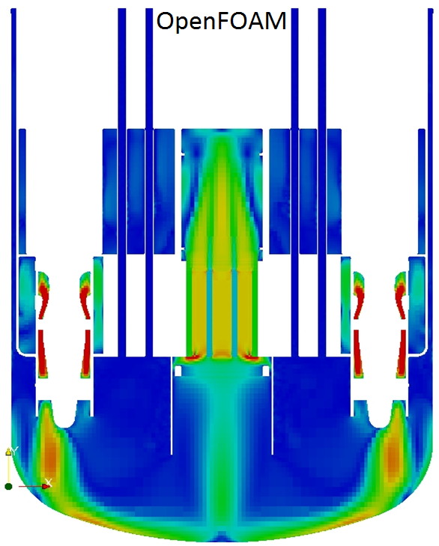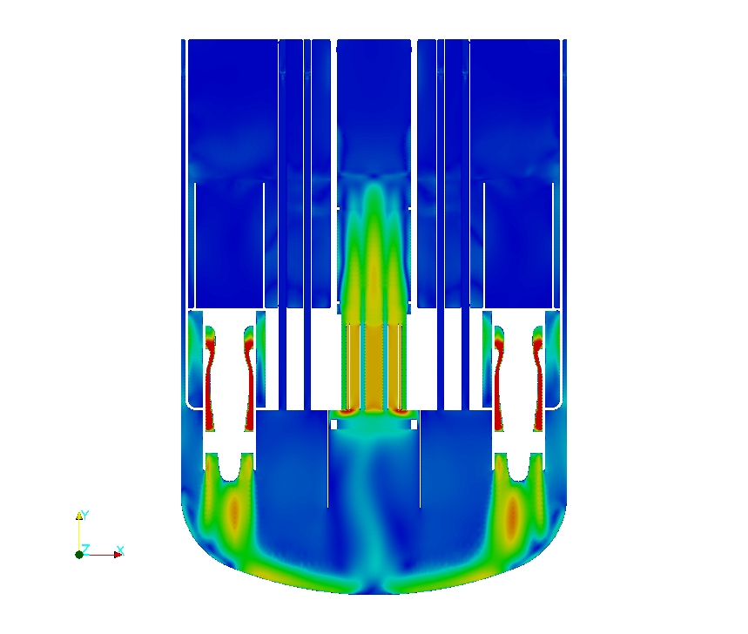
Figure 35: Velocity magnitude contours in the vertical symmetry plane z=0. a) Single phase, steady-state simulation b) Multiphase unsteady simulation after 100 seconds of simulation time

The reference pressure difference in the VoF simulation was set to zero at the first pump outlet height the same way as for the single phase case, though the simulation was diverging due to the inadequate initialization of the buoyant pressure. Therefore, based on previous experiences, the reference was shifted close to the top of the computational domain, into the argon region, resulting in a stable transient section of the simulation start-up.
The pressure drop through the reactor is estimated to 2.45 bar. The free surface of the upper and a lower plenum is separated by a height difference of 2.4 m (Figure 36). As predicted by the steady state there is 6 cm of height difference between the upper plenum inside and outside of the barrel, resulting in fountains of LBE dropping to the upper plenum surface.

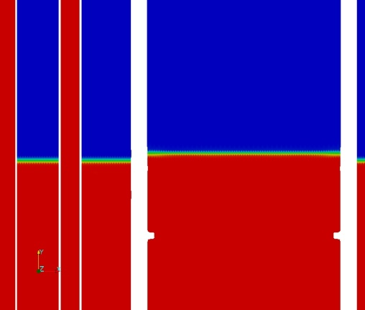
Figure 36: LBE void fraction in the vertical symmetry plane z=0 a) Full view b) Zoom to the barrel region c) vertical symmetry plane x=0

Other than these fountains, the free surface of the LBE is relatively smooth, only some wave like interference patterns are present (Figure 37).

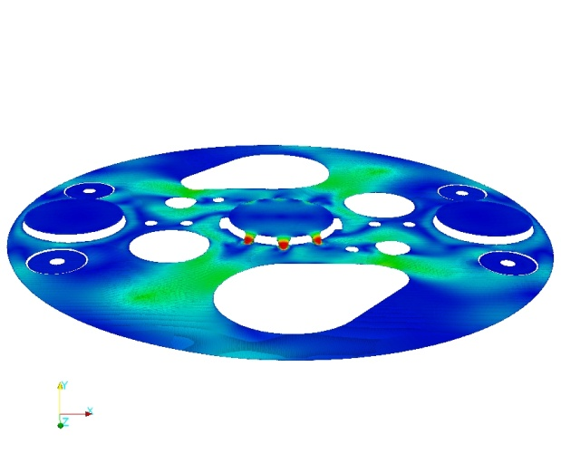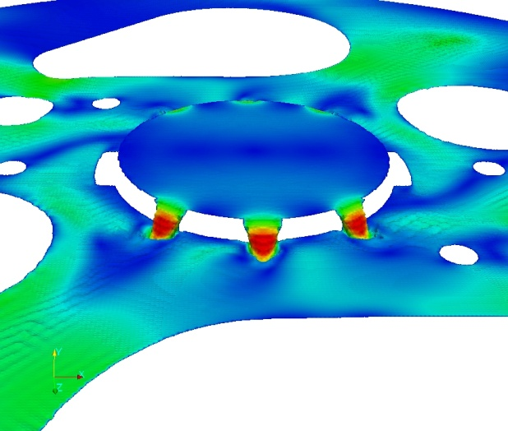
Figure 37: LBE free surface level colored by velocity magnitude between 0-0.5 m/s a) Full view b) Zoom to the barrel region

Comparing the thermal fields, we can observe some differences. First of all, the thermal stratification is not as strong as for the steady case. The unsteady, multiphase solver predicts more mixing in the barrel, as well as, in the upper plenum. Note that the current figures are extracted at computational time 180 seconds, when the temperature field is most probably not yet fully developed.

Figure 38: Temperature contours in the vertical symmetry plane z=0. a) Single phase, steady-state simulation b) Multiphase, unsteady simulation

On the top of the computational domain for the steady state model, a symmetry boundary condition was imposed for the temperature, corresponding for the multiphase simulation to the free surface location. The boundary condition at the cover wall, for the VoF case, was set to adiabatic wall.
The hot LBE rising in the barrel heats up the argon above but since the flow in the argon is not of interest, the cover gas is modelled as a fluid with constant density. We can see that hot plumes are exiting through the upper barrel holes
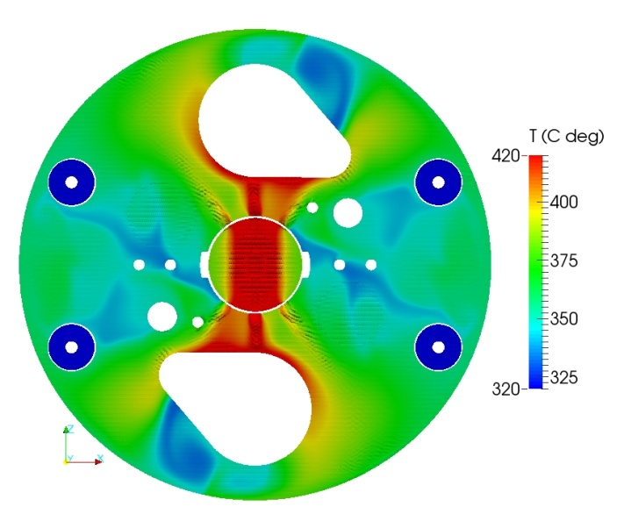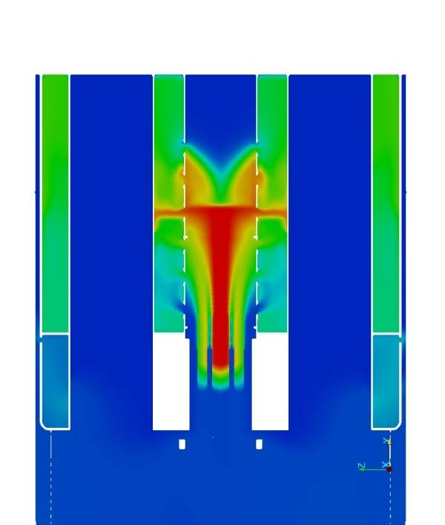

Figure 39: Temperature contours in the vertical symmetry plane z=0. a) Single phase, steady-state simulation b) Multiphase, unsteady simulation

What next (conclusion)
Due to the complex geometry and the interaction of the various physical phenomena in a nuclear reactor, the numerical analysis of such systems is very challenging. However, the ultimate advantage of numerical simulation is that it allows a detailed look inside an existing domain, which could not be obtained only through experimental measurement, or inside a facility that is yet only present on the design table.

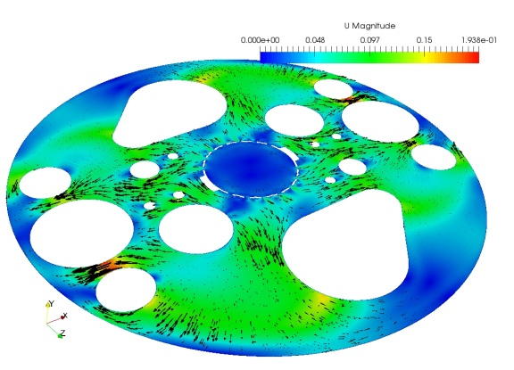
Figure 40: LBE free surface level colored by velocity magnitude between 0-0.5 m/s a) design version 1.4 b) design version 1.6

Such second case is the MYRRHA reactor. The thermo-hydraulic simulations are integrated to the design process. Based on the results and the structural constraints the design can be updated leading to a more efficient geometry. Such a geometrical modification is the re-design of the Above Core Structure between the design version 1.4 and 1.6. The above core of the 1.4 version had holes driving the hot fluid arriving from the core to the upper plenum in a staggered way. Depending on the free surface level of the upper plenum, it is possible to have higher LBE level inside the barrel than outside leading to small fountains of liquid metal. In order to avoid this situation, in the design version 1.6 the holes are elongated. In this way, at every level there is a region where the LBE can leave the barrel, not allowing the previously described level difference. The other modification adopted based on the simulation results in the barrel is a multi-level plate that forces the hot LBE to leave the barrel before the free-surface, enhancing the mixing and resulting in less thermal stratification.

Figure 41: Temperature contours in the vertical symmetry plane z=0. a) design version 1.4 b) design version 1.6

To perform such simulations is not easy and is computationally relatively expensive. Moreover, it is the responsibility of the researcher to employ the most relevant models, improve them, if needed, in such a way to enhance the strategy of numerical simulation of pool configurations. As such, these simulations are the result of a joint effort of many years of fundamental research in the field of mathematics, physics, sometimes chemistry and computational sciences. The need of this synergy led to the relative late start of the application of CFD in the field of nuclear research.
The numerical simulation of pool type configurations is a work continuously in progress…

References
- http://myrrha.sckcen
- Aragonese, C. and Buono, S. and Fotia, G. and Maciocco, L. and Moreau, V. and Sorrentino, L., A beam window target design with independent cooling for the EADF, CRS4 Technical report, 2000, http://publications.crs4.it/pubdocs/2000/ABFMMS00e
- Aragonese, C. and Buono, S. and Fotia, G. and Maciocco, L. and Moreau, V. and Sorrentino, L., A thermal fluid-dynamic transient analysis of the EADF down-comer channel., CRS4 Technical report, 2000, http://publications.crs4.it/pubdocs/2000/ABFMMS00h
- Moreau, V. and Mansani, L. and Petrazzini, M., A case history of cfd support to accelerator driven system plant design, Proceedings of The 17th Int. Conf. On Nucl. Eng, 2009, http://publications.crs4.it/pubdocs/2009/MMP09
- Moreau, V., FASTEF Heat exchanger tube rupture CFD simulation, Nuclear Engineering and Design, vol. 252, pp. 42-51, 2012
- Handbook on Lead-bismuth Eutectic Alloy and Lead Properties, Materials Compatibility, Thermal-hydraulics and Technologies, Nuclear Energy Agency 2007 Edition http://www.nea.fr/html/science/reports/2007/nea6195-handbook.html
- R. Rehme, “Pressure drop and velocity distribution in rod bundles with spacer grids” Nuclear Engineering and Design, Volume 62, Issues 1-3, page 349-359 - December 1980.
- R. Rehme, “Pressure drop correlations for fuel elements spacers”, Nuclear Technology, Volume 17, page 15-23, 1973.
- N. E. Todreas and M. Kazimi: Nuclear Systems I-II., 1990.
- P. A. Ushakov, “Problems of Heat Transfer in Cores of Fast Breeder Reactor, Heat Transfer and Hydrodynamics of Single-phase Flow in Rod Bundles”, Izd. Nauka, Leningrad (Russia), 1979.
- http://www.openfoam.org/docs/user/snappyHexMesh.php
- Moreau, V., Towards a full 3Dsimulation of MYRRHA primary coolant loop, pp. 1-30, chapter in the book: Fluid mechanics and chemistry for safety issues in HLM nuclear reactors, VKI, 2014, http://publications.crs4.it/pubdocs/2014/Mor14
- Moreau, V. and Buckingham, S. and Planquart, P. and Koloszar, L., Challenges in the CFD modeling of MYRRHA Primary System, Proceedings of the SEARCH/MAXSIMA 2014 International Workshop}, 2014, http://publications.crs4.it/pubdocs/2014/MBPK14
- I.E. Idelchik: Handbook of Hydraulic Resistance, 2005

