D38
CFD modeling and validation of a GEN-IV reactor mockup under seismic load
Version [1] – 30/08/2024

V. Moreau, M. Profir (CRS4)


The PASCAL project has received funding from the EURATOM research and training programme 2014‐2020 under Grant Agreement No 945341.

Document properties
Title: CFD modeling and validation of a GEN-IV reactor mockup under seismic load
Type: Deliverable
Number: D[nn]
Work Package: WP[n]
Lead beneficiary: CRS4
Contributing partners: [any other]
Dissemination level: [Public]

History of changes
Version | Changes |  | Drafting | Review | Approval
1 | -- | Signature
 |  | Name | [Vincent Moreau] (CRS4)  (Main author) | Ivan Di Piazza (ENEA)  (WP Leader) | Giacomo Grasso (ENEA)  (Coordinator)
 |  | Date
 |  | Signature
 |  | Name | [Name Surname] (ORG)  (Main author) | [Name Surname] (ORG)  (WP Leader) | Giacomo Grasso (ENEA)  (Coordinator)
 |  | Date

Abstract
This document reports on the modelling and simulation of the mockup of ALFRED, a GEN-IV reactor, under seismic load. The mockup has been built and operated, in water, by VKI in collaboration with CRS4 and ANN. It is inspired by the current ALFRED design and it is focused on the representation of the main components present in the upper plenum, still maintaining an open connection with the lower bulk.
The experimental mockup is shortly presented. The geometry of its numerical counterpart is described. The numerical modeling was described in the deliverable D13“Sloshing CFD modeling and validation with SHAKESPEARE first experimental campaign” and required some few adaptations to this new application, which are explained here.
The simulation results are shown and then compared with the experimental ones. First, the technical feasibility of the numerical mockup is ascertained. Second, the comparison is done on artificial harmonic forcing. Then, simulations are performed with existing seismic loads taken from the last 20 years major earthquake in Italy in 2016, applying the necessary scaling. The methodology is reused to investigate on the mockup seismic signals of higher amplitude, from Romania in 1977 and Turkey in 2023. The wave amplitude is measured as well as the force induced on the vessel and the DHR components.
We then concentrate on the simulation of the 2011 Japan earthquake causing the tsunami that was the initial trigger of the Fukushima incident.
We observe that the highest intensities of the forces applied to the vessel and the components arise from the seismic high frequency component. It is therefore compulsory to first and foremost strongly filter this component by means of carefully designed damping systems. With a numerical low pass filter at 1 Hz which mimics a possible damping system, the peak force on the mock-up vessel is reduced by a factor of 20. Nevertheless, the effect of sloshing can be observed but remains much lower than the direct effect of the seismic acceleration.

Table of contents

Document properties 1
History of changes 1
Abstract 2
Table of contents iii
1 Introduction 1
2 Numerical model 2
2.1 Geometry and mesh 2
2.2 Probes 3
2.3 Procedure for new simulations 5
2.3.1 VKI Data treatment 6
2.3.2 Restart 7
3 Mockup validation 7
3.1 Case 1: Mockup_2024_02_02_A30_f108_5mm 8
3.1.1 Elevation at probes 9
3.1.2 The free-surface integrity 10
3.1.3 The maximum velocity burst issue 12
3.1.4 Gaps and pump pipe holes flows 12
3.1.5 Time step 14
3.1.6 Forces 15
3.2 Case 2: Mockup_2024_02_05_A30_f068_5mm 16
3.2.1 The velocity burst issue 16
3.2.2 Main results 19
3.3 Case 3: Mockup_2024_02_07_A15_f104_5mm 21
3.3.1 Free surface height 21
3.3.2 Cut domain 24
4 Simulations from seismic loads 27
4.1 Data 27
4.2 Mockup simulation from the Perugia 2016 earthquake 28
4.3 Mockup simulation from the Romania 1977 earthquake 29
4.4 Mockup simulation from the Turkey 2023 earthquake 32
4.4.1 Simulation results 33
4.4.2 Elements of analysis and discussion. 34
4.4.3 Regularization of the displacement input signal. 35
4.5 Mockup simulation from the Japan 2011 earthquake 37
4.5.1 Enforcing consistency and setting input displacement data 38
4.5.2 Japan event results 40
4.5.3 Damped Japan event 42
4.5.4 Damped Japan event, first order in time. 44
5 Discussion 46
6 Conclusion 49
7 Added volumes (Appendix ) 50
References 52

Introduction
The aim of this work is written in the PASCAL proposal and reads: “To further enhance the modelling and computational readiness level of sloshing dynamics in compact liquid-metal filled pools and to retrieve the expected impact forces and dislocations on the involved components for a reference system (e.g. ALFRED).” This deliverable is the second of two. In the first one (D13 Sloshing CFD modeling and validation with SHAKESPEARE first experimental campaign [1]), several fundamental aspects of sloshing and its simulation have been tackled, taking as reference a partially filled vertical cylinder under horizontal harmonic forcing. In particular, a stability map in the normalized amplitude frequency domain has shown to be unexpectedly dependent on the cylinder radius. The value of the behavior transition from linear harmonic to chaotic was shifted, increasing the chaotic region. This was first discovered experimentally, and used as a very demanding criteria for the numerical simulation validation. The transition value was found numerically to be identical to the experimental one up to a very small difference well within the effects of the unavoidable differences between the experiment and its numerical representation. An important lesson from the first part was that it is relatively easy to perform an apparently perfectly sound and qualitatively representative sloshing simulation. However, reaching a quantitative validation has been much more demanding and could not have been obtained without direct access to its experimental contemporaneous counterpart, simply because the otherwise accessible data from the literature was, as already mentioned, unfit. In this particular case, not only the simulation was validated by the VKI experimental campaign [2], but also the surprising experimental results were confirmed by the simulations.
The first part thus allowed to gain confidence with the experimental setup, the numerical setup and the mutual information exchange. For the current second part discussed here, we want to push further the investigation and switch from a very simple, almost academic test case to a more practically oriented one, able to give potentially relevant information about qualitative and quantitative effects that seismic induced sloshing could produce on ALFRED.
The design of an ALFRED mock-up has been elaborated by VKI [2] in collaboration with CRS4 and ANN. It has been built and operated at VKI while the CAD model has been provided to CRS4. The CAD model has been used to build the CFD geometrical model. The resulting CFD model mainly combines the new geometrical model with the previous numerical setting described in the deliverable D4.3.
In section 2, we start by describing the numerical model of the ALFRED mock-up. The geometry and the mesh are illustrated. A particular attention is given to the representation of the probes giving the free-surface level. Having encountered some issues with the streamlining of the simulation and in particular with the data files associated, we describe precisely the procedures followed.
In section 3, we validate the numerical model by direct comparison with experimental data. Three cases are selected among those provided by VKI. They consider a harmonic forcing with an initial linear ramp of 10s. The three cases differ by the forcing frequency or terminal amplitude. The comparison is performed on the free-surface height at the three experimental probe positions. Other aspects of the simulation such as the control of the free-surface smearing, local velocity bursts, quantification of the bypass flows and the forces applied to the main components are investigated.
In section 4, we apply the consolidated numerical model to four renowned sufficiently recent seismic events of increasing damage output. The last two events exhibit displacement above the capability of the SHAKESPEARE table with regards to the mock-up. From their crossed comparison, we put in evidence some incongruences of the results and the necessity of a very careful treatment of the input data while purely numerical settings are clarified.
A discussion of the results is given in section 5 and some conclusions are drawn in section 6.

Numerical model

Geometry and mesh
The CFD geometry has been built from a CAD file provided by VKI and is shown in Figure 1. There are three groups of three components distributed evenly at 40 degrees intervals and listed below.
- Steam Generators (SG) 60 mm diameter, centered at radius 154 mm, fitted in a hole 64 mm diameter. For the campaign of test, plain cylinders are used.
- Pumps (P) 50 mm diameter centered at radius 153 mm, fitted in a hole 54 mm diameter. Lateral walls are 5 mm thick. The four windows are 23 mm wide and 130 mm high.
- Decay Heat Removal (DHR) centered at radius 152 mm, 5 cm diameter. While in the mockup there is a small gap between the DHR and the diaphragm plate, in the CFD model, both are in contact.
The flow bypasses are shown in Figure 2 and require a very fine mesh to be reasonably represented. A posteriori, it would have been greatly beneficial for the cost of the simulations, both in mesh load and execution time, to close the unnecessary gaps. The required mesh refinement is illustrated in Figure 3. The gap between the support plate and the component serves two purposes: first, to accommodate some screw heads and second, to cope with position tolerances. The screw heads are not represented in the CFD geometry, being considered irrelevant to the simulation scope. The position tolerance is a more serious issue because it introduces a large uncertainty on the evenness of the circular bypass flow. The relevance of these bypass flows are discussed later on.
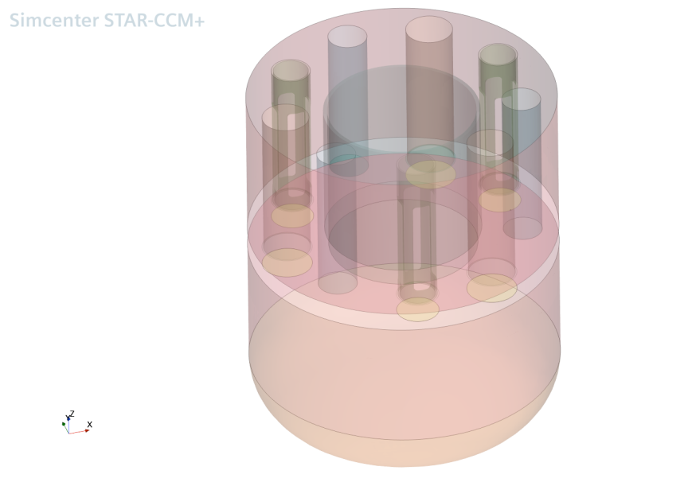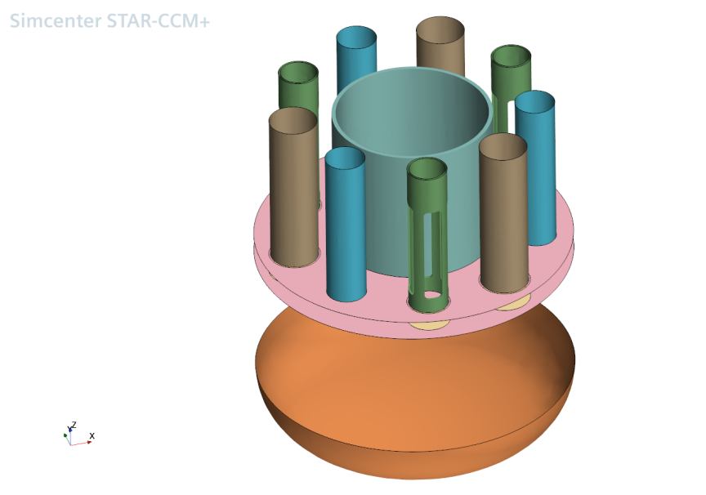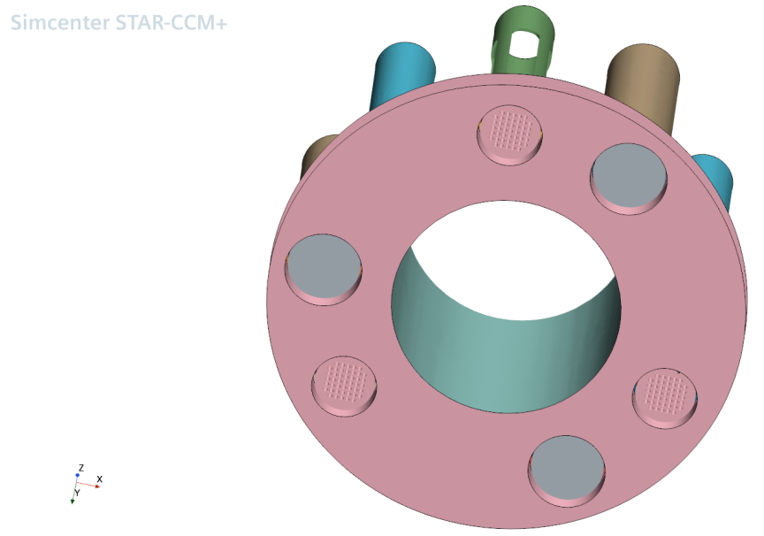
Figure 1: Mockup CFD geometry
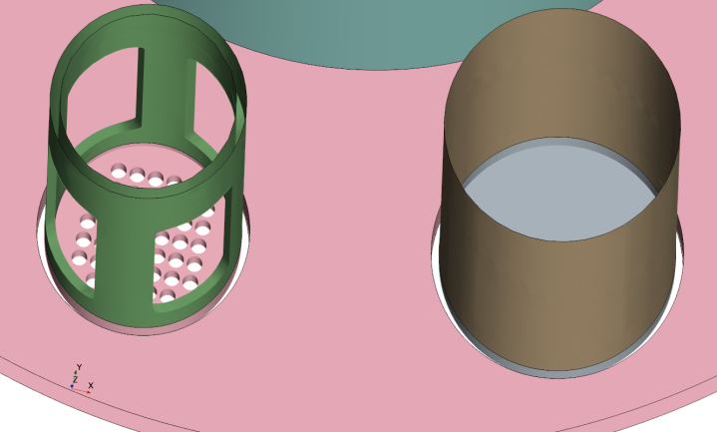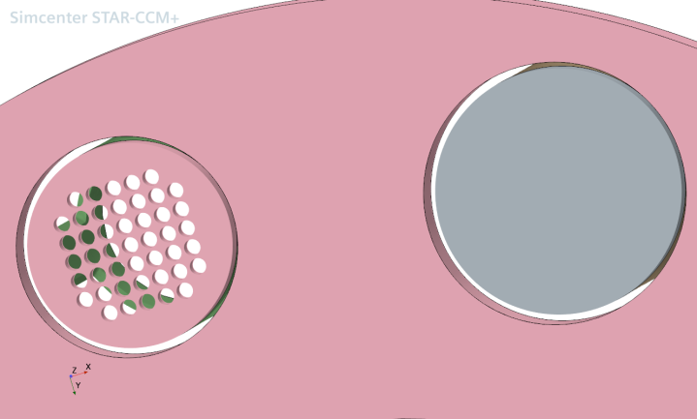
Figure 2: Mockup CFD geometry. Zoom on the PP grid and PP plus SG bypass.
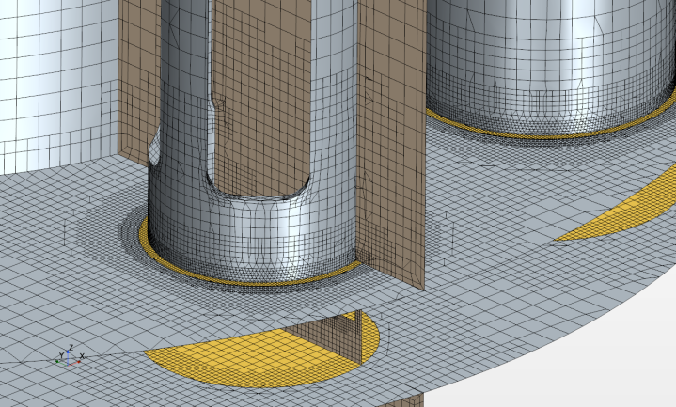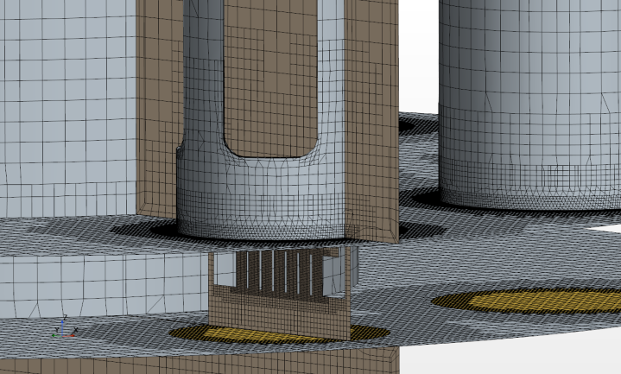
Figure 3: Mockup CFD mesh with close- up to PP grid and bypass refinements.

Probes
The probe position is inferred from VKI indication as shown in Figure 4. In fact, it could not be inferred from the CAD file that has only one PP positioned and oriented in a different way. The actual position of the probes is indicated in Figure 5 and differs somewhat from their theoretical position. In particular, it seems that the digit numbers of P2 have been swapped. This has relevance as the main information comes from the comparison of height at the probes between experimental and numerical measures.
The position of the probes in the numerical model is indicated in Figure 6. What is effectively measured is the mean height over a small (~3mm radius) centered domain. Because the real probe is made of two lambs of a wire separated by ~9mm, we also made the measure on separated small regions both sides from the probe center. The small domains of integration for the P1 probe can be visualized on Figure 7.
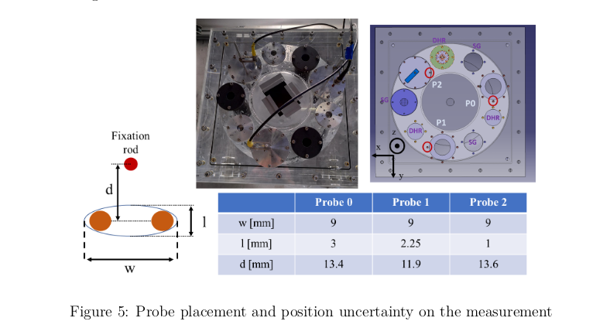
Figure 4: Probe placement and position uncertainty on the measurement (courtesy of VKI)
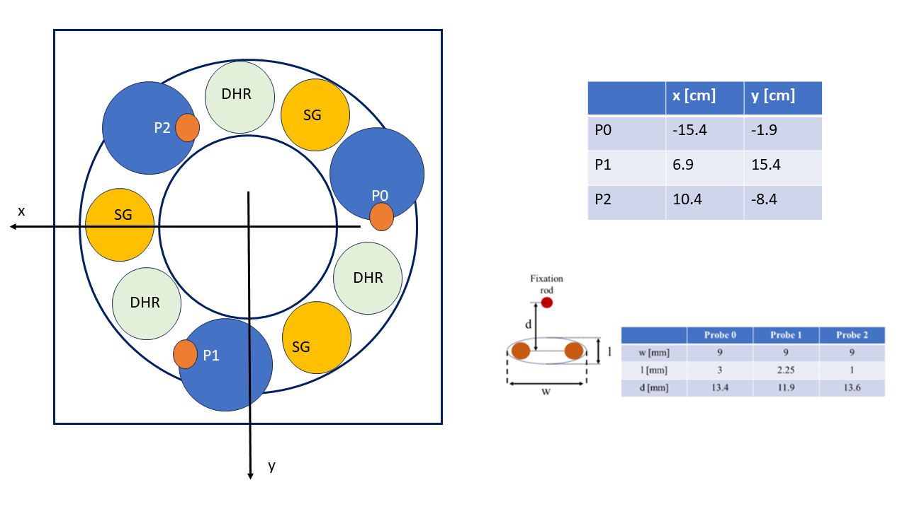
Figure 5: Probes placement and actual coordinates (courtesy of VKI)
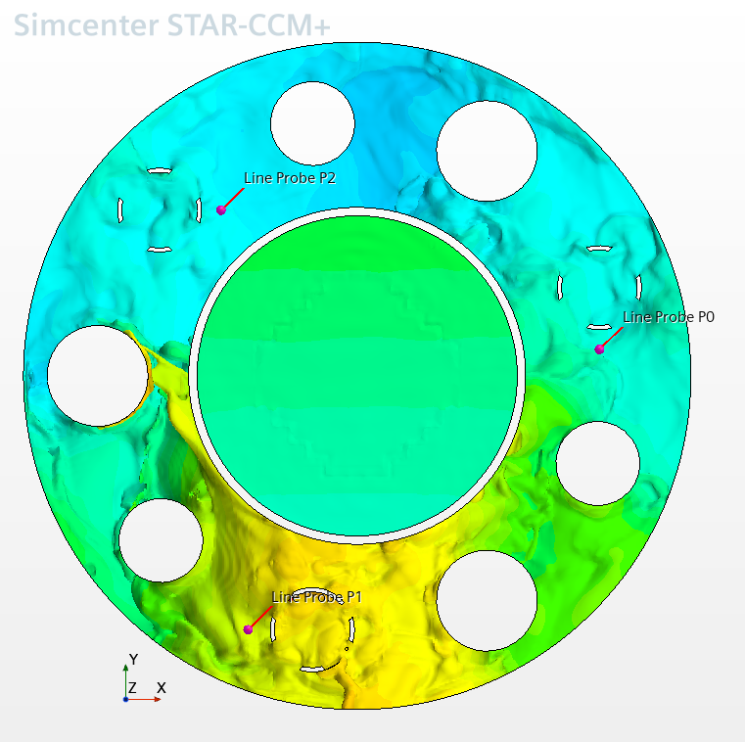
Figure 6: Locations of the probes in the numerical model with underlying free-surface colored by height.
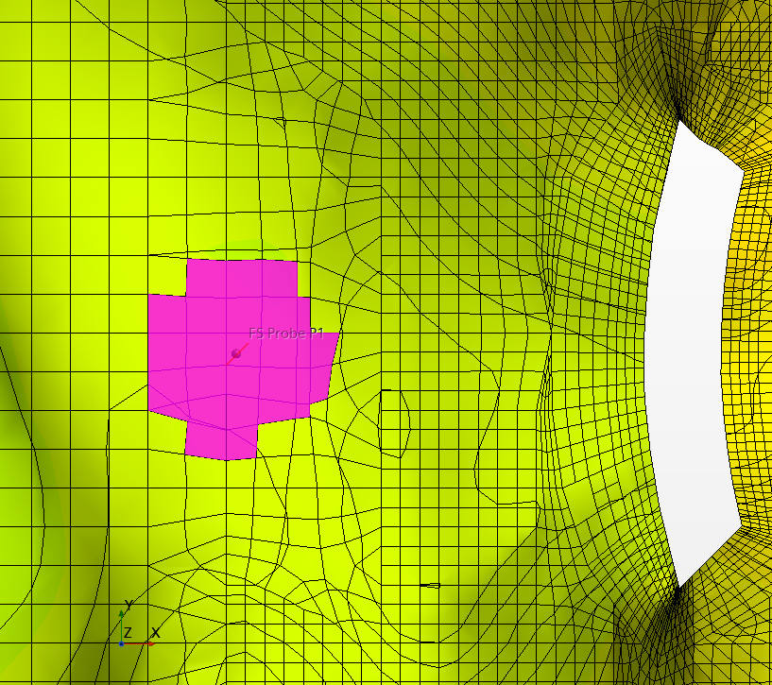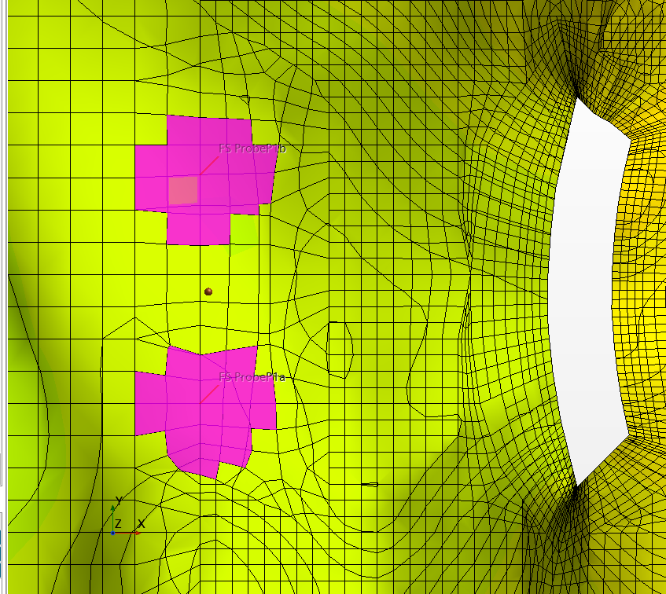
Figure 7: Probe P1. Extension of the numerical measure. Left, centered. Right: both wires.

Procedure for new simulations
For a given campaign of test, the geometry only needs to be built once. There are however many other steps that must be performed to be compliant with further tests after the first one.

VKI Data treatment
VKI provided two different sets of data, in separate .zip files:
- The displacement input to the sloshing table
- The probes height in time.
The software STARCCM+ can read .csv files with data in columns and first line headers. Fields must be separated by commas. The VKI displacement file presents three columns separated by semicolons, for the displacement in the X, Y and Z direction. Beware that the data is given in mm. There are no headers nor time. Frequency of acquisition is given independently and is 200 Hz (used to be 100 Hz).
We had a relatively hard time finding a procedure allowing to integrate the experimental data into the numerical CFD software. The procedure is surely not optimal but is functional. It is written in details below for further operative reference.
Here is the procedure for the displacement file (with .csv extension) once it has been extracted from the .zip archive:
- Open the file with LibreOffice, indicating Semicolon as separator.
- Insert column before the first for the time (Column Fill down)
- Insert first line for names: Time, X, Y, Z
- Save as *_Timed.csv with ticking “Edit filter settings” indicating
  - Field delimiter: comma ,
  - String delimiter Double quote “
  - Tick Quote all text cells
- Check with Vim that negative numbers are correctly handled.
- Read the file in STARCCM+ simulation under: Tools->Tables-> New Table -> File Table, the message should be similar to: “Found 4 columns while importing table Sine_y_A15mm_f1040Hz_Timed.csv: 'Time', 'X', 'Y', 'Z' Imported 16001 rows for all columns.
- Create a new plot or use an existing one: Plots -> New Plot -> XY Plot.
- Add the new data: Data Series -> Add Data
- Time is automatically set on the X-Axis, set the desired displacement component on the Y-Axis.
- Check the congruency of the displacement component.
- Create a new Field Function under Automation for the corresponding velocity component, the content of the function can be similar to: “ (${Time}-${Time0y} < 0) ? 0 : (${Time}-${Time0y} < 80.0) ? differentiateTable(@Table("Sine_y_A30mm_f1080Hz_Timed"), "Time", CUBIC_AKIMA, "Y", (${Time}-${Time0y}))/1000 : 0 ” taking into account that the last division per 1000 allows to reinterpret the data in meters (from millimeters). An alternative is to change the scale in the .csv file.
- Modify the vector Field Function “Translation Velocity” used by the motion in order to update to the new velocity field function.
- Clear solution
- Initialize solution
- Save as new name.
For the VKI results file, the situation is more simple because the .csv file can directly be read and included in the simulation file. It also contains headers to ease the interpretation. There is only need to adapt the initial time delay.
From the STARCCM+ client part, it is necessary first to create a new directory and start the client from that directory. Then new sub-directory must be created to accommodate each of the animation images.

Restart
In case of a new simulation with the same geometry, there are checks to be performed and parameters to be adapted:
- Velocity function for the vessel displacement: field function “Translation Velocity”, remember that the table orientation and corresponding data are opposite to the CAD (Model) orientation.
- Initial FS level: if changed, need to re-mesh with related zero of mesh alignment
After re-meshing:
- Initialization
- Adapt parameters using the reports:
  - Total volume
  - Fluid volume
  - Bottom volume
  - Top volume
  - FZ_0 (Vertical force on the vessel at rest).
- Save
In particular, the indicated volume parameters must be precisely set with as many digits of precision as possible to avoid instabilities from non respect of the mass conservation. However, the reports, while effectively calculating double precision values, provides only single precision values. To get the parameters at the desired precision, reports of the difference between the parameter and the related report, in fact an error estimate, allow to fix in a few steps the parameters up to machine precision.

Mockup validation
Several “debugging” simulations have been performed on the first mockup which main outcomes are briefly reported here:
- The table orientation and related files are in the opposite directions X and Y of the CAD file, while the CFD geometry follows the CAD file orientation. Displacements and velocities must take this into account.
- Large aspect ratio of the BL cells leads to numerical instability. This is clearly seen when the instability appears where the boundary layer lies on a wall at 45 degrees angle with the Cartesian bulk mesh and thus has larger cells.
- The trimmed mesher makes strongly concave cells at the small annuli exits. This has forced us to make a separate region around the bypass flows.
- Surface size should be everywhere no more than half the base cell size.
- The mockup has a much higher density of wall than the simple cylinder and phase pollution appears predominantly at the walls. To keep the interface sharp, the control parameters must be strengthened. In particular, the sharpening parameter has been set to “high”. Also, the interface width is monitored by use of different iso-surfaces and volume measures of intermediary volume fraction extension.
A peculiarity of the mockup is the presence of important small scale particulars, such as:
- A small circular gap between each PP and the plate
- A small circular gap between each SG and the plate
- A perforated plate at the bottom of the PPs with many small holes in lieu of the PPs hydraulic resistance. Precisely, there are 45 holes with a 4 mm diameter.
These particulars control the flow between the lower and the upper plenum and cannot be ignored. Being quite small, they require a sufficiently fine mesh for a correct flow representation.
The plate itself could have shown a similar gap with the vessel, but a rubber ring was added to ensure perfect contact and avoid some bypass flow.

Case 1: Mockup_2024_02_02_A30_f108_5mm
We now report on our first validation test case. At this stage, the question about how to treat the top boundaries on the numerical model arises. In the experiment, the top is mainly closed, but closure is probably not tight and there can be some small crossing local air flows. Numerically, there are 4 different and separated top boundaries, one for the plenum and one at the top of each PP. Large pressure boundaries are subject to instabilities when the physics of the case indicates likeliness of local reverse flows. Therefore, the plenum top is considered as a plain wall. For the PPs top, there is no obvious choice, and the choice of BC has been made on a case by case basis.
In this first case, we set outlet BCs at the PPs top.
Other case specifications are as follows:
- Mesh: Holes 1.3 M Control Volumes (CV), Main with initial refinement: 1.4 M CV.
- Displacement provided by VKI: terminal amplitude 30mm, after a linear ramp of 10s.
- Frequency 1.08 Hz.
The case is characterized by quite large flow displacement far from the linear behavior and with traveling waves indicating a more shallow water behavior.
The simulation was run on 96 CPUs and it made only 8.25s in ~60 hours (over the weekend) but the simulation was slowed a lot by visualization of 3D fields . Even if the Scene windows were closed, the run remained slowed. Restart improves the simulation speed but the time step remain very close to the hard limit minimum at 0.00005 s (0.05 ms) due to the strong flow agitation. A lot of spurious localized velocities appear for short times. It is believed that causes may be multiple, making their resolution difficult. However, the simulation seems to proceed normally as demonstrated by the close relation between the numerical and experimental measures at the probes. The time step is consequently reduced to satisfy the CFL condition, thus making the simulation very lengthy.

Elevation at probes
The numerical (thicker) and experimental (thinner) elevation above the initial FS level at the probe location is shown on Figure 8 for 30s and zoomed for 10s on Figure 9. The agreement is generally good even if not perfect. The numerical local extrema are slightly more intense than the experimental ones during the first seconds. However, the general trend and also the general variability from one extremum to the other is well represented. The maxima are also slightly and progressively shifted. This may be caused by a very slight delay in the response time of the sloshing table. In effect, the signal that is given to the numerical simulation is the same as the one given to the table and numerical initial time calibration is performed by aligning the first maxima.
There is also a numerical event between time 27.5 and 28 s in which we most probably see the passage of a bubble below the main free surface.
Obviously, the elevation depends on the position and we must quantify this dependence with regards to the numerical measurements. The previous curves were using the centered probe position, in reference to Figure 7. In Figure 10, we make a closer look at the differences between the measure done at the centered numerical domain and at the two out-centered domains 4.5 mm away. It can be seen that the differences are very small and that the centered measure lies in between the two out-centered ones, and it is a good mean representation.
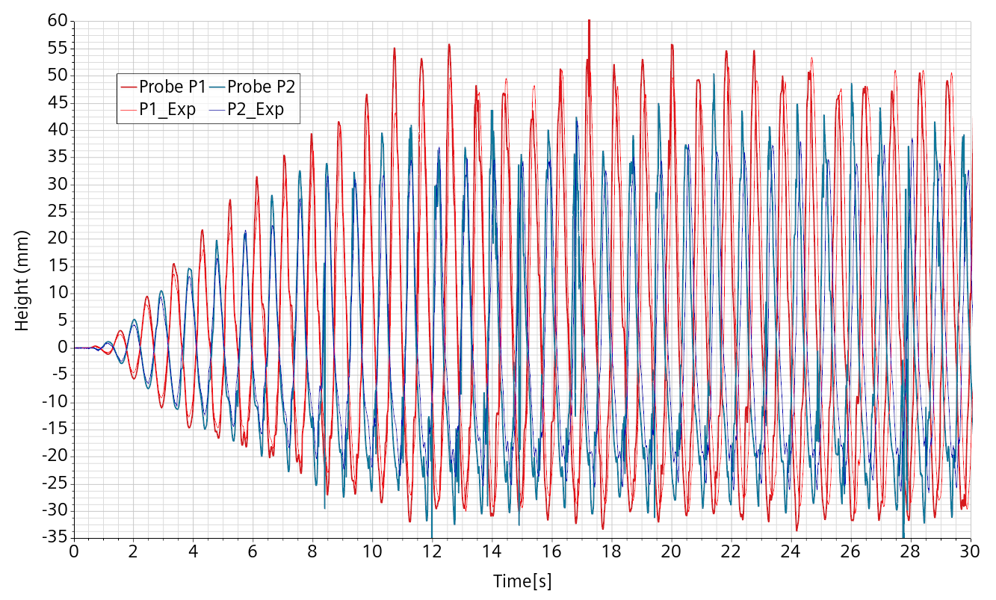
Figure 8: Comparison between experimental (thinner) and numerical (thicker) elevation at probes P1 and P2
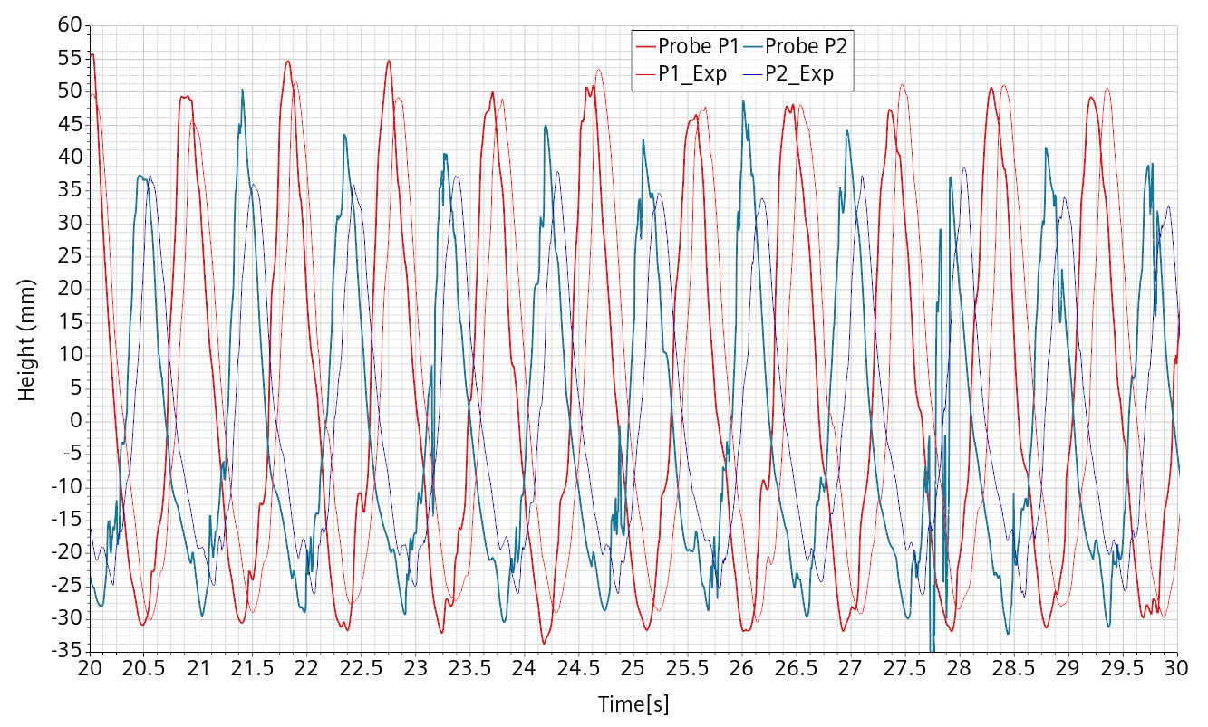
Figure 9: Comparison experimental (thinner) numerical (thicker) elevation at probes P1 and P2, reduced time interval
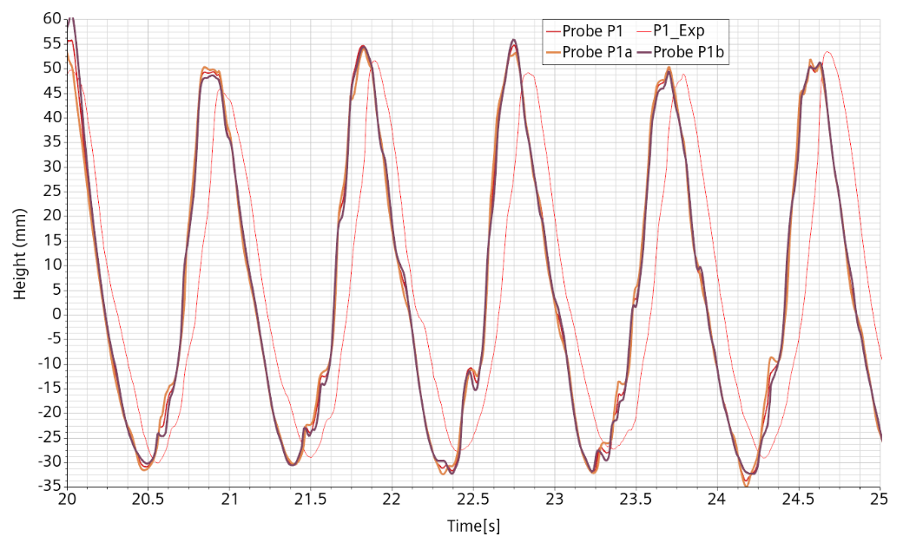
Figure 10: Probe P1 elevation on a reduced time interval.

The free-surface integrity
The flow is characterized by a heavily disrupted free-surface with droplets and bubbles. However, at the end of the simulation, the free surface remains well defined without apparent undue smearing as shown on Figure 11 where the 0.5 water volume fraction iso-surface is intended as a good representation of the free-surface. The surface is quite articulated with a rather sharp trace on the vertical planes.
In order to quantify the numerical sharpness of the free-surface, we first monitor the area of the iso-surface, as given in Figure 12. Then, we measure the volume of cell sets defined by having the volume fraction in a given range: [0.1 ; 0.9], [0.05 ; 0.95] and [0.02 ; 0.98]. The normalized mean free-surface “width” is obtained by dividing the volume by the area and is given in Figure 13.
The free-surface width is initially zero because the computational grid is built so that the free-surface is initialized at the interface between 2 horizontal cell layers. The mesh base is 5 mm with 2 refinements near the free-surface so that the mesh size around the free-surface is about (and no more that) 1. 25 mm. As soon as the free-surface starts to evolve, it needs at least one cell layer with an intermediary volume fraction.
The free-surface area increases by about 50% during the initial ramp stage. Then it remains essentially constant up to a modulation related to the forcing frequency. The [0.1 ; 0.9] free-surface width only marginally increases during the ramping phase and then remain essentially constant, confirming the visual impression on the surface sharpness. The [0.05 ; 0.95] width reaches about 2.5 mm, that is 2 cells width and maintains this value. Same thing with the [0.02 ; 0.98] width, corresponding to 4 cells.
The important information given by these figures is that the numerical free-surface integrity do not tend, even slowly, to degenerate. Therefore, the measures taken to enforce the free-surface sharpness and integrity seem perfectly adequate for this simulation.
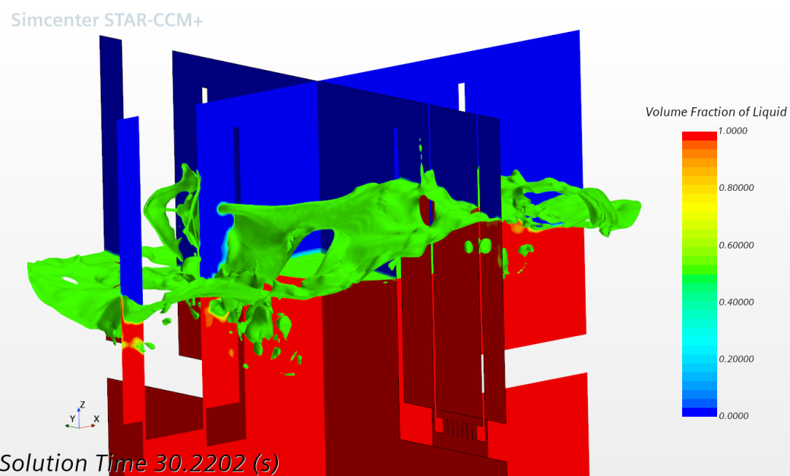
Figure 11: End of simulation, 0.5 iso-surface of the water volume fraction interpreted as free-surface.
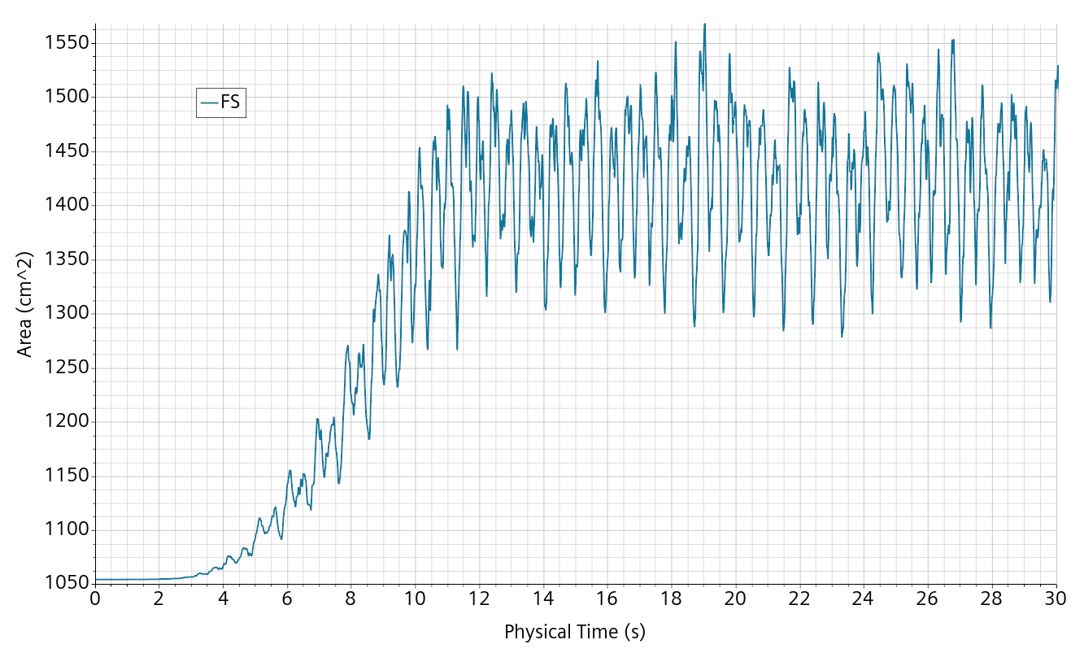
Figure 12: Area of the 0.5 water volume fraction iso-surface (i.e. free-surface area).
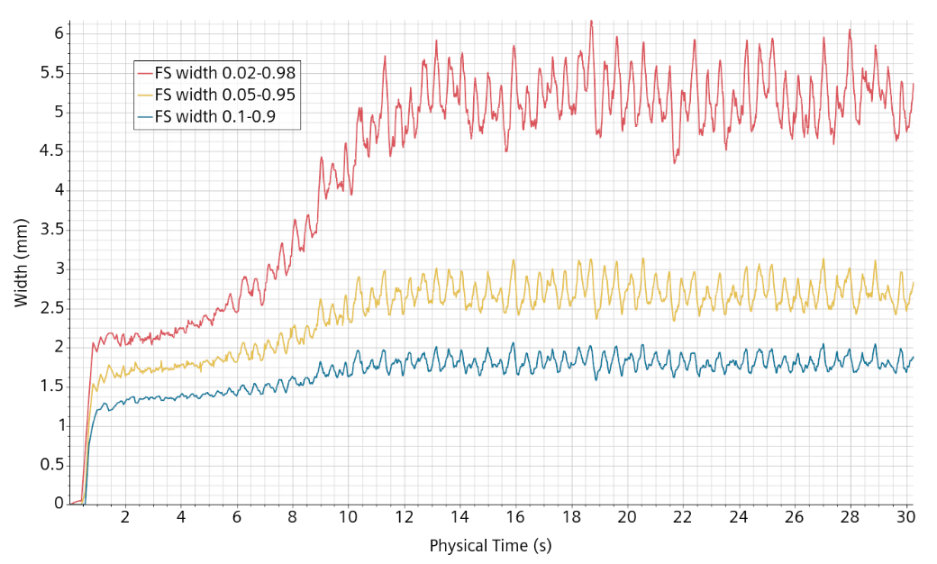
Figure 13: Mean width of the free-surface depending on the characteristic range of volume fraction.

The maximum velocity burst issue
The plague of the velocity burst that was thought to be put under control in the previous deliverable appears anew with even more intensity. The phenomenon clearly intensifies with the wave height. It is generally very localized in one or few cells which change from time to time and are not necessarily highly deformed. Fortunately, there is no perceptible impact on the global flow and that is why we decided to prolong the simulation up to 30 s.
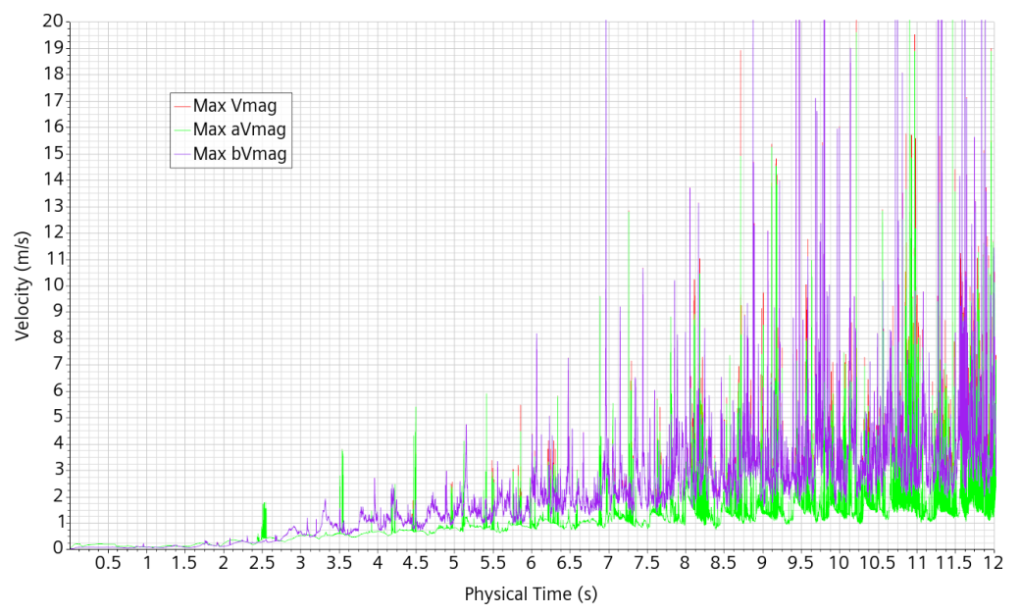
Figure 14: Maximum numerical velocity magnitude. Green in the fluid , violet in the air and red at the free surface.

Gaps and pump pipe holes flows
Our aim is to represent in the mockup salient features of ALFRED. One of them is the mass transfer through the pumps and the SG. The holes at the pump pipe bottom are thought to mimic the pressure losses in ALFRED due to the pump pipe and the pump at rest. The SG is represented as a plain cylinder and must be understood as an envelop condition.
The gaps between the plate and the components stem from experimental necessity. It was initially thought that they are sufficiently small to be neglected. Further consideration questioned this initial thought, thus it was decided to check this hypothesis by including the gaps in the fluid domain.
The main vertical velocity in the gaps and in the PP holes is given in Figure 15. The corresponding total mass flow rates, which incorporate the information of the relative cross sections, are given in Figure 16. It turns out that we observe velocities near the meter scale and a consistent transfer of mass. The values registered at the gaps, while of inferior magnitude, are of similar values than the one registered at the pump pipe holes.

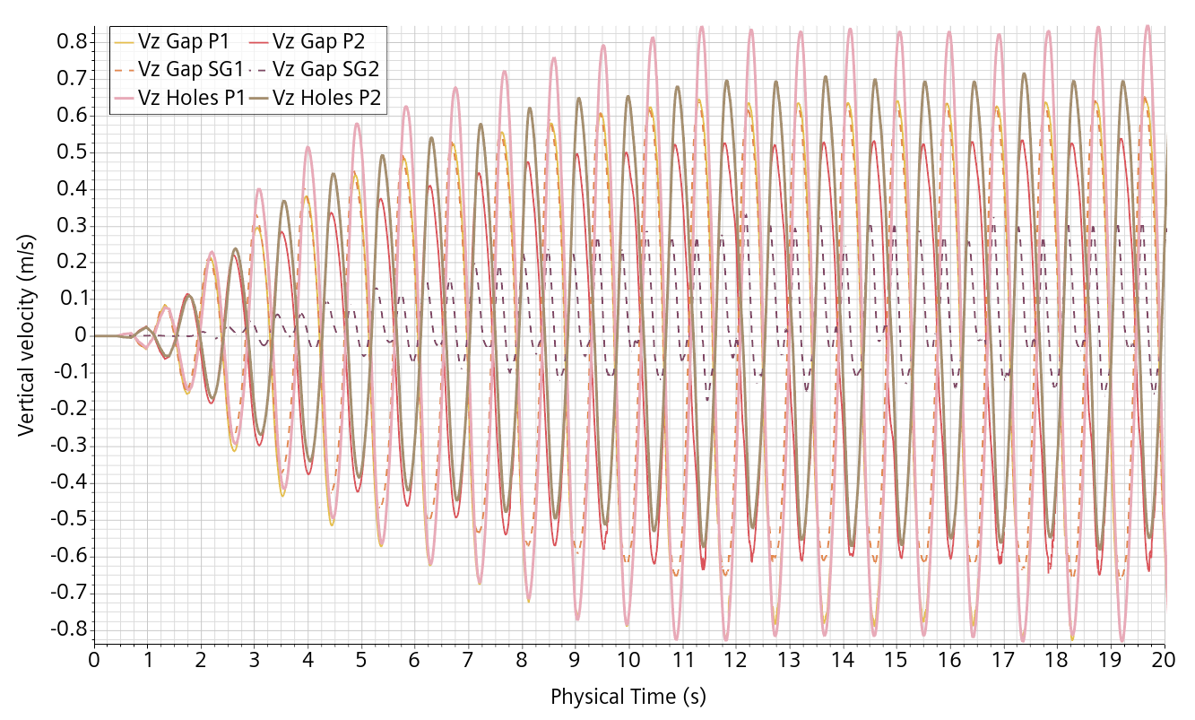
Figure 15: Mean vertical velocity through the gaps and the pump pipe holes.
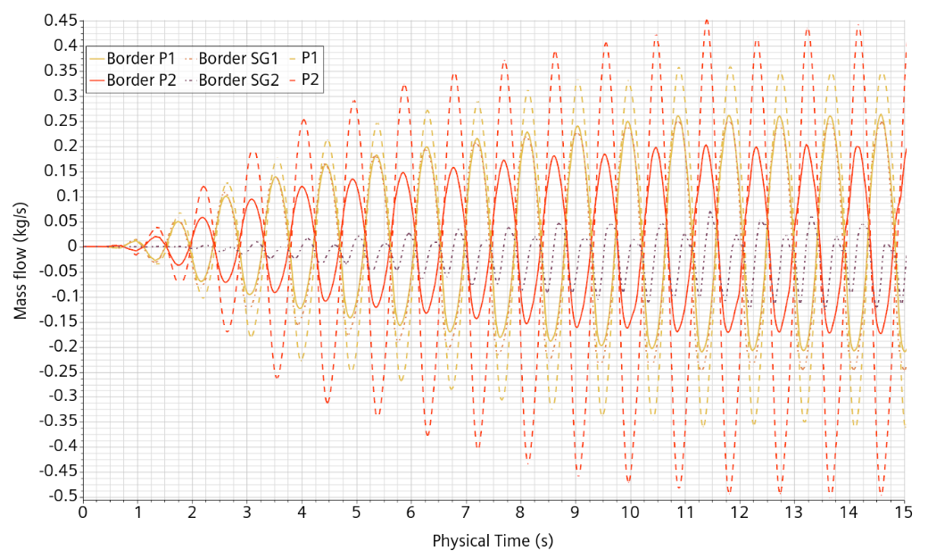
Figure 16: Mass flow rates zoomed on the first 15 s through the gaps and PP holes.

Time step
We use a variable Adaptive Time-Step conditioned by:
- Convective CFL Condition: target mean CFL number at 0.5 with maximum at 5 (default)
- Free-surface CFL Condition: limited to 0.4 (default)
- Maximum value 0.002
- Minimum value 0.00005.
The time step is plotted on Figure 17. It decreases with the development of the wave oscillations and reaches a mainly repeatable pattern after 9s. From 8s on, the time step often reaches the allowed minimum. However, the time-step is already so low that the simulation has become very lengthy, requiring nearly 2 weeks on 96 CPUs. Surprisingly, the time-step does not seem to resent on the velocity bursts, confirming that the convective CFL condition is a target one that can discard a few extreme values.
Instead, the time step is controlled by the velocity at the bottom border of the PP holes where the mesh size is at its minimum value of 0.3125 mm, as illustrated in Figure 18. In effect, most of the computational cells with a convective CFL above 0.5 are located there.

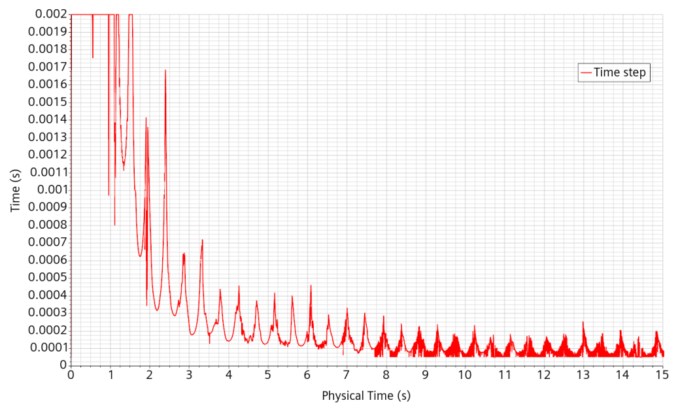
Figure 17: Simulation time-step.
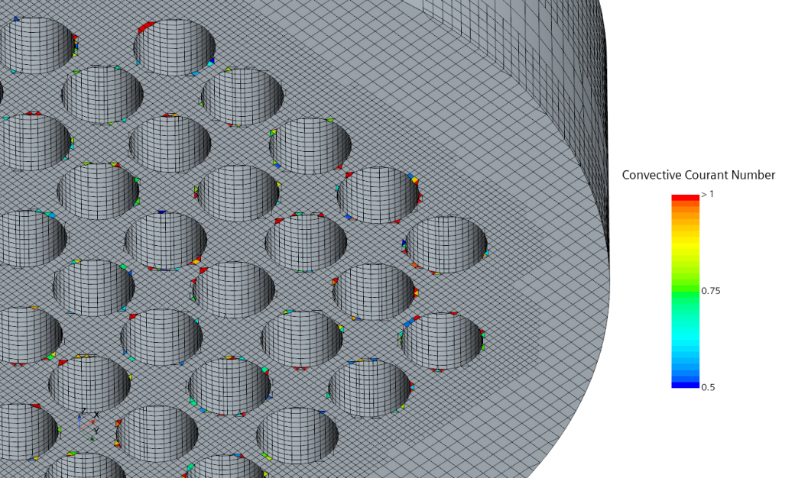
Figure 18: Mesh of the PP bottom surface together with cells of convective CFL above 0.5.

Forces
The forces applied to the vessel and to the DHR components have been measured and monitored. They are evaluated by integral on the pressure normal component. Without surprise, the more intensive one is on the vessel in the Y direction, which is the forcing direction, followed by occasional burst in the X direction, as shown in Figure 19. The cause of the bursts in both direction is not clear. It is sought to be linked with the velocity bursts but there is no clear one to one correspondence. The variation of the vertical component of the force on the vessel is much lower.
Restricting to the DHRs, rescaling and focusing, see Figure 20, we can observe that the more intensive signal is on the DHR0 in the Y direction. The 0, 1 or 2 digit of a component reflects the closeness to the corresponding probe. The force is not symmetrical because the DHR0 is close but some distance away from the X-axis. The signal shows some noise but the forcing frequency is clearly apparent, even on the lower intensity ones.
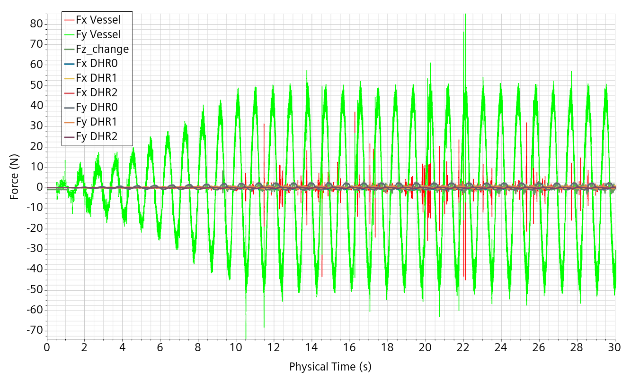
Figure 19: Forces applied to the vessel and to the DHR components.
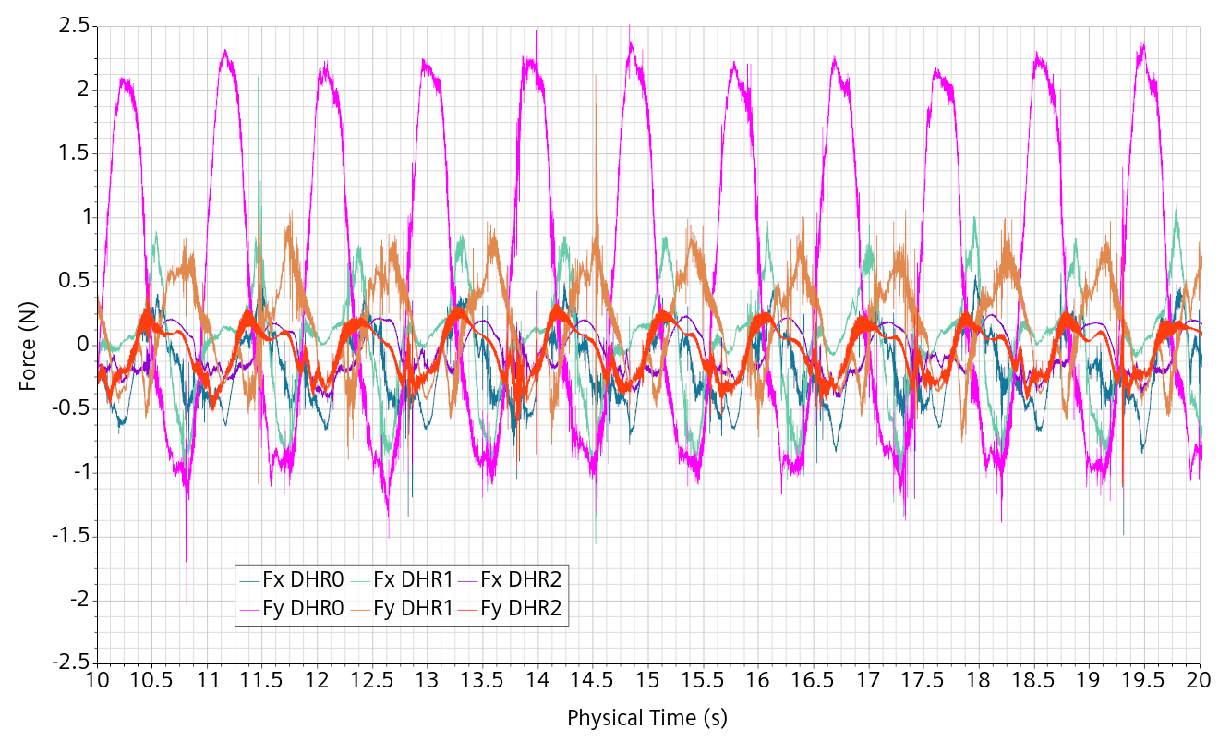
Figure 20: Forces applied to the DHRs on a reduced time interval.

Case 2: Mockup_2024_02_05_A30_f068_5mm
This case is built and reinizialized from Case 1: Mockup_2024_02_02_A30_f108_5mm taken at 8.25 s with the only change being the Frequency now at 0.68 Hz
The simulation is run for 30s. The forcing amplitude is kept at 30mm.

The velocity burst issue
The wave amplitude is much lower than previously allowing to run faster. The spurious velocity now shows a repeatable pattern with 2 spurious close peaks in the fluid followed by a single isolated peak in the gas during each period, as shown in Figure 21. A zoom on a single event is given in Figure 22 left for an event in the liquid phase and on the right in the gas phase.
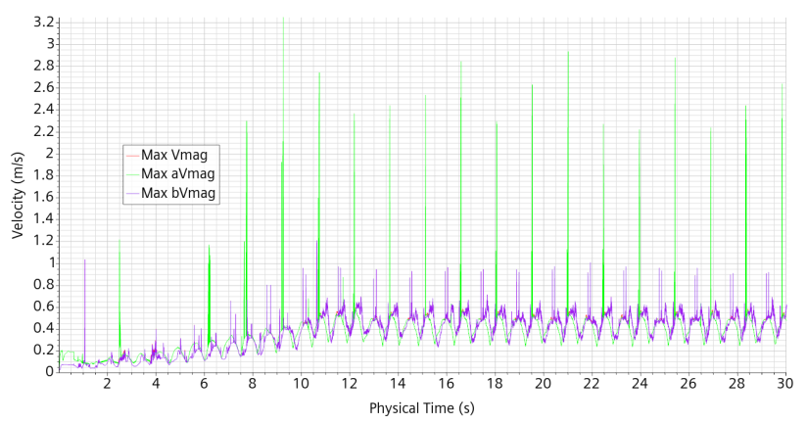
Figure 21: Maximum speed in time. Free surface in red, water in green and cover gas in violet.
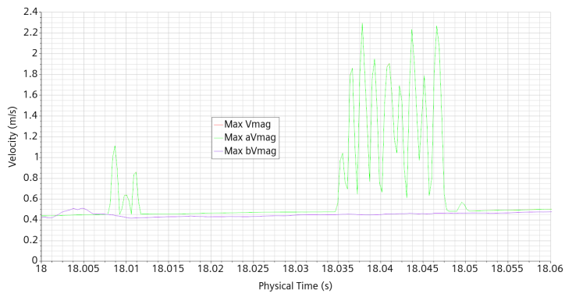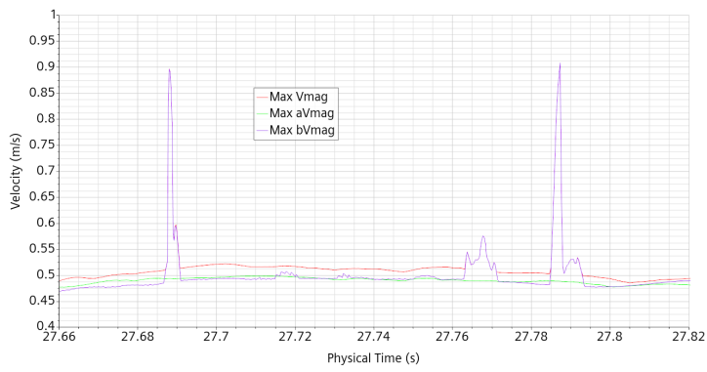
Figure 22: Same as previous figure with zooming at the main typical events.
The simulation is saved every 3s. An event in the liquid phase starts very shortly after the saved simulation at 18s, so we more straightforwardly inquire on it. For this, we prepare a scene with 4 variable components: the volume fraction iso-surfaces at values 0.02, 0.5 and 0.98 plus a cell set containing the cells where the velocity magnitude is above 0.4 m/s. The three iso-surfaces allow to control the free-surface local width. The cell set is chosen for an initial possible localization of the event. This is shown on Figure 23 top, in which the scene is taken one time-step before the event starts. The spurious velocity is found at the next time-step, Figure 23 bottom left, and strongly increases one time-step further, Figure 23 bottom right.
In turns out that only one cell is involved in the event. The faces of this cell are divided to connect to the neighboring cells which have probably just been refined due to the proximity of the free-surface. The cell is very badly shaped, as illustrated in Figure 24, with 3 out of its 5 corners needle shaped. In fact, it lies at the border of the boundary layer, which is somewhat round shaped, connecting the boundary layer to the regular bulk structure.
The second spurious velocity event in water appearing at 18s034 is very similar and involves a cell positioned slightly above the first one in conjunction with a slightly higher free-surface, as illustrated in Figure 25.
It seems that the velocity burst event appear due to the conjunction of:
- A badly but acceptably shaped cell in the bulk close to the BL
- Local refinement
- Additional dynamic refinement due to the proximity of the free-surface.
In previous preliminary simulations, the burst events appeared also in the boundary layer where the cell is oriented at 45 degrees with the horizontal axis and has the maximum face area ratio along a circumference. Making the boundary layer cells smaller in the orthogonal direction removed these velocity burst events.
The trimmed meshed is very suitable for local and dynamic refinements. It also permits to have a good free-surface initial condition. However, it does not always deal very well with the connections to rounded boundaries or their boundary layer. Local meshing issues and how they are tackled by the mesher are apparent in Figure 23 to Figure 25.
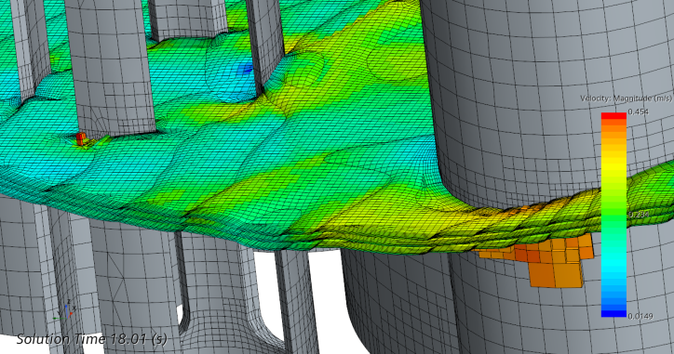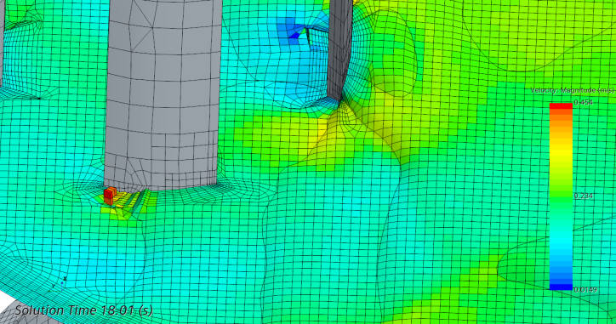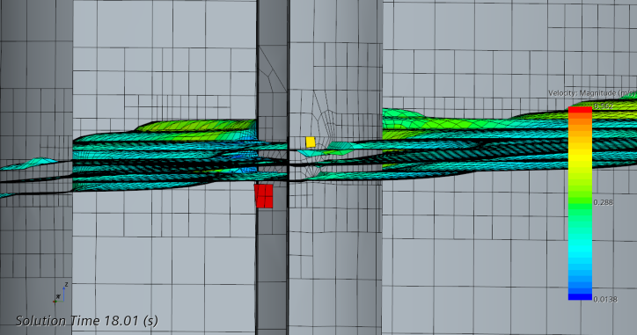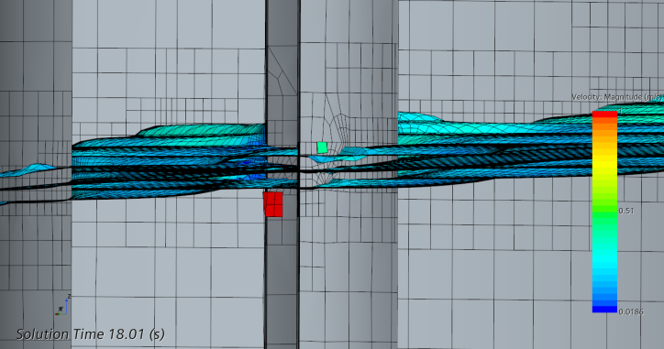
Figure 23: Spurious velocity event. Volume fraction iso-surfaces at values 0.02, 0.5 and 0.98 plus cell set above 0.4 m/s. Top: one time-step before the event for localization. Bottom left and right: first and second time-steps of the event.

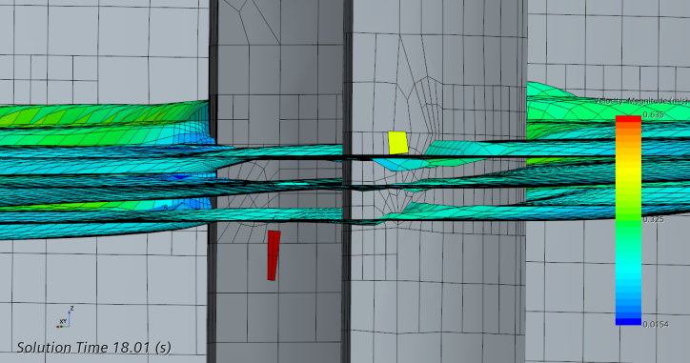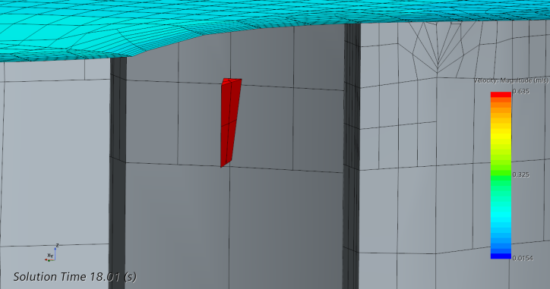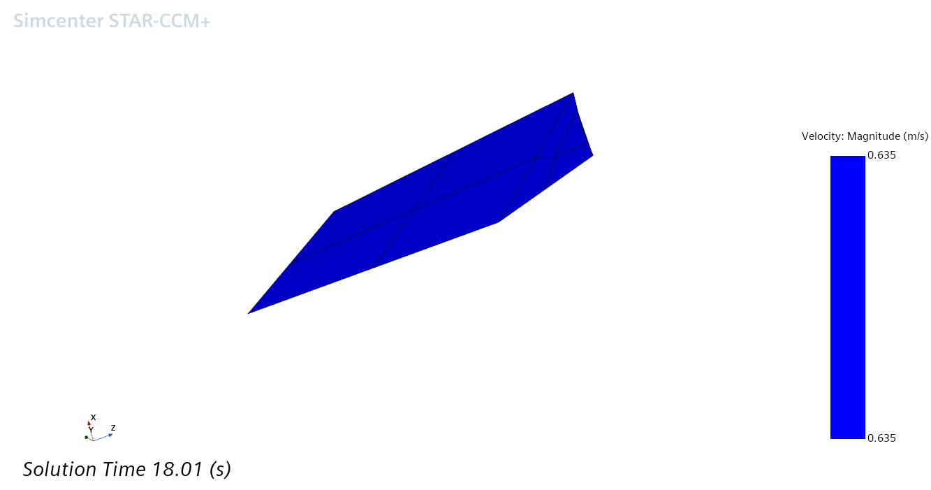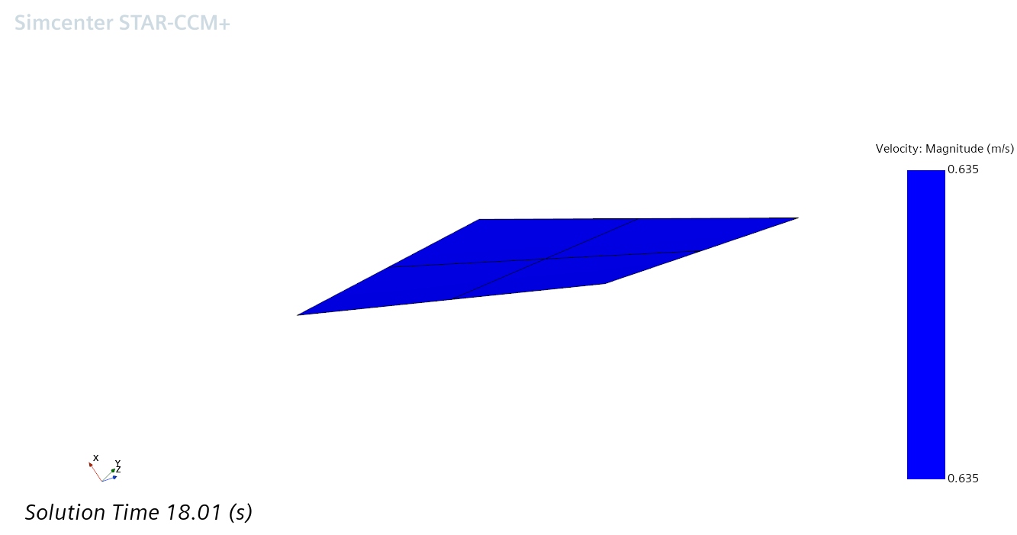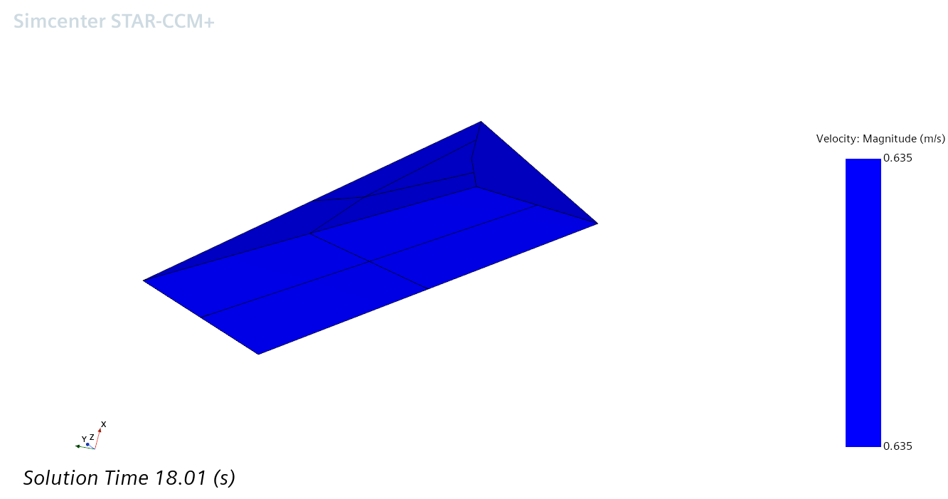
Figure 24: Spurious velocity event. Top: localization. Bottom: View of the faulty cell at different angulation.
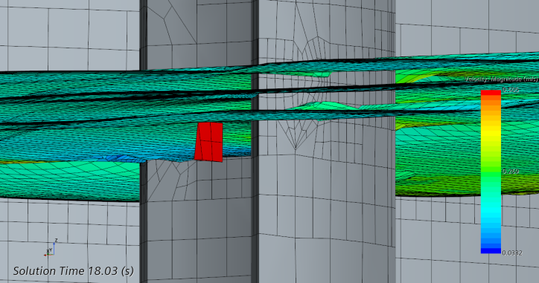
Figure 25: The two cells involved in the two different water spurious velocity events.

Main results
At this frequency, the free-surface excitation is quite low and relatively symmetrical with an amplitude close to 20 mm, as shown on Figure 26. The small and progressive shift observed previously is still present with seemingly the same extend but in the opposite direction with the experimental signal now preceding the numerical one. In Figure 27, we give a closer look at the differences in height measured at the center of P1 and on both sides. The centered value is almost indistinguishable from the mean of both sides and would have required an even much closer look to be seen. Besides, we give the height that would be given by following the 0.9 water volume fraction iso-surface (instead of the 0.5 one) which consistently lies about 1-2 mm below.
Once again there are some differences, up to near 10%, between experimental and numerical measurements of the height amplitude.
The forces applied to the DHR components are shown on Figure 28. The signal is smaller and smoother than for the previous case with the more intense one still being the Y component on DHR0 peaking at about 1 N.
The mass flows through the openings are about one third of the previous case with the bypass flows being a consistent fraction of the pump flows, see Figure 29. The free surface area changes very little and as a consequence it remains quite sharp. This is shown on Figure 30.
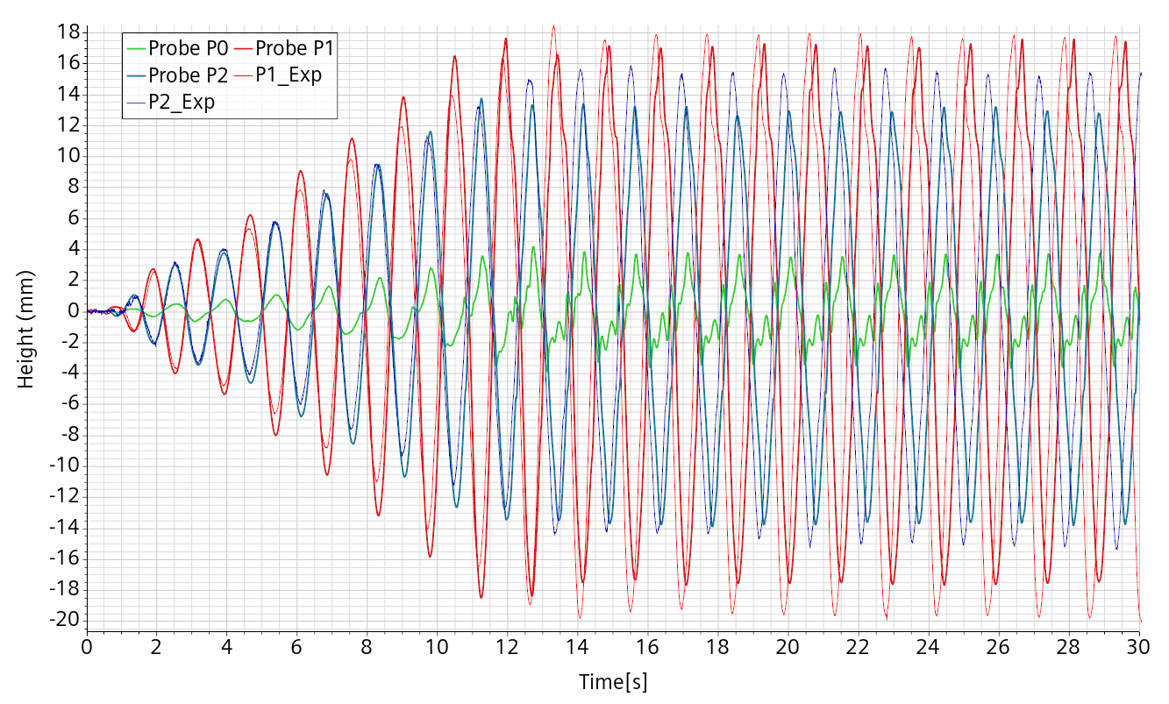
Figure 26: Case A30_f068, comparison experimental (thin), numerical (thick) free-surface height.
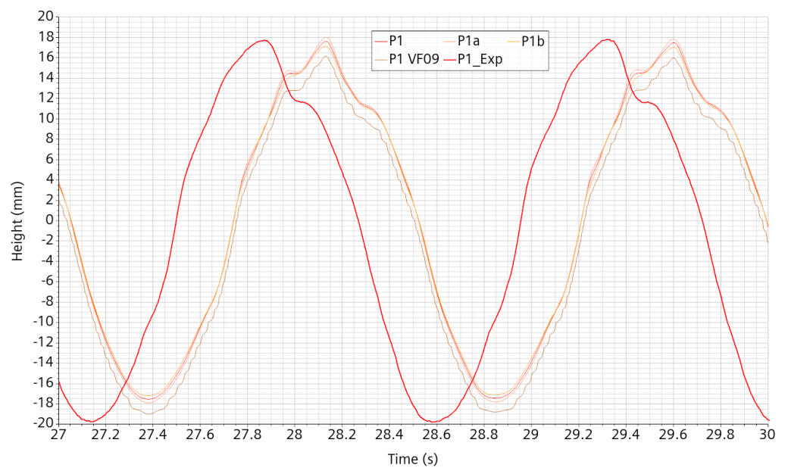
Figure 27: Case A30_f068, comparison experimental (thick), and different numerical (thin) free-surface height of P1.
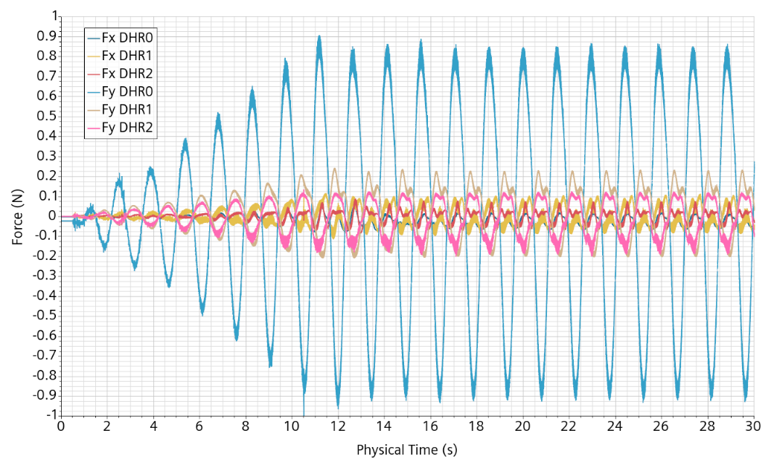
Figure 28:Case A30_f068, forces on the DHR components.
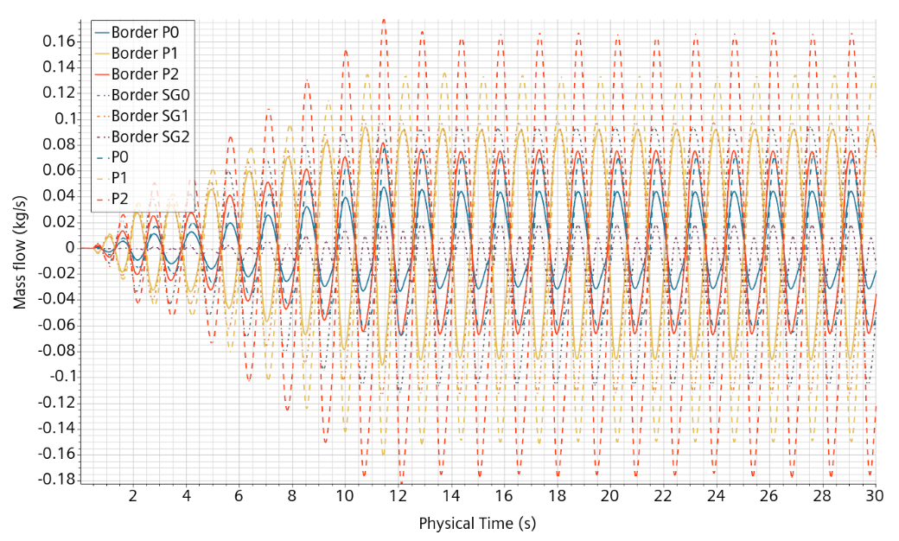
Figure 29: Case A30_f068, mass flows in the openings.
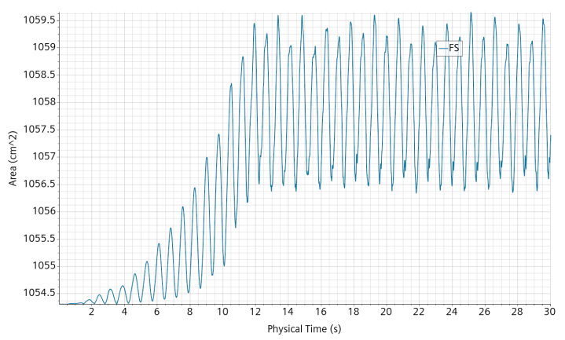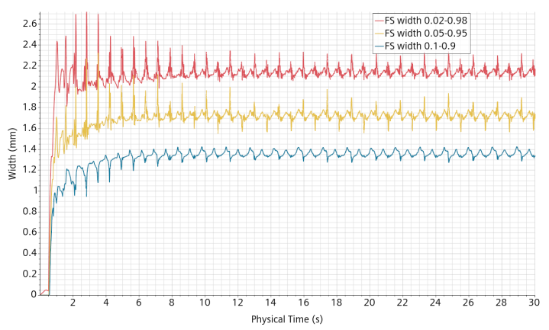
Figure 30: Case A30_f068, area (left) and mean widths (right) of the free-surface.
.

Case 3: Mockup_2024_02_07_A15_f104_5mm
This case was built from the Mockup_2024_02_05_A30_f068_5mm simulation file at 30s and reinitialized with the following changes:
- Reset to wall BC at the PPs top
- Frequency 1.04 Hz
The simulation was run for 33.1s and it is shown up to 30s for homogeneity.

Free surface height
The free surface heights, both experimental and numerical at P1 and P2 are shown on Figure 31. The flow seems very similar to the first case with a smaller intensity with a range of elevation between -25 and +35 mm. The numerical signal intensity at the initial ramp always slightly overestimates the experimental one. After that, there is a certain variability of the extrema from period to period numerically and experimentally similar. The time shift is still present.
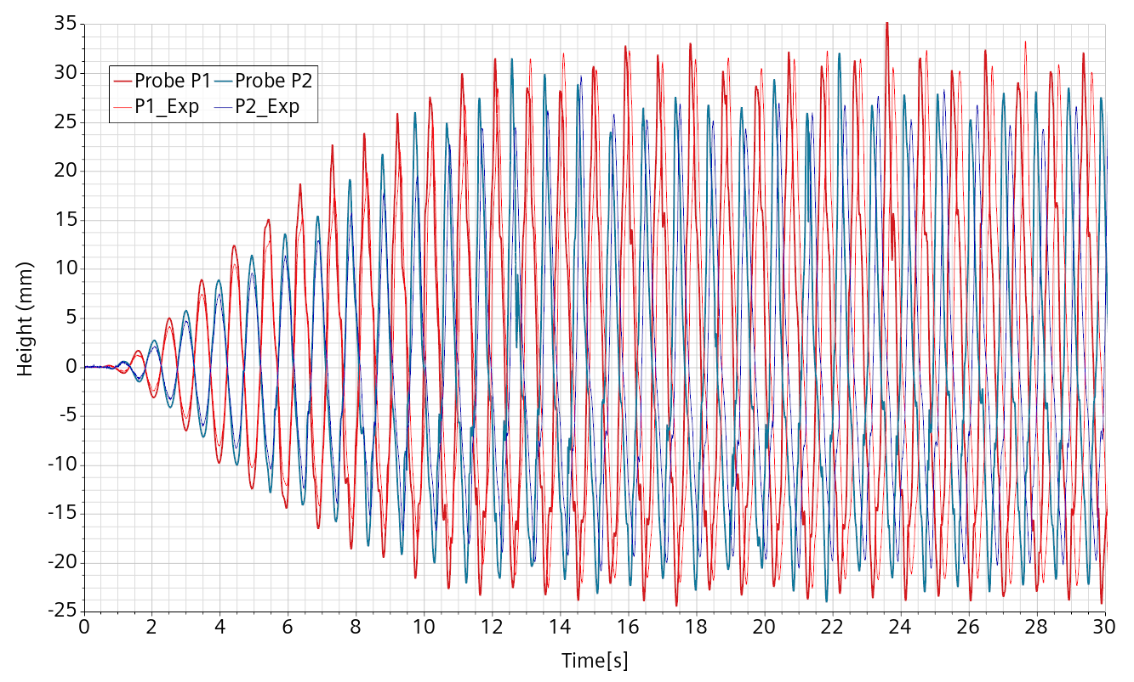
Figure 31: Case A16_f104. Comparison numerical experimental of the free-surface height at probes P1 and P2.
Alternative probe positions are added from VKI indication from Figure 5. The point P2 would fall inside the pump pipe and we believe that the coordinates X and Y have been swapped. The new points, taking the simulation orientation opposed to the shaking table one, are thus:
P0(15.4 ; 1.9), P1(-6.9 ; -15.4) and P2(-8.4 ; 10.4)
with values in cm to be compared with the numerically derived ones
P0(14.38 ; 1.57), P1(-6.57 ; -15.07) and P2(-8.08 ; 9.83).
Three local cylindrical coordinate systems have been created and linked to the Motion “Translation Mockup”.
Three derived parts restricting the 0.5 volume fraction iso-surface within 3 mm of the coordinate system vertical axis have been created.
Three reports of the mean height have been created and monitored.
The respective numerical probe positions are shown on Figure 32.
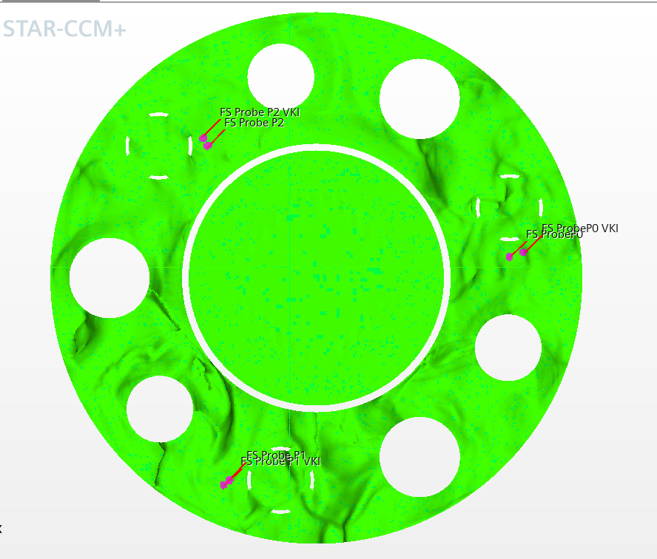
Figure 32 : Case A16_f104. Position of the numerical probes.
For the two experimental probes available for comparison, we take a closer look at the influence of the exact position of the probes. This is shown on the [26 ; 30]s time interval in Figure 33. There are no real substantial differences, indicating a rather widespread and smooth elevation. There are also some curve features which look like small reflections present in both positions but not in the experimental data.
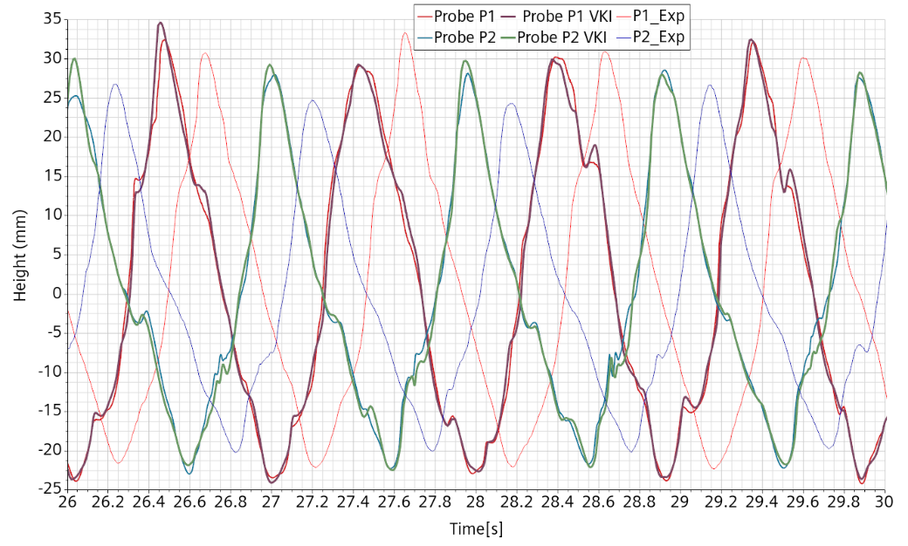
Figure 33 : Case A16_f104. Comparison of the elevation between the probe position from CAD and from direct measurement.
For completeness, maximum velocities and adaptive time step are shown on Figure 34, forces and mass flows on Figure 35 and free-surface area and widths on Figure 36. There is no particular new information except that they show a global consistency of the simulation.
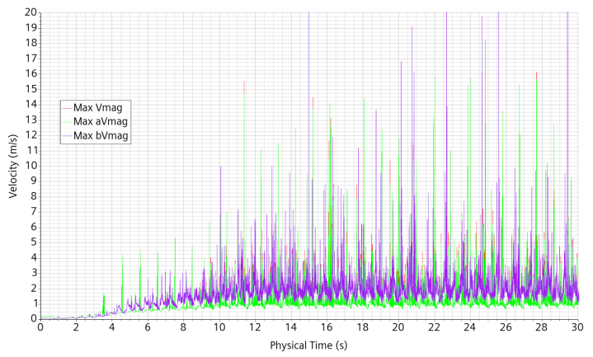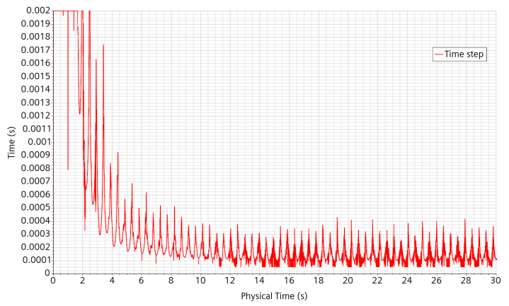
Figure 34: Case A16-f104. Left: maximum velocities. Right: adaptive time step.
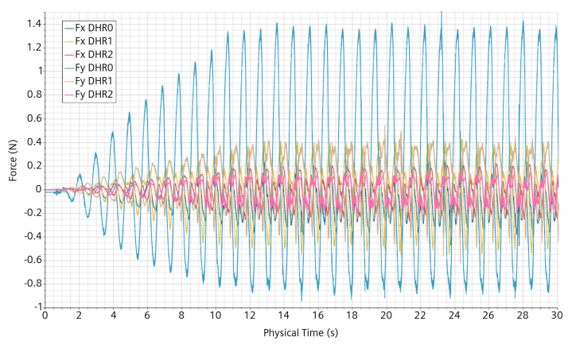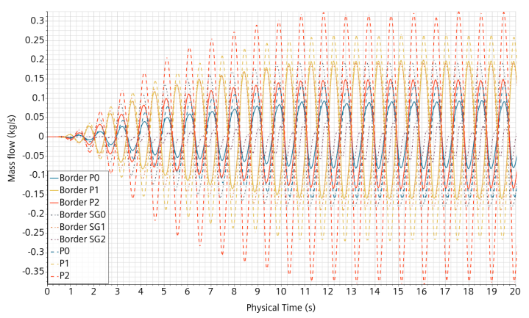
Figure 35: Case A16_f104. Left, forces on the DHR components. Right, mass flows through the openings.
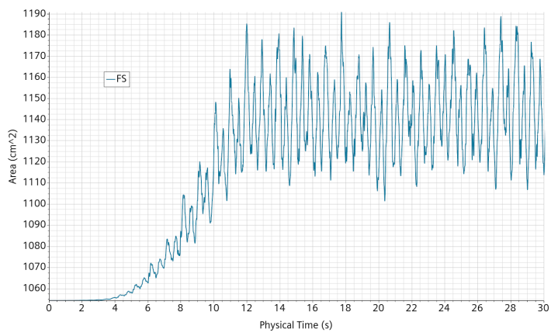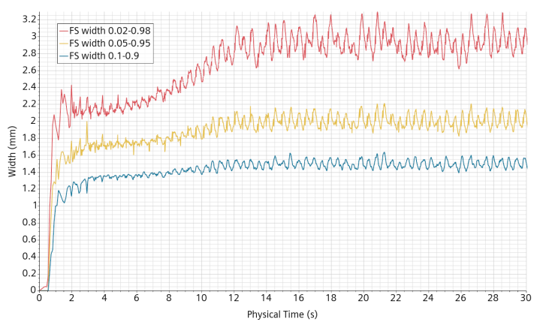
Figure 36: Case A16_f104. Left: free surface area. Right: free-surface widths.

Cut domain
Case 3: Mockup_2024_02_07_A15_f104_5mm is restarted after “cutting” the connections between the lower plenum and the hot plenum. This is done by changing the relevant interfaces from internal to baffle. The objective is to quantify the effect of flow through the bottom.
The elevation at probes P1 and P2 is given in Figure 37. With regard to the uncut case, the time shift is similar. The main difference is that the P1 peak values are no more correctly captured. To a lesser extend, we can also see stronger reflections on the P2 curve.
For the “uncut” simulation, the passage of a P1 maximum elevation is illustrated in Figure 38. It can be seen that the strong peak elevation is quite a local phenomena and it is a posteriori not a surprise that removing the bottom connections can also hinder this very local phenomena. The corresponding event with the cut connections is shown in Figure 39. We can observe a small time shift of the maximum between the two simulations with the “cut” one delayed by about 0.1s.
The comparison with experimental data was calibrated for the initial time by visual inspection of the first oscillations. But this method gave slightly different values for the “cut” and “uncut” simulations. Setting the same value for both simulations, we see an initial shift of the elevation curves for the “cut” simulation, as shown on Figure 40. This means that we are quite unsure of the initial calibration.
The difference between the two simulations is not very large but still relevant and the comparison with the experiment is improved by considering the bottom connections. However, there is also a relevant uncertainty on the quality of the connections flow, both due to approximation, among others, between the CAD and the CFD geometries on one hand and between the CAD and the real geometry on the other hand.
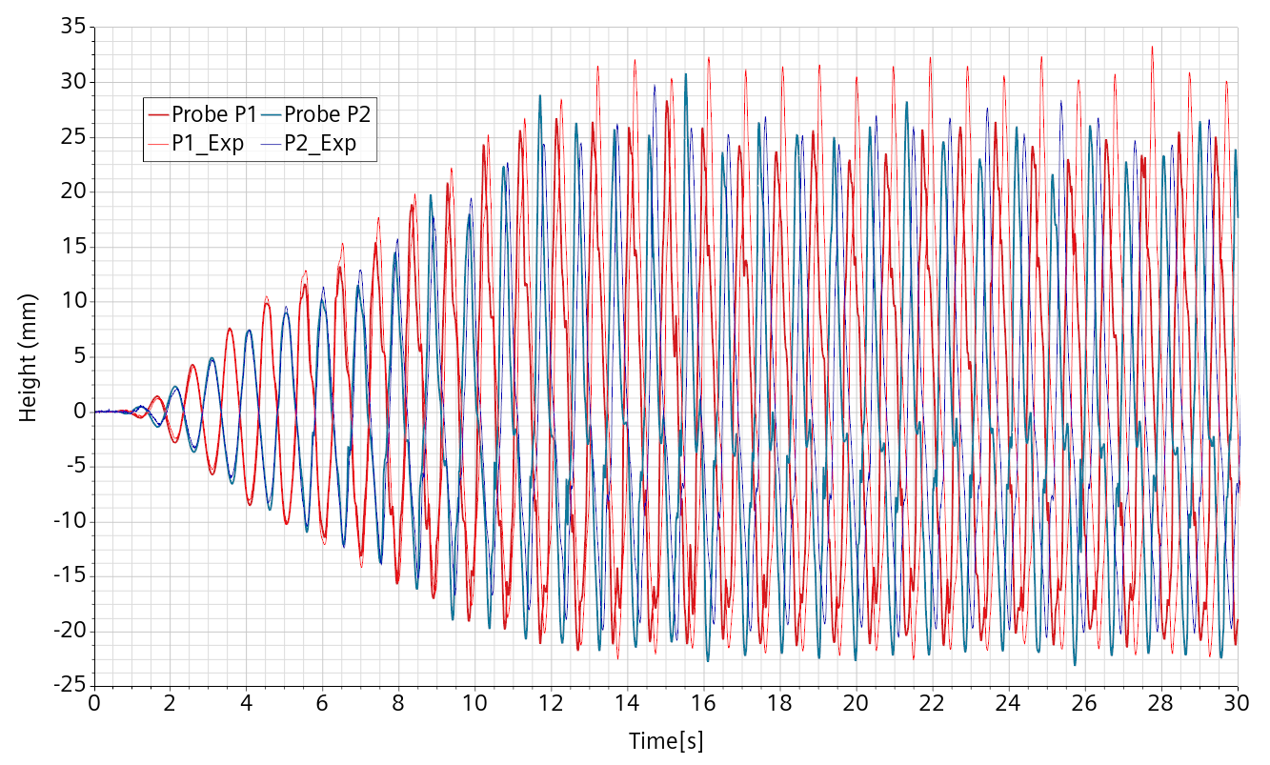
Figure 37: Case A15_f104_5mm with cut connections to the lower plenum. Experimental (thin) and numerical (thick) elevation at probes P1 (red) and P2 (blue).
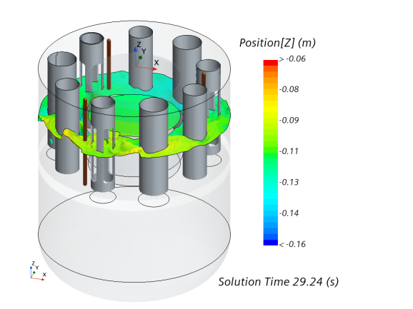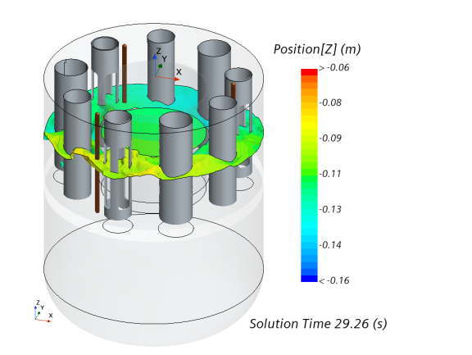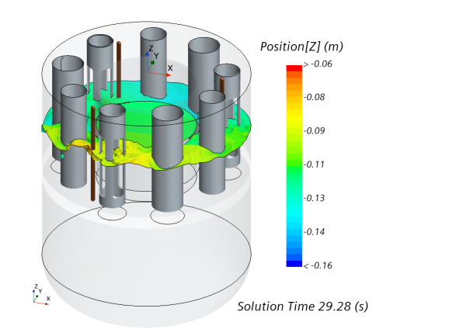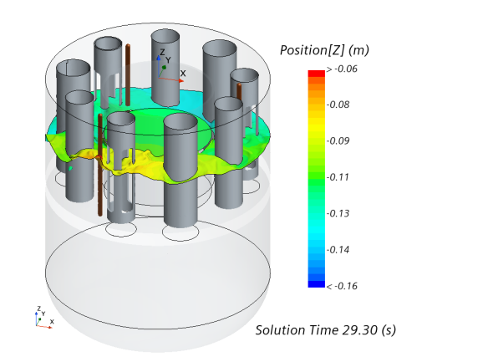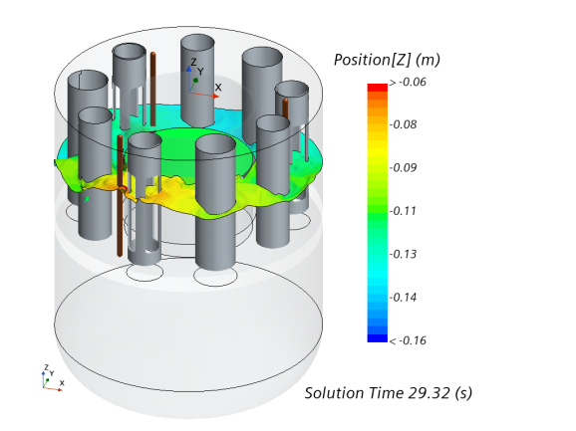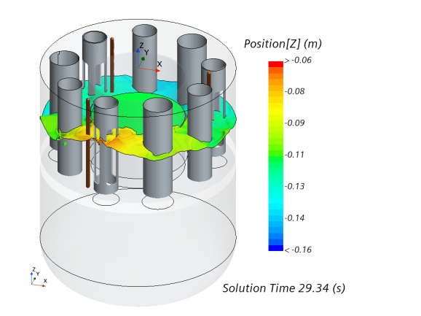
Figure 38: Case A15_f104_5mm (uncut). Free-surface snapshots around a maximum elevation at P1.
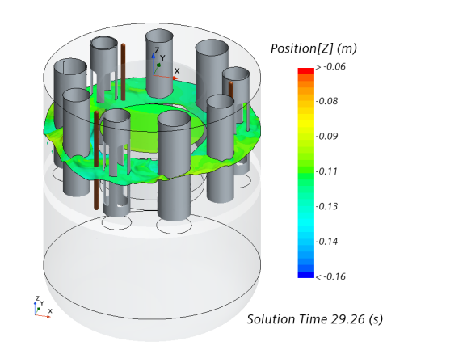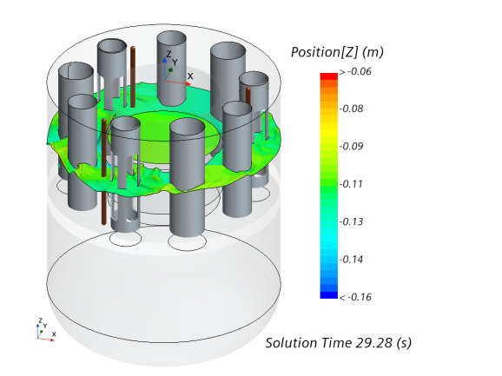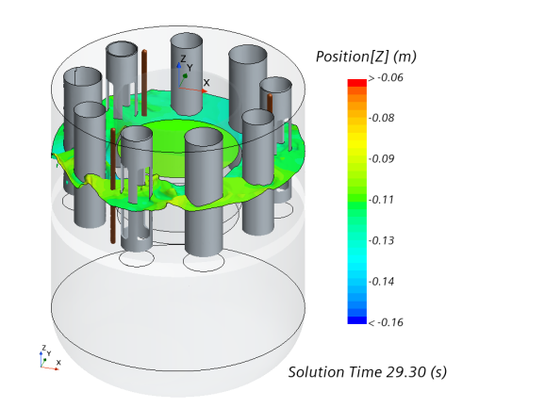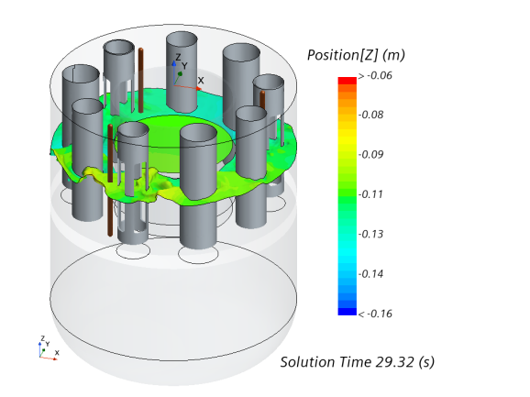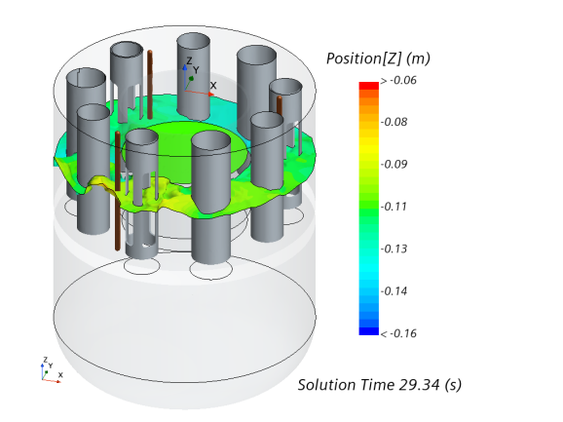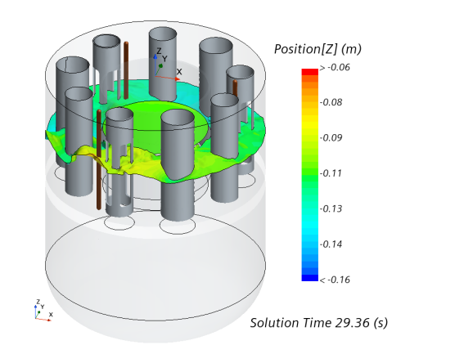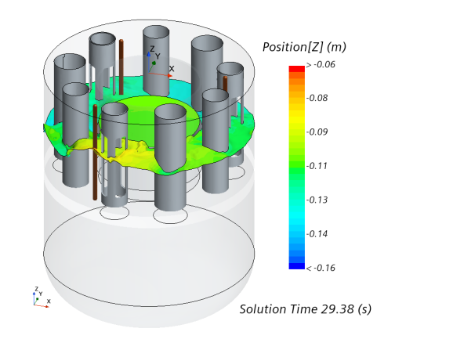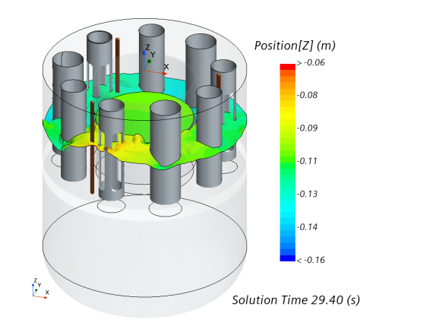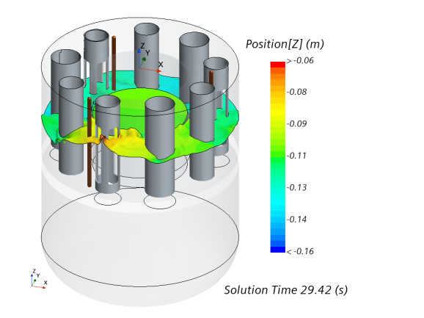
Figure 39: : Case A15_f104_5mm with cut connections to the lower plenum. Free-surface snapshots around a maximum elevation at P1.
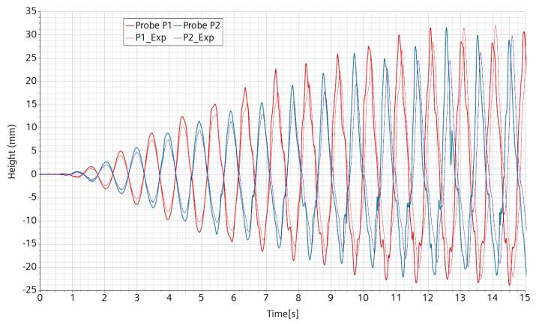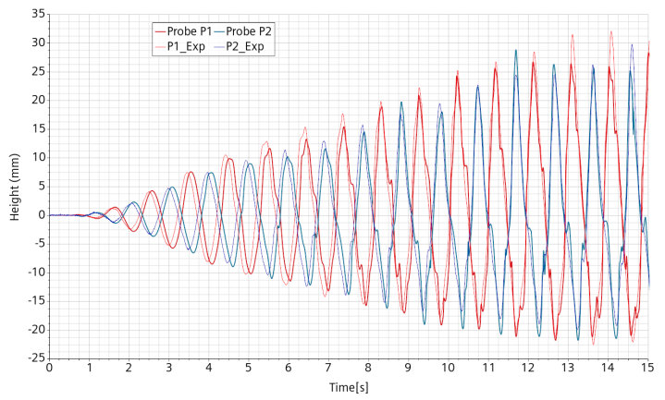
Figure 40: Case A15_f104_5mm. Elevation at the P1 and P2 probes. Left, with bottom connections. Right, without bottom connections.

Simulations from seismic loads
The numerical model being validated, it is used to evaluate the impact of real seismic loads from significant earthquakes. The considered earthquakes are of increasing intensity in order to allow a progressively better understanding of the interesting features. It also allowed to get progressively faced with new issues, both numerical and conceptual.

Data
The seismic data have been retrieved from the following websites:
- Perugia (Italy 2016) [3]: INGV STRONG MOTION DATA (ISMD) http://ismd.mi.ingv.it/
- Romania and Turkey: Engineering Strong Motion Database (ESM Database) Errore. L'origine riferimento non è stata trovata. https://esm-db.eu/#/event/search Errore. Il segnalibro non è definito.

Data from the following earthquakes have been selected:
- Perugia (Italy) October 30, 2016, magnitude 6.5 http://ismd.mi.ingv.it/evento.php?var1=8863681&path=161030064017&rev=man
- Romania April 3, 1977, magnitude 7.5 at epicenter and 6.3 at station ISC-webservice https://esm-db.eu/#/event/RO-1977-0001
- Turkey June 2, 2023, magnitude 7.8, https://esm-db.eu/#/event/INT-20230206_0000008
- Japan November 3, 2011, magnitude 9.0 at epicenter and 6.6 at station TSUKIDATE https://www.kyoshin.bosai.go.jp/kyoshin/quake/index_en.html
The seismic data are registered by several stations more or less distant from the epicenter. The data chosen is from the station with the highest Peak Ground Acceleration (PGA) or displacement (PGD).
- Perugia: distance 38 km, PGA 618 cm/s² (T1243):
- Romania: distance 164 km, PGA 194 cm/s²
- Turkey: distance 24.6 km, Horizontal PGA 584 cm/s², Horizontal PGD 109 cm.
- Japan: distance 175 km, Peak acceleration 2933 cm/s² (Gal)
Displacements along East-West (X-axis)), South-North (Y-axis) and Down-Up (Z-axis) are used. Either they are directly available or constructed by successive integrations of the accelerations.
The scaling law is such that time scales like the square root of length, so that acceleration is an invariant. The length ratio between ALFRED and the mockup is estimated at 18.4, making the mockup flow of time go 4.29 times faster than the ALFRED flow of time. The applied forces scale with the density and the volume. In consequence, 1 N on the mockup represents about 10.4 * 18.4³ = 65 kN on ALFRED.
The mockup liquid inventory is 39.9 l for 39.8 kg. The free-surface at rest is 8.84 cm above the diaphragm plate.

Mockup simulation from the Perugia 2016 earthquake
The earthquake of magnitude 6.5 in Perugia happened on October, 30. It caused the death of 299 people from the collapse of a huge number of buildings [5]. The data were acquired at only 38 km from the epicenter.
The used displacement data were previously treated and filtered. Here are the main information extracted from the data files:
- BASELINE_CORRECTION: REMOVED
- FILTER_TYPE: BUTTERWORTH
- FILTER_ORDER: 4TH
- LOW_CUT_FREQUENCY: 0.1
- HIGH_CUT_FREQUENCY: 45
- MEAN_REMOVED
- DISPLACEMENT_OBTAINED_FROM_PROCESSED_ACCELERATION
The earthquake displacement curve is shown in Figure 41 while the corresponding mockup scaled displacement is shown in Figure 42.
The mockup is simulated by imposing the scaled displacement. The free-surface elevation at the probes is shown on Figure 43. The forces are correctly measured only after ~2.4 s. The forces applied to the vessel by the fluid pressure are given in Figure 44 left, while the horizontal forces on the DHR components are given on Figure 44 right.
Being the first real earthquake to be simulated, we did not know what to expect. It turned out that the maximum displacement is very low, inducing sub-centimeter range water waves. However, peak forces reach 3,000 N on the mockup vessel wall which seems huge considering the ~40 kg of water. At first, these measurements seemed consistent with the huge structural damages. We will see later on that the forces measured are flawed with issues in the input data treatment and the numerical setting.
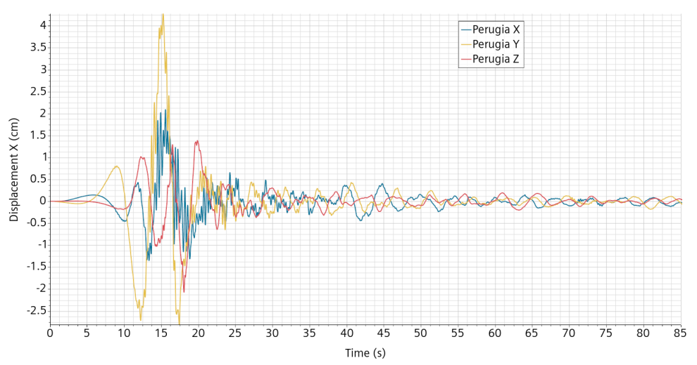
Figure 41: Displacement signal of the Perugia 2016 event.
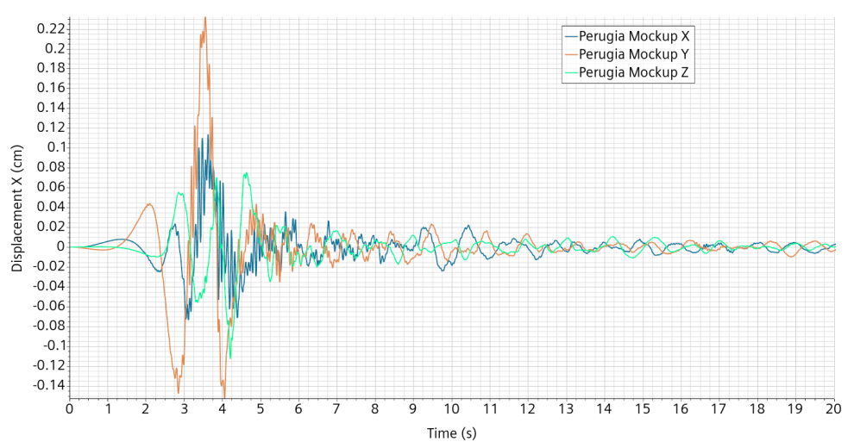
Figure 42: Displacement signal applied to the mockup in relation to the Perugia 2016 event.
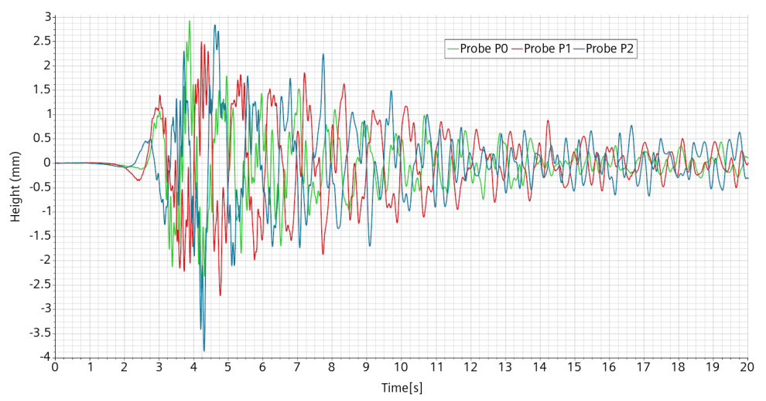
Figure 43: Perugia 2016 event. Mockup free-surface displacement at the probes.
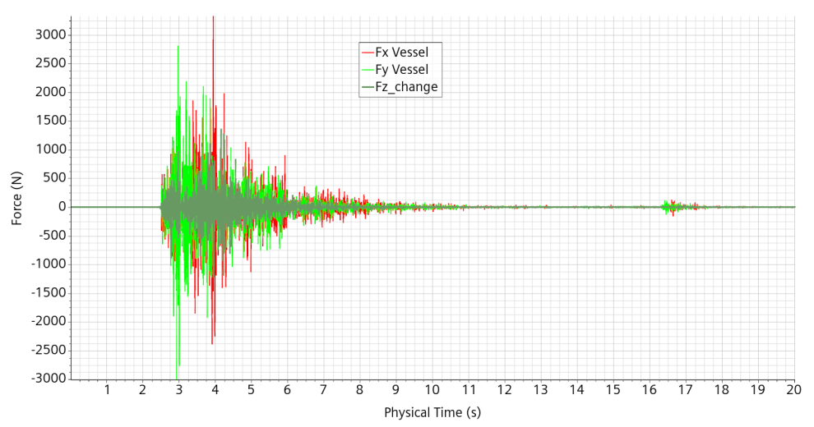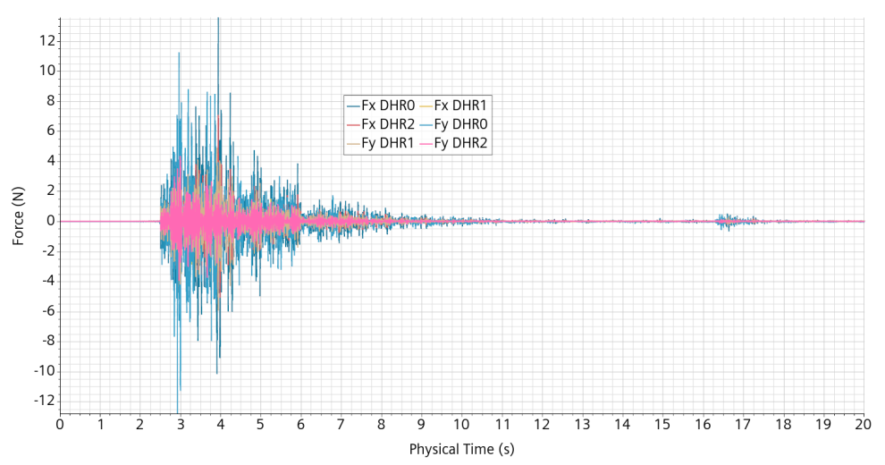
Figure 44: Perugia 2016 event. Left, forces on the vessel. Right, forces on the DHR components.

Mockup simulation from the Romania 1977 earthquake
The earthquake took place on April 3, 1977. Its magnitude was 7.5 at the epicenter but reduced to 6.3 at the data acquisition place. It caused the death of 1,578 people and destroyed or severely damaged about 32,900 buildings [6].
The data used here come from the ESM database [3]. The displacement data used were previously treated and filtered. Here are the main information extracted from the data files:
- BASELINE_CORRECTION: BASELINE REMOVED
- FILTER_TYPE: BUTTERWORTH
- FILTER_ORDER: 2
- LOW_CUT_FREQUENCY_HZ: 0.200
- HIGH_CUT_FREQUENCY_HZ: 25.000
- DATA_TYPE: DISPLACEMENT
Besides, the data is quite old and the original non-processed acceleration data lasts for only 16.1 s. Concern is that the data processing could heavily alter the data quality with regards to the use for sloshing impact evaluation. In order to appreciate the alteration provided by the data treatment, processed data and unprocessed data of the acceleration in the Y-direction are plotted on Figure 45. From visual inspection, it is seen that the processed data is sound and mainly aims at having a null final displacement.
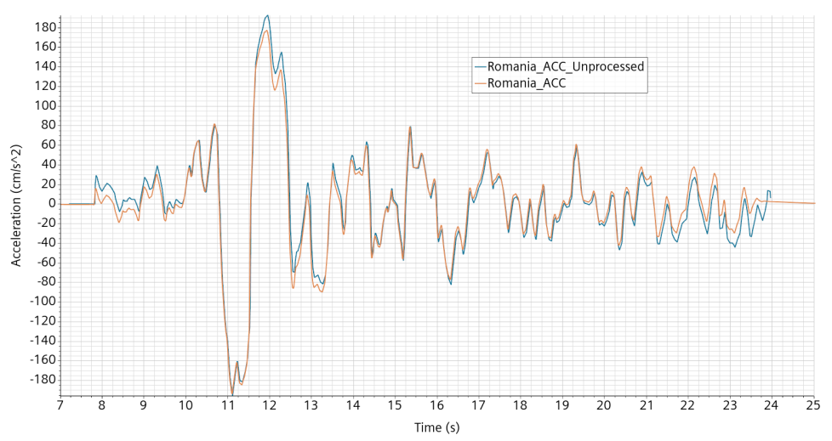
Figure 45: Romania event. Processed and unprocessed Y-acceleration from the ESM Database.
The displacement imposed to the mockup is shown on Figure 46. The free-surface elevation at the probes is shown on Figure 47. The forces applied to the vessel and to the DHRs are given in Figure 48. The free-surface area and its numerical width is given in Figure 49.
The forces measured in the simulation suffer from a strong numerical high frequency noise. This noise is enhanced by the adaptive mesh refinement performed each 5 time steps. In order to better understand the consequences of this issue, the signal is regularized by passing it 5 times to a 3 time-steps running mean, making a regularization quite similar to a Gaussian regularization on 5 time-steps width. The regularization is quite effective but is not totally legitimate because of the variable time-step. The peak value of the force and the vessel drops from 300 N to 70 N when regularized and the signal becomes more easily interpretable. The regularized force on the vessel in direction Y is strongly correlated to the acceleration, see Figure 50, with a ratio giving an equivalent mass about 35 kg, to be compared with the 40 kg water inventory. This ratio is interpreted as follows. The water in the lower plenum weights 30 kg and is displaced mainly as a rigid body. The vessel displaces about 5 kg of water in the upper plenum, the remaining 5 kg being displaced by the internal structures, up to the free-surface evolution. When the event is finished after 6s, a periodic forcing of initial amplitude about 1 N and 2.5 Hz frequency remains and slowly decays.
With regard to the DHRs, the more intense solicitation is found on DHR0 in the direction Y. The regularized force peaks at 0.6 N during the event then decays from 0.4 N with a pseudo-periodic forcing at about 2.5 Hz, see Figure 51.
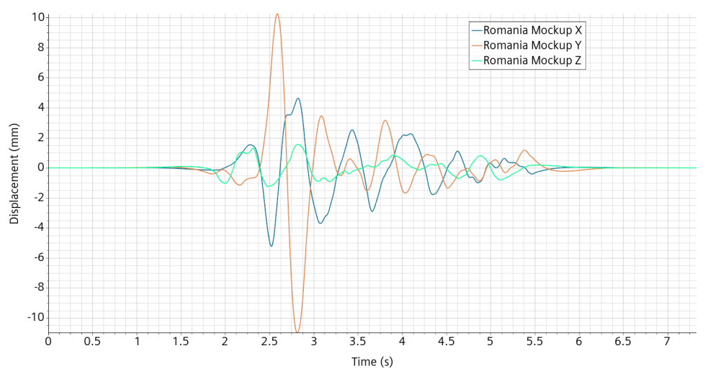
Figure 46: Romania 1977 event. Displacement imposed to the mockup.
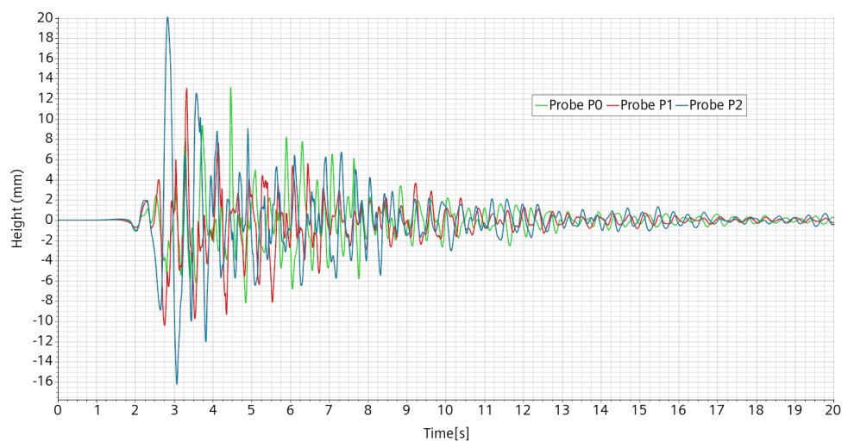
Figure 47: Romania 1977 event. Free-surface elevation at probes.
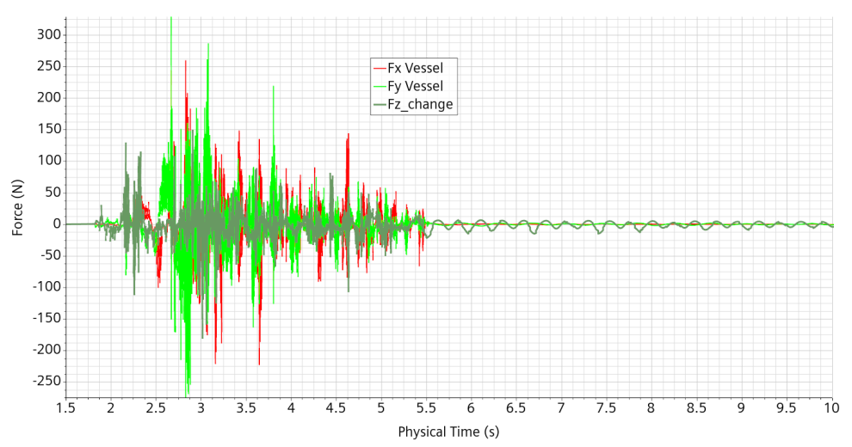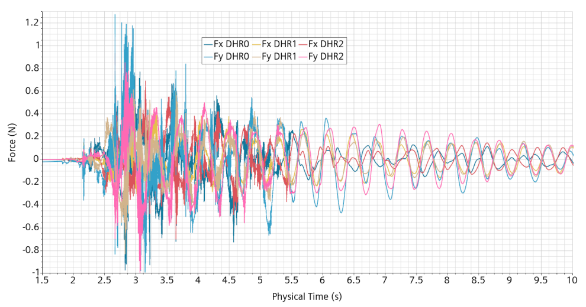
Figure 48: Romania 1977 event. Left, forces on the vessel. Right:, forces on the DHR components.
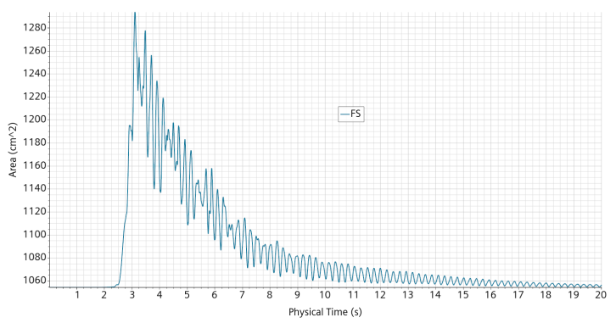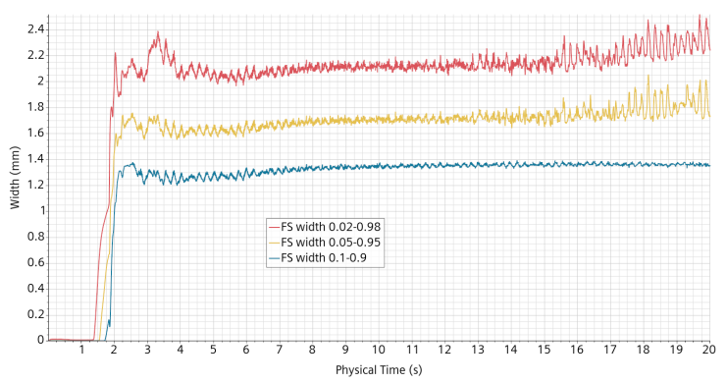
Figure 49: : Romania 1977 event. Left, free-surface area. Right, mean numerical width of the free-surface.
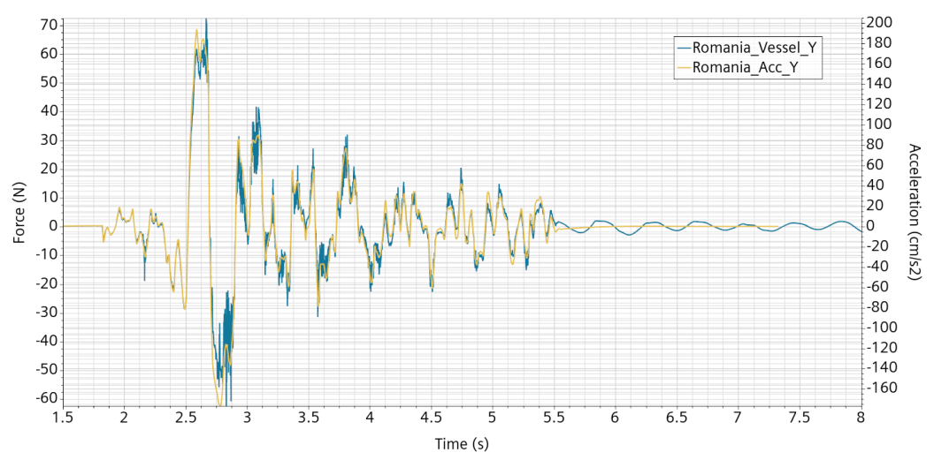
Figure 50: Romania 1977 event. Regularized force on the vessel and (minus) the imposed acceleration.
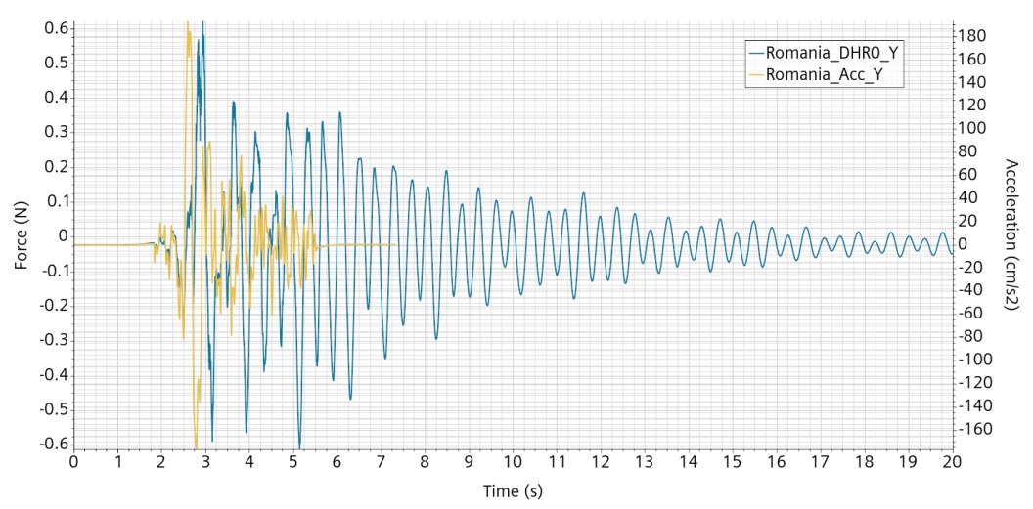
Figure 51: Romania 1977 event. Regularized force on DHR0 and (minus) the imposed acceleration.

Mockup simulation from the Turkey 2023 earthquake
The Turkey February 6, 2023 earthquake is of higher epicenter magnitude 7.8 than for the previous cases and is also measured at a shorter distance, 24.6 km. It caused widespread damages over 350,000 km², affecting 14 millions people of which 1.5 millions were left homeless. The death toll for the sole Turkey amounts to 53,537Errore. L'origine riferimento non è stata trovata. [7].
The displacement data used were previously treated and filtered. Here are the main information extracted from the data files:
- BASELINE_CORRECTION: BASELINE REMOVED
- FILTER_TYPE: BUTTERWORTH
- FILTER_ORDER: 2
- LOW_CUT_FREQUENCY_HZ: 0.030
- HIGH_CUT_FREQUENCY_HZ: 40.000
- DATA_TYPE: DISPLACEMENT
The displacement measured on site is given in Figure 52.The displacement imposed to the mockup is shown on Figure 53.

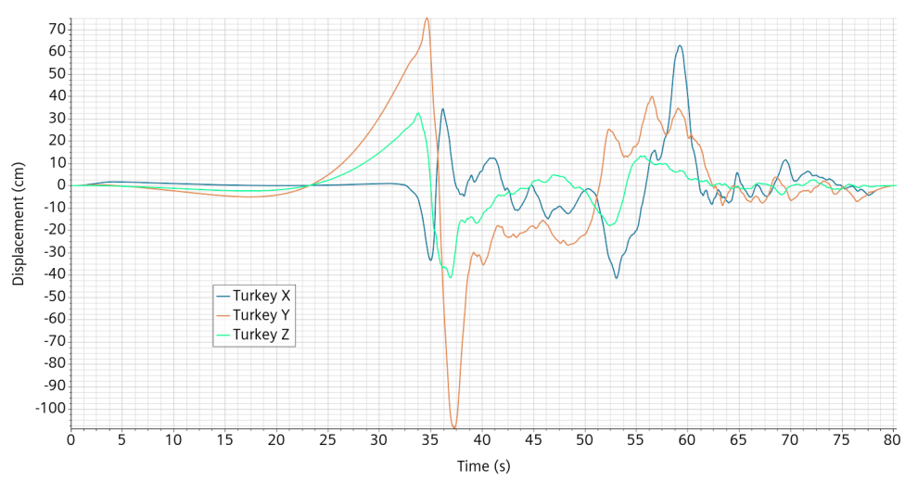
Figure 52: Turkey 2023 event. Displacement measured at the station.
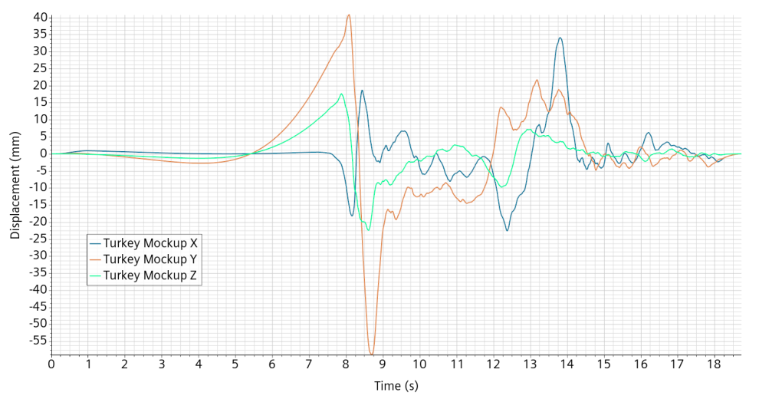
Figure 53: Turkey 2023 event. Displacement imposed to the mockup.

Simulation results
The free-surface elevation at the probes is shown on Figure 54. The elevation is given in a fixed inertial reference frame and includes the mockup vertical displacement. The forces applied to the vessel and to the DHRs are given in Figure 55. The free-surface area and its numerical width is given in Figure 56.
It should be noted that the position span in direction Y is slightly above the 9 cm allowed by the SHAKESPEARE table.
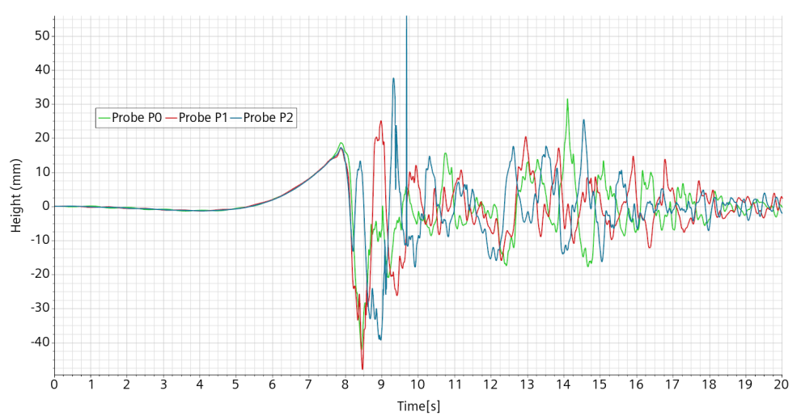
Figure 54: Turkey 2023 event. Free-surface elevation at probes.
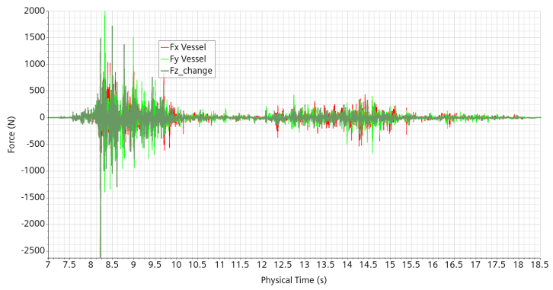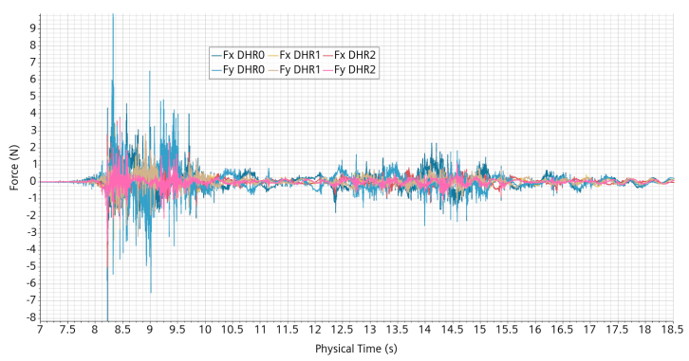
Figure 55: Turkey 2023 event. Left, forces on the vessel. Right:, forces on the DHR components.
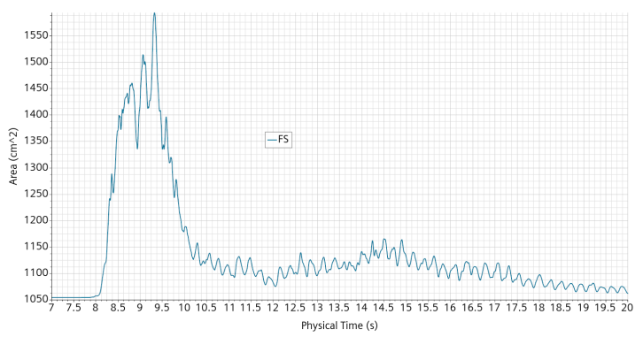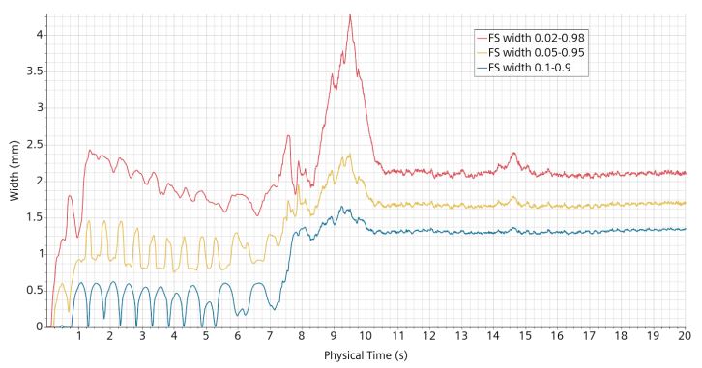
Figure 56: Turkey 2023 event. Left, free-surface area. Right, mean numerical width of the free-surface.

Elements of analysis and discussion.
The sloshing intensity increased from the Perugia event to the Romania event and further to the Turkey event. However, the PGA of Perugia is greater than the Romanian one. It is thus not a very good criteria to order the events for sloshing. The PGA is very sharp and quite dependent on the high frequency cut of the seismic signal. Moreover, dampers are supposed to absorb the high frequency component of the signal. It is not yet clear what is the meaning of high frequency in this contest but a cut value of 10 Hz seems a conservative educated guest.
The volume of the immersed part of each DHR is V_{DHR}= 174 cm³. We would like to characterize the water volume directly responding to a moderate impulse acceleration.

Regularization of the displacement input signal.
For the mono-dimensional harmonic forcing, the method used was the “Translation Motion” which technically requires to provide a velocity to the solver. The data was provided as displacement by VKI and included as a discrete displacement table in the Star-ccm+ simulation. The velocity is obtained by building a user function which reads the table, creates an interpolated extension of the table and it derives the interpolated extension. The syntax is similar to:
differentiateTable(@Table("Table_VKI"), "Time_Mockup", CUBIC_AKIMA, "X-VKI", ${Time})
where “CUBIC_AKIMA” means that the interpolation first determines the slopes at the discretized table values and then passes a cubic polynomial between each pair of data.
Another option is “LINEAR” in which the values at intermediate times are directly obtained by linear interpolation.
The real seismic signals are 3-dimensional, it seemed at first more convenient to use the “Trajectory” motion option which requires only to provide only one file table, but containing columns for all three directions. It turns out that this procedure is equivalent to the former one but implicitly using the “LINEAR” option.
With the linear interpolation of the displacement, the velocity is constant and the acceleration is null between two discretization points. The acceleration is then concentrated as discrete potentially very high jumps when passing across the data points. The smaller the time-step the higher the jump. In our simulations, the displacement data are given at 0.01s intervals, while the time steps are generally much smaller. While there is no real impact foreseen on the global simulation evolution, the forces which react strongly to acceleration through Newton’s law become extremely noisy and can be interpreted only after due filtering. The filtering of the results is not very handy because of the variable time-step. That is why, after understanding of the strong noise issue, the seismic simulations have been repeated enforcing the smooth interpolation approach based in theory on an acceleration at least piecewise continuous. The effect on the measured forces can be appreciated, in the case of the Perugia, Romania and Turkey events, in Figure 57, Figure 58 and Figure 59. It can be seen that the peak forces have been reduced by at least a factor 3 and up to one order of magnitude.
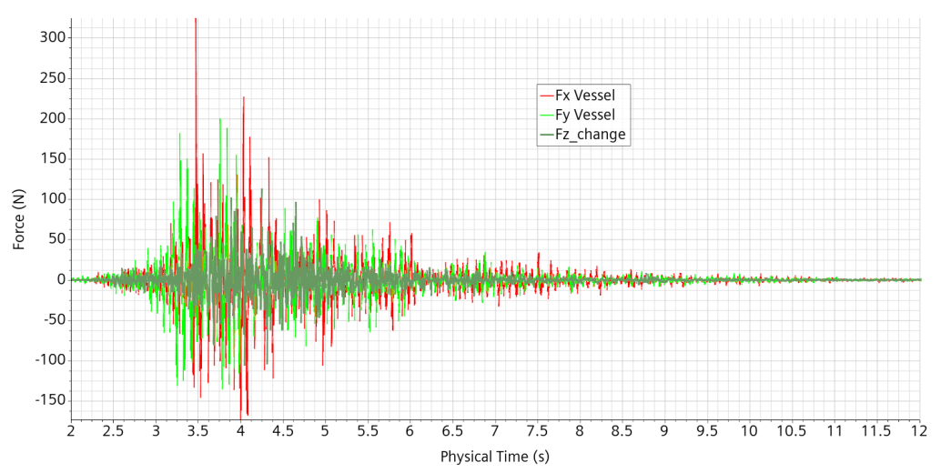
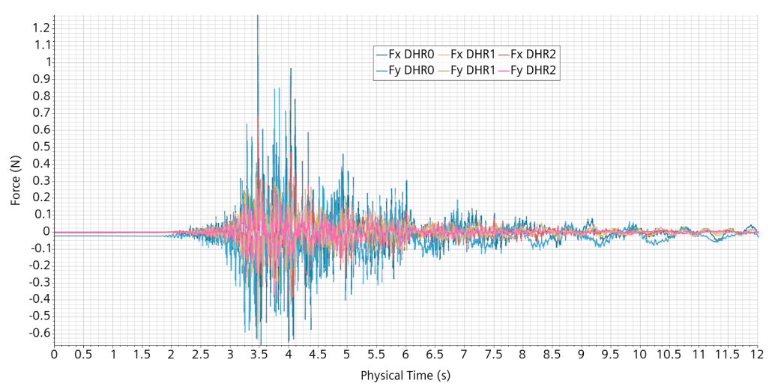
Figure 57: Perugia event. Forces on vessel (top) and on DHRs (bottom). Left, with linear displacement interpolation. Right, with cubic polynomial displacement interpolation.
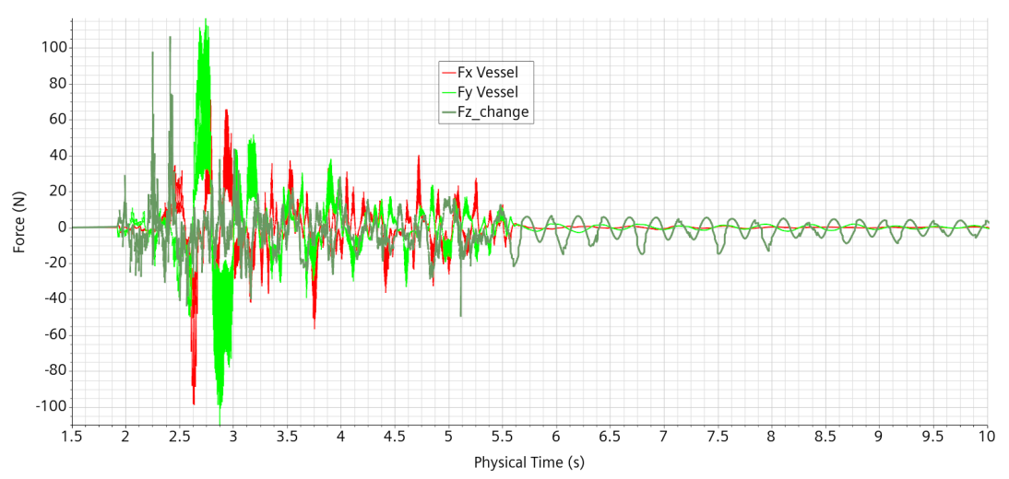
Figure 58: Romania event. Forces on vessel. Left, with linear displacement interpolation. Right, with cubic polynomial displacement interpolation.
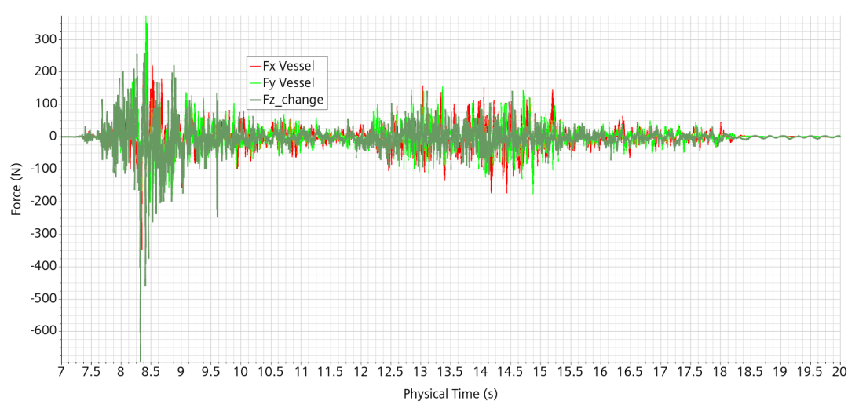
Figure 59: Turkey event. Forces on vessel. Left, with linear displacement interpolation. Right, with cubic polynomial displacement interpolation.

Mockup simulation from the Japan 2011 earthquake
On March 11, 2011, an earthquake of magnitude 9.0, the largest ever recorder in Japan, and fourth largest worldwide since 1900Errore. L'origine riferimento non è stata trovata. happened about 150 km off the pacific coast of the northeaster Tohuku region. The Japan 2011 earthquake, followed by a devastating and deadly tsunami was the initial event leading to the notorious Fukushima incident.
For the earthquake and tsunami combined, “[t]he official figures released in 2021 reported 19,759 deaths, 6,242 injured, and 2,553 people missing.” [8]
The ground motion has been registered at thousands of sites [9]. It has been measured and registered at hundreds of location in Japan. The data chosen is the one exhibiting the highest peak acceleration intensity, about 2.8 g, at K-NET Tsukidate Miyagi prefecture not so far away from the Fukushima Daiichi nuclear power plant, see Figure 60. The earthquake intensity onsite is of magnitude 6.6.
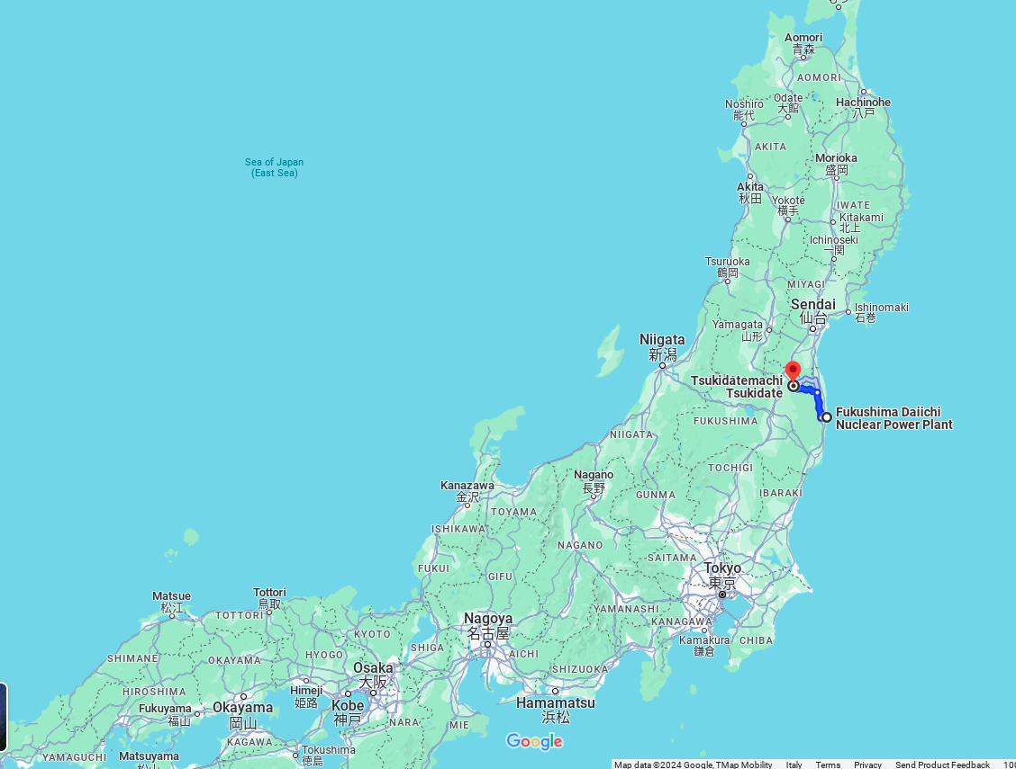
Figure 60: location of the data site and of the Daiichi NPP (Google Maps)
The acceleration data have been downloaded, after due registration, from the National Research Institute for Earth Science and Disaster Resilience[4].
The downloaded acceleration data are rough without any filtering, for a total duration of 300 s and at a 100 Hz acquisition frequency, as shown in Figure 61. The peak acceleration is above 2.5 g but is extremely sharp.
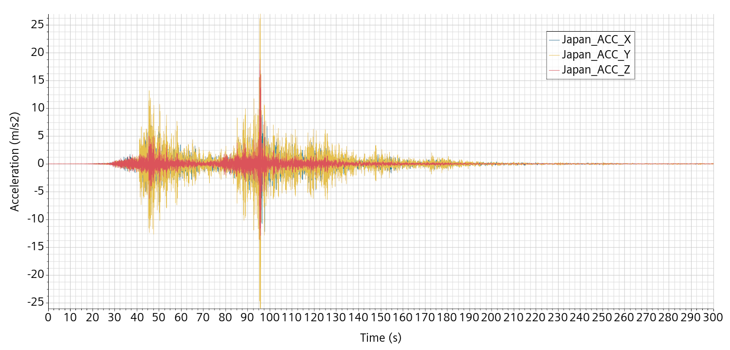
Figure 61: Japan event rough acceleration data.

Enforcing consistency and setting input displacement data
The downloaded data are the accelerations in the three directions East-West (direction X), North-South (direction Y) and Up-Down (direction Z). At a later stage under internal review, it turned out that the direction Z should have been direction –Z. This has no practical consequence but should be taken into consideration for future developments.
We had a very hard time treating the data in a consistent way for our purpose.
Removing the baseload (mean value) on the acceleration is the common practice first step, ensuring that the final velocity is equal to the initial one, set at zero. In principle, this procedure is not sufficient to ensure that the terminal displacement is also zero. This however should be the case under the condition that the accelerometers work perfectly and in particular do not lose their initial calibration.
The x-velocity obtained by integration of the acceleration data, after removing the baseload, is shown in Figure 62 left. This velocity is totally unrealistic, having non zero initial slope and leading to a final displacement of more than 50 meters, see Figure 62 right. Our interpretation is that the acceleration signal is so intense that the accelerometers calibration withstand a random small shift during the most critical periods. This hypothesis is somehow corroborated on the Wikipedia page [8] indicating saturation of many seismographs.
In fact, there is a difference in the baseload considering the initial or the final part of the data. The baseload to be removed must be different at the beginning and at the end of the curve so as to enforce a mean flat null velocity at the beginning and a mean null curvature at the end of the curve. This values must be propagated as far as possible from both sides towards the time laps of more intense seismic activity. Doing this, we get an initial flat zero velocity curve and a final constant slope velocity. Acting on the acceleration curve on some internal intervals, we must enforce both a null and a flat final velocity. In other words, we need to “free” at least two additional degrees of freedom.
To make things manageable, we carefully select two contiguous relatively small time intervals in the most active region and play with the local normalization to obtain the desired results. We recognize that there is a part of arbitrariness in the procedure, principally in the choice of the time intervals. Afterward, by a lengthy trial and error succession of approximations, there should be in principle only one couple of normalization values that can satisfy the requirements.
In reality, different intervals have been tested and initially discarded because the maximum displacement seemed excessive. However, the trial and error successive approximation procedures always led to the overall same shape of displacement curve.
The final velocity and associated displacement curves we decided to adopt are shown in Figure 63.
The maximum horizontal displacement is about 3.5 m while the vertical one is nearly 3 m in depth. It should be acknowledged that the maximum displacement found in [10] is only 16 cm. However, a high pass filter of 0.1 Hz has been used both for velocities and displacement. We do not know if the filter has been used twice in raw to compute successively velocities and then displacements. Moreover, from GPS data on a larger time scale before and after the event, a fault slip peak of 35 m and a horizontal displacement field on firm lands near the site of 1-2m meters towards East has been reported in [11] and [12]. How much displacement can be ascribed to the main shock is not known. Therefore, while imposing a null total displacement is somewhat arbitrary, the maximum displacement amplitude is consistent.
The displacement of the ALFRED mockup is obtained by applying the length ratio of 0.054 and the time ratio of 4.29. In practice, the simulation requires as input a velocity which is given by regularization and differentiation of the displacement data table. It can be seen in Figure 64.
It should be noted that the imposed displacement, up to 18 cm, is out of range of the SHAKESPEARE table, ±4.5 mm in each direction.

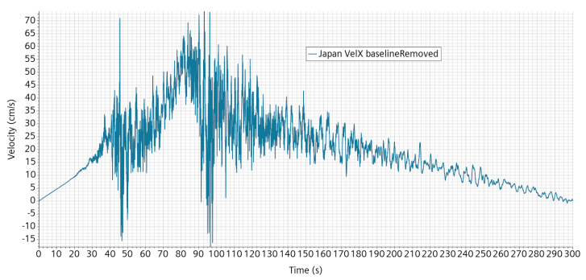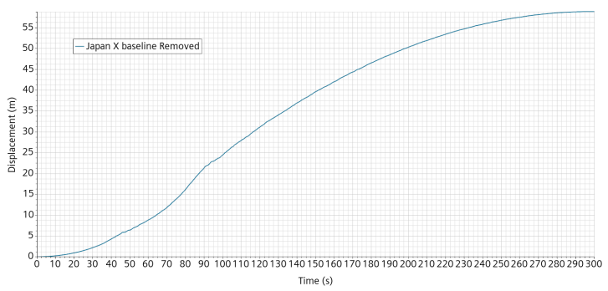
Figure 62: Japan event. Left: X-velocity if baseline is removed from the acceleration data. Right, associated displacement.
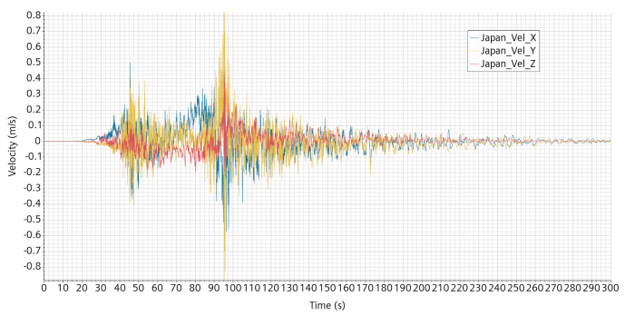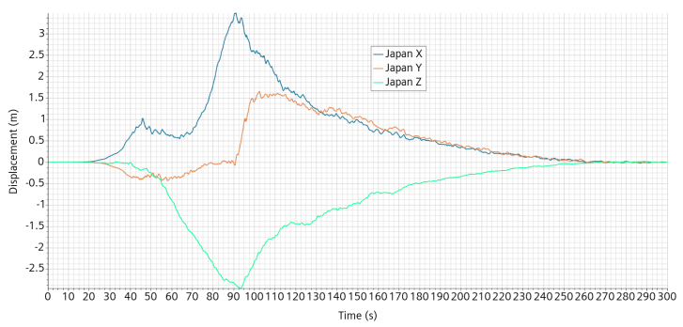
Figure 63: Japan event. Left: corrected velocity. Right, associated displacement.
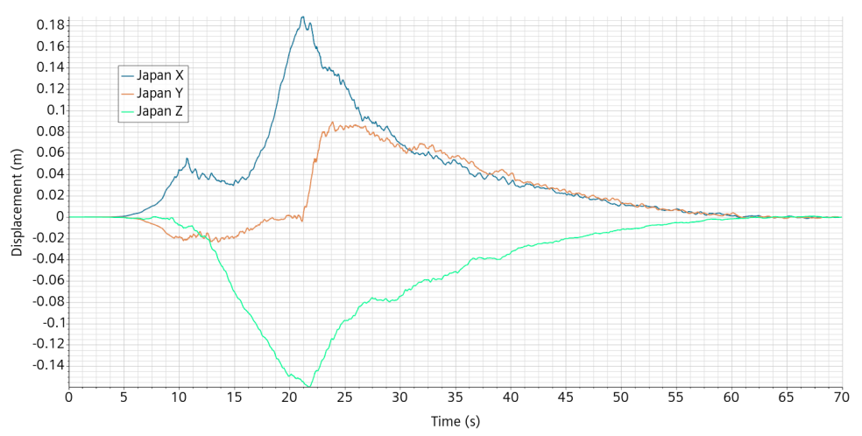
Figure 64: Japan event. Displacement imposed to the ALFRED mockup.

Japan event results
The simulation is performed using the cubic interpolation of the displacement data. However, unlike the other events simulation, no low-pass filter has been applied meaning that the high frequencies are only limited by the rate of sampling of the data table which is 100 samples per second.
From the analysis of the Turkey event results, it has been understood that the fluid height should be referred to the moving mockup system of reference.
In order to fully appreciate the relative magnitude of the displacement, the free-surface and mock-up position at simulation start and after 22 s is shown on Figure 65.
The flow elevation in the mockup reference coordinate system at the three probes location is shown in Figure 66.
The forces applied to the vessel are strongly correlated to the instantaneous high frequency component of the acceleration, as can be seen in Figure 67. We can also see that there is a shift in vertical force. This is due to the position of the reference pressure which makes the mean pressure at the lid increase by 0.1 kPa for each centimeter the mockup falls down. The mockup surface is about 12 dm², explaining a shift of about 180 N for going down 15 cm.
The situation with regard to the components is similar but not identical. Looking at the force and acceleration in the X direction on the mockup DHR0, see Figure 68, we can observe also a strong correlation but the force is also somewhat modulated. This is clearly apparent after 44s when the external forcing acceleration is essentially finished but a rather small oscillating force on the component remains. This force is the one associated with the remnant sloshing wave.
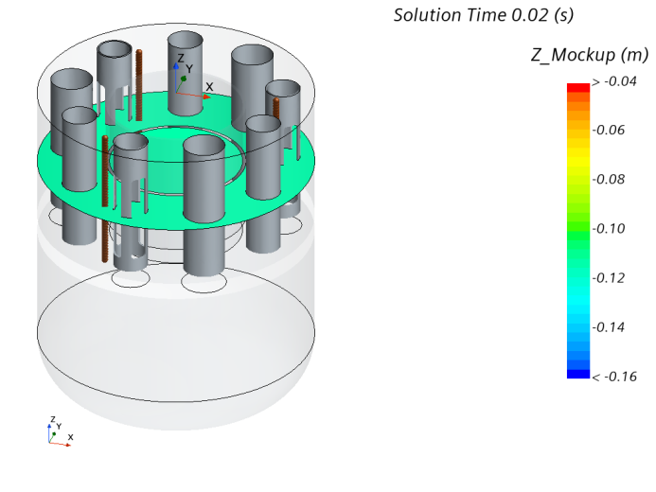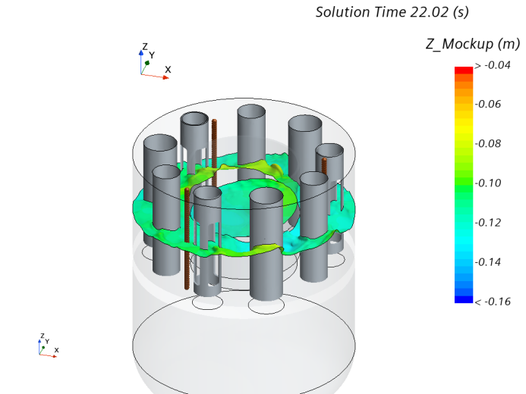
Figure 65: Japan event. Free-surface and position of the mock-up at simulation start and after 22s.
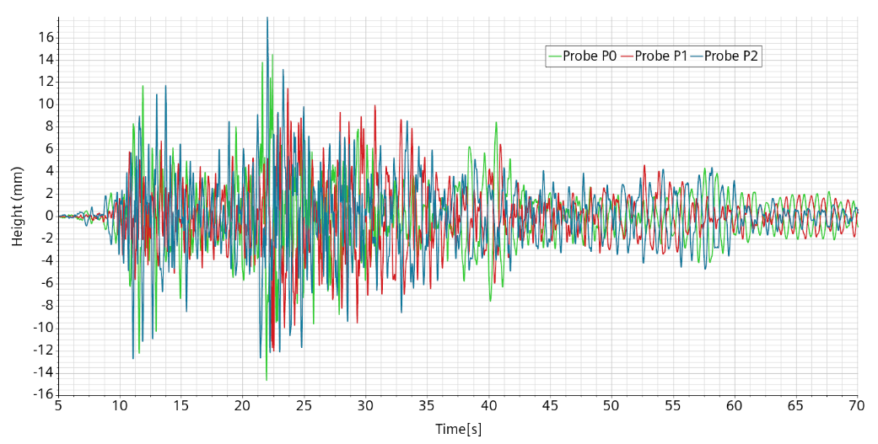
Figure 66: Japan event. Free surface elevation at the probes in the mockup coordinate system.
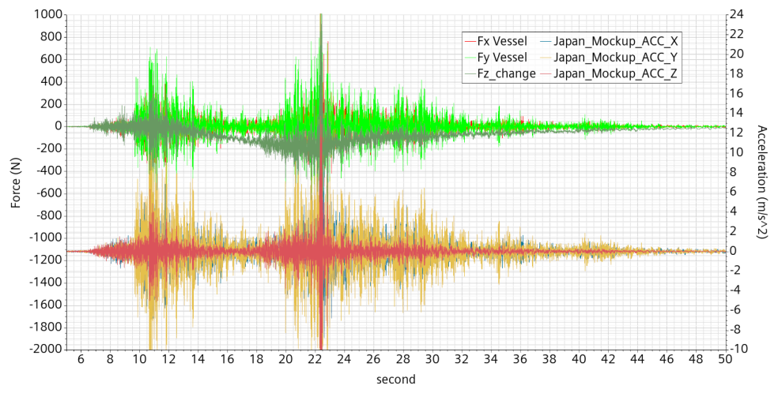
Figure 67: Japan event. Forces on vessel and imposed acceleration
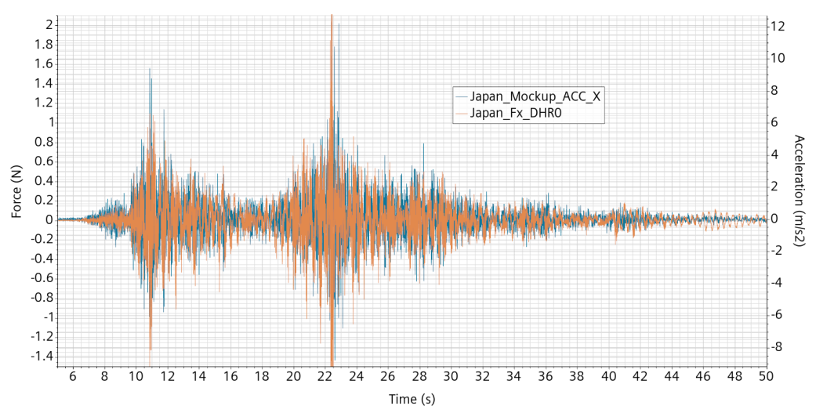
Figure 68: Japan event. Force and acceleration in X-direction on the mockup DHR0.

Damped Japan event
In the previous simulations, the imposed acceleration is directly provided from the ground measurement data sampled at 0.01 s. For the simulation of the Turkey event, the displacement data was already smoothed, with a high cut frequency at 40 Hz, the frequency content below 40 Hz remaining untouched. The Japan event peak acceleration is very narrow but is not filtered. This explains why the peak force on the vessel, about 1,000 N, is much higher than the Turkish event one, about 300 N.
The ALFRED demonstrator is expected to be protected from seismic events by use of dampers supposed to absorb the high frequencies. In this simulation, we pre-treat the previously built acceleration signal data at the full scale event timescale with a Butterworth digital low-pass filter at 1 Hz critical frequency parameter. The mockup displacement and position are then obtained in the usual way. The idea is to start an iteration process giving input on the effect of a numerical filter to help the designer define the anti-seismic barrier.
With regard to the displacement curve, the filtering effect is barely perceptible, as illustrated in Figure 69. This is an indication of a reasonably small damper deformation. The acceleration curve instead is drastically changed both in shape and in intensity scale. This is illustrated, only in the X-direction for clarity, in Figure 70.
The surface level at the probes is given on Figure 71 in the coordinate system moving with the mockup. The sloshing intensity is quite low and not very different from the non-filtered simulation. A direct visual comparison can be performed by looking at Figure 72.
The low-pass filter has drastically reduced the peak force in X-direction from 700 to 50 N. The force applied to the vessel in the X-direction is shown in Figure 73 together with the corresponding acceleration. The two curves have been put at a scale in which they almost completely match, with the acceleration curve hiding most of the force curve. In comparison with the acceleration curve, the force curve has its extrema often smoothed.
This was at first erroneously interpreted as an effect of the free surface displacement which could have introduced a small delay on the would-be completely rigid displacement.
The ratio of force to acceleration is expected to give an equivalent added mass resisting the acceleration. This added mass should not exceed the total liquid mass involved. However, this ration gives a value of about 62 kg, to be compared to the 40 kg liquid inventory. The reason of the mismatch is explained in the next section but points in this simulation to an overestimation by at least 50% of the applied forces.
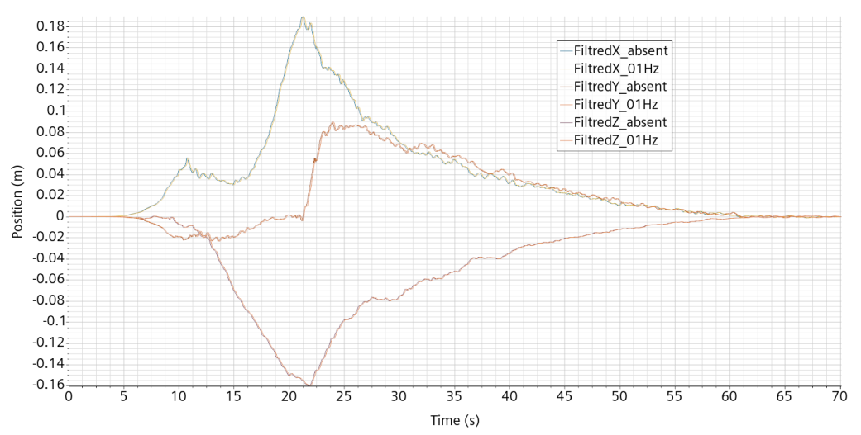
Figure 69: Japan event. Comparison of the displacement curves before and after filtering.
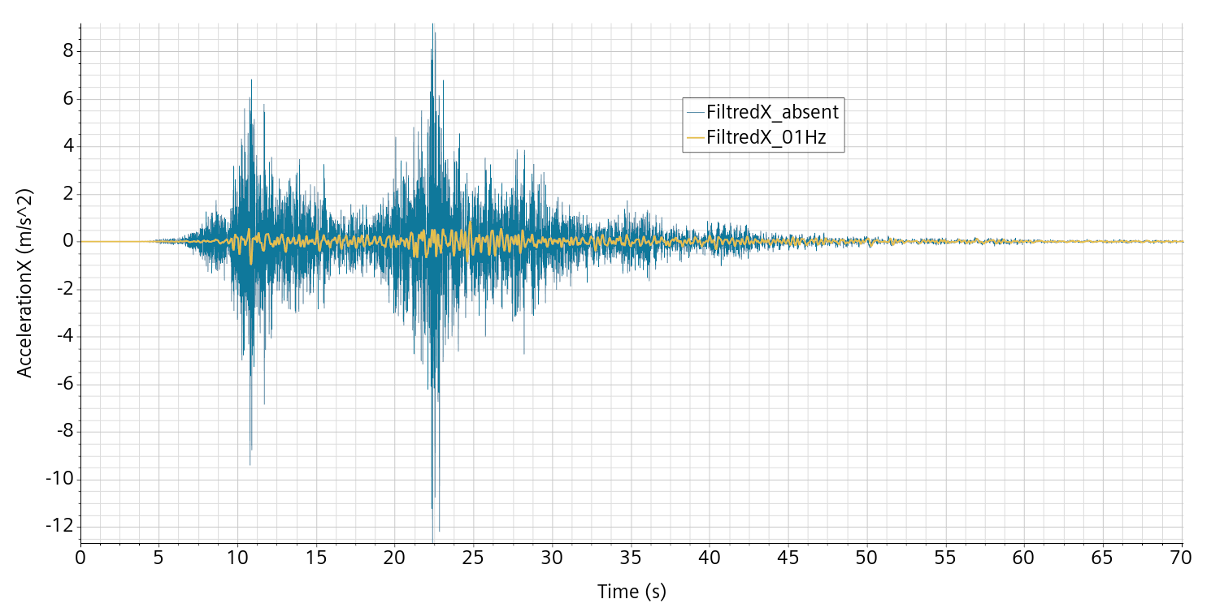
Figure 70: Japan event. Difference between non-filtered and filtered mockup acceleration in X direction.
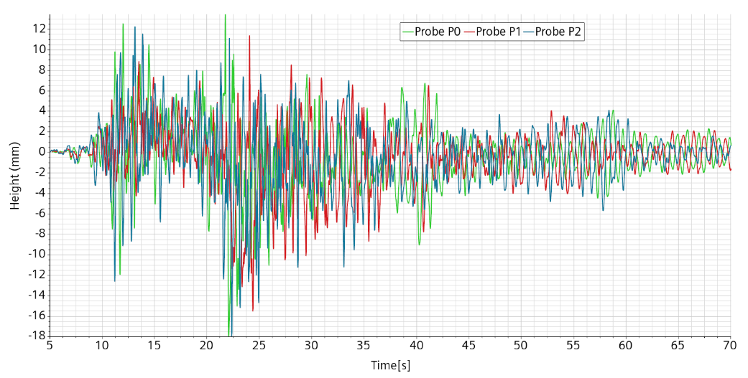
Figure 71: Japan event, filtered 1Hz. Surface level at the probes in the mockup reference system.
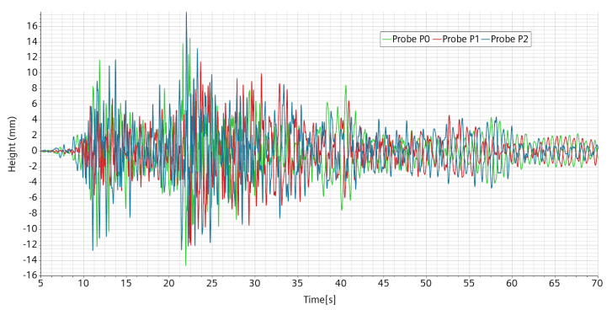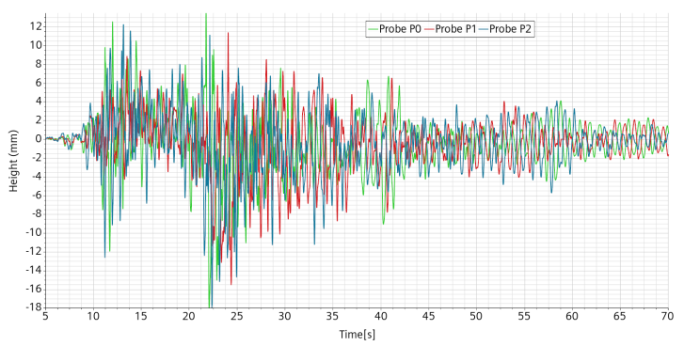
Figure 72: Japan event. Comparison of the surface level at the probes between the non-filtered signal on the left and the signal filtered at 1 Hz on the right.
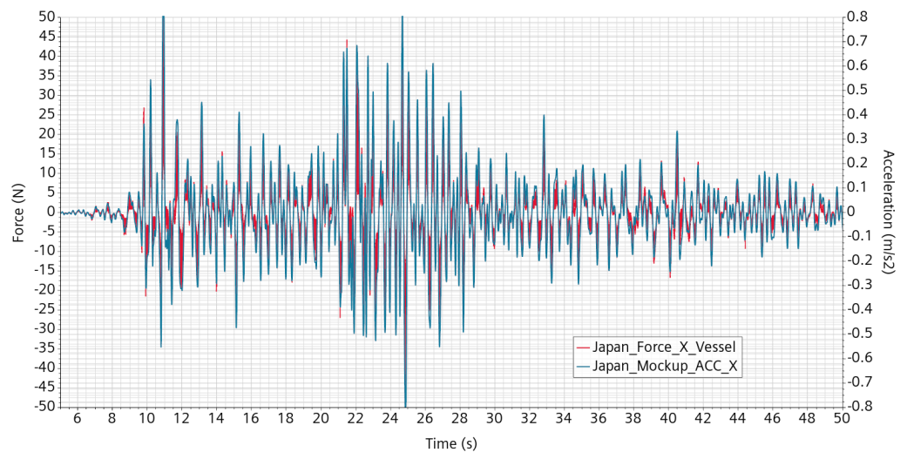
Figure 73: Japan event, filtered 1Hz. Comparison between the forces applied to the vessel and the acceleration, X-direction.

Damped Japan event, first order in time.
The previous simulation of the Japan event with a low pass filter cut at 1 Hz works fine under almost every aspect, except for the overestimate of the forces applied to the vessel and by consequence probably also on the components.
We have already uncovered the importance of the interpolation procedure to consistently represent the acceleration induced by a tabulated velocity. However, even if regularized, the acceleration is highly variable, to the point that the condition under which the second order in time is more accurate than the first order could fail.
Therefore, the simulation is repeated with first order time discretization as single and only change.
In Figure 74, we make a closer look at the X-force on the vessel comparing first and second order time scheme on a 2 s interval. We can see that the first order curve is much smoother than the second order one and does not resent of the 5 time steps re-meshing interval. Moreover, the first order curve looks pretty much like a regularized version of the other curve, essentially passing through the middle of it.
Going back to our previous and erroneous estimate of the equivalent added mass, by looking at the curve at a large scale, we were in fact confusing the curve with its envelop, and grossly overestimating the added mass by something like a factor of two.
The procedure to evaluate the vessel added mass it thus repeated on a reduced time laps, interval 22-28 s as shown on Figure 75. In this figure, we can see that we can obtain quite a good matching between the acceleration and the force, with a small modulation that we interpret as being the effective sloshing contribution. The ratio of the scales 25 N and 0.8 m/s² gives an estimated added mass about 31.2 kg.
By looking towards the end of the event, interval 40-60 s, with the acceleration going down, we can see on Figure 76 the progressive and relative misalignment of the two curves due to the remaining sloshing effect.
For completeness, we also give in Figure 77 the surface level at the probe which is almost unchanged.
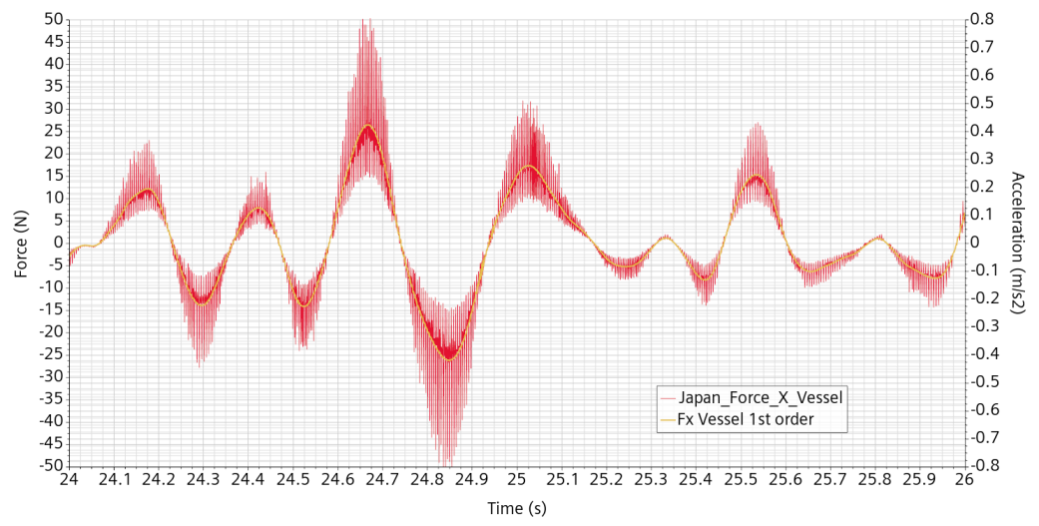
Figure 74: Japan event filtered 1 Hz. Forces on the vessel during the acceleration peak. In red, second order in time. In yellow, first order.
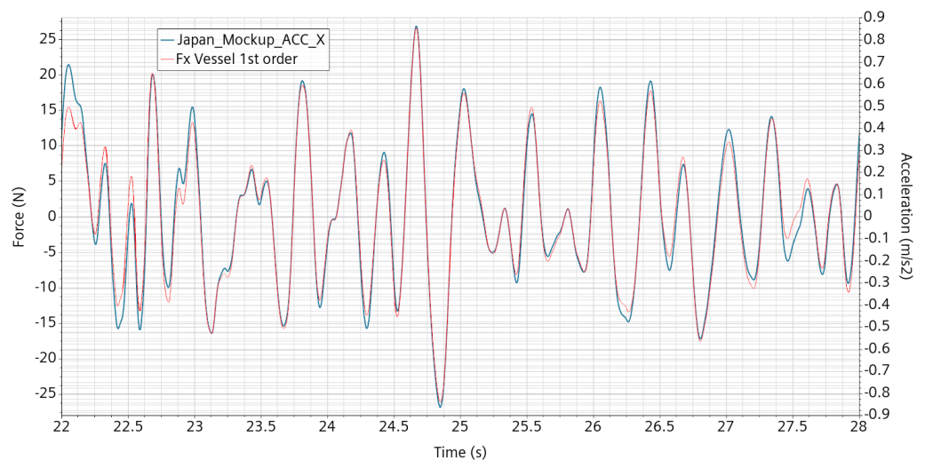
Figure 75: Japan event filtered 1 Hz, 1st order. Forces on the vessel during the acceleration peak with acceleration scale fit to overlay the curves.
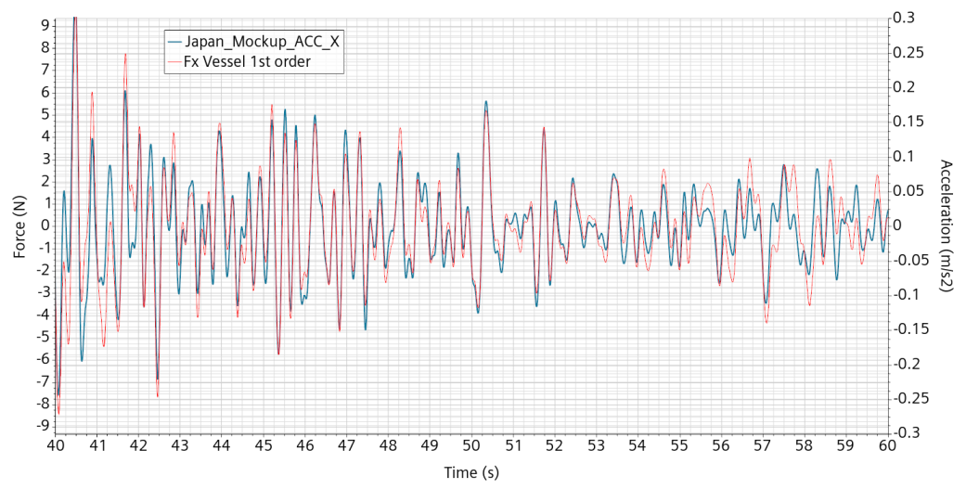
Figure 76: Japan event filtered 1 Hz, 1st order. Forces on the vessel at finishing event with acceleration scale fitted to overlay the curves.
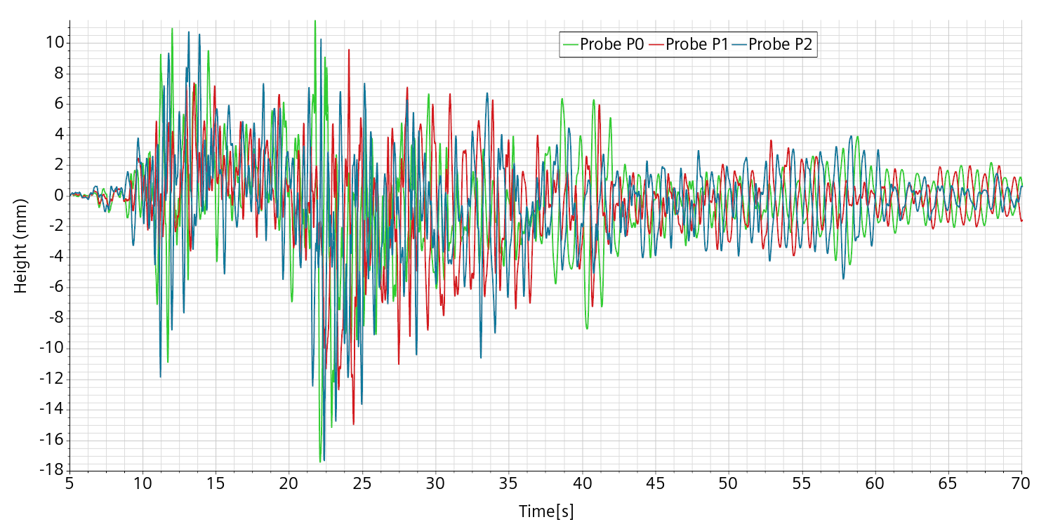
Figure 77: Japan event, filtered 1Hz, 1st order. Surface level at the probes in the mockup reference system.

Discussion
From the PASCAL proposal the aim of the work presented is “To further enhance the modelling and computational readiness level of sloshing dynamics in compact liquid-metal filled pools and to retrieve the expected impact forces and dislocations on the involved components for a reference system (e.g. ALFRED).”
This deliverable is the second of two. In the first one [1], several fundamental aspects of sloshing and its simulation have been tackled, taking as reference a partially filled vertical cylinder under horizontal harmonic forcing. The scaling laws have been determined allowing a direct correspondence and extrapolation from a water small scale mockup and a large scale lead reactor. The general numerical framework has been established based on a combination of the two-phase flow VoF paradigm with an adaptive time step and mesh refinement strategy. Validation has been performed by direct comparison with experiments performed by VKI on the SHAKESPEARE platform.
In this deliverable, we build on the recently acquired known-how to pursue the work on a decisively more complex geometry intended to significantly reproduce a mock-up of ALFRED. A new geometrical model is built and is complemented by an upgrade of the previous numerical overall approach. A special feature has been developed to keep under control the numerical smearing of the free-surface. While we already know how to restrain the smearing with a suited volume fraction source/sink term, we prefer to limit the intensity of such a sharpening term. The risk of smearing increases with the free-surface agitation, so it may not be adapted upon going from a lesser to a higher agitation. The intensity of the sharpening term was determined on an empiric basis and by subjective feeling from occasional “visual control”. Having in mind applications to more and more unpredictable surface agitation, we felt the need for a more simple and less empirical procedure to check the free-surface integrity, as implemented and explained in 3.1.2.
At first, we validate the numerical model using displacement input data provided by VKI and by making a direct comparison, still with result data provided by VKI, on the water level above three positions. The mock-up being much more complex, there are also much more possibilities for discrepancies between the experimental data and the numerical results. Direct comparison however provides a good matching. Nevertheless, we analyze the possible causes for non reaching the almost-perfect matching we managed to reach previously. In particular, we cannot rule out that a slow small drift in frequency could not have an experimental origin.
Another concern regards the annoying and potentially critical issue of the occasional re-appearance of numerical and unphysical bursts of velocity. These bursts are extremely local both in time and space and seem to originate from the creation of highly deformed cells at the double interface between the adaptive re-meshing boundary, the boundary layer and the bulk mesh. Fortunately, the solver swiftly resolves these events without apparent harmful effects on the simulation validity, but unfortunately leading to smaller time-step and higher calculation time.
All these preliminary activities have put us in position to test our numerical model on existing seismic events of increasing intensity. The idea was to progressively take confidence with the data, their implementation and how to interpret the results. The idea was also to progressively focus on the forces induced on the vessel and the components, as it is the final goal of this work.
The acceleration data on the Italian, Romanian and Turkish events are already regularized by a low and high pass filter.
The 2016 Italian event involves a small vessel displacement, maximum 2.2 mm, and in turn a very low mock-up free-surface deformation, below 4 mm. The high frequency forcing on the vessel is very high, peaking at 3,000 N. At this stage of the work, these results point to a negligible sloshing effect.
The 1997 Romanian event is of higher intensity with a higher maximum displacement of 1 cm and a wave up to 2 cm high, rapidly decreasing. The peak force is surprisingly much lower at 300 N and a look at a shorter scale indicates a strong pulsation on a 5 time-step basis, apparently caused by and totally correlated to the adaptive re-meshing process, also each 5 time-steps. A hand-made Gaussian-like regularization at 5 time-steps lowers the peak force from 300 to 70 N. On the vessel, the regularized force is observed to be strongly correlated to the imposed acceleration. In comparison, a small forcing survives for some time at about 2.5 Hz at finished event, which can be ascribed to the free-surface wave.
With the 2023 Turkish event, we enter a displacement scale that exceed the SHAKESPEAR table capability for its representation of the mock-up. The vessel displacement is now in the same range as the free-surface elevation. Looking at the animation made us realize that the free-surface elevation should from now on be measured in a reference frame linked to the vessel.
It is only with this simulation that we could better understand the origin of the issue with the intensity of the forces exerted on the vessel and the components.
The Japan event involves even higher displacements, to the point that it must be taken into account in order to keep the mock-up inside the visualization window.
We were initially focused on the free-surface sloshing wave to evaluate the force impact on the structures. It turned out that the force mainly responds directly to the acceleration applied to the structure and, in our cases, only marginally to the surface waves. Moreover, great care must be put on the numerical setting to get meaningful numbers.
Of particular importance, is the preliminary treatment of the seismic data. Several aspects must be considered:
- The data are given in tabular form and sampled generally at 0.01 s intervals. This effectively cuts all frequencies above 100 Hz.
- The time-step of the simulations is controlled by the convective and the free-surface CFL numbers and results much lower than the sampling interval.
- The data may be regularized, with variable high frequency cut found between 25 and 40 Hz.
- The data may also be regularized with a low frequency cut which in fact forces the final position to be the same as the initial one.
- Linear interpolation of displacement data, leads to spurious peaks of acceleration and in turn spurious peaks of measured forces. The spurious peaks increase in intensity if the simulation time step decreases.
- Cubic interpolation of the displacement data removes the spurious acceleration peaks. In practice, it reproduces a high frequency cut.
Moreover, there is a specific issue with the interaction of the second order temporal scheme with the adaptive meshing. The interaction works perfectly for what concerns the velocity field but introduces a high frequency pressure beat in coincidence with the 5 time-steps re-meshing interval. The high frequency pressure beat translates directly in a force pulsation on the structures. Its intensity is of the same order as the force averaged over the 5 time-steps. This pulsation combines with the one coming from the displacement data interpolation issue making it initially difficult to recognize. Reverting to the first order in time numerical scheme effectively solves the issue.
Even if we approached the problematic from the numerical setting point of view, we have learned that the impact of the forces on the structure are overwhelmingly controlled by the high frequency accelerations of the input displacement signal. In our simulation representative of real strong seismic events, sloshing or more simply surface wave induced forcing are only negligible modulations of the main forcing that became more apparent for some time once the critical event is essentially over.
Under seismic like events, for what concerns the forces applied to the structures when they are at the highest peak, the mock-up together with its water filling reacts essentially as if it were a rigid body. As a consequence, before we can seriously evaluate a possible consistent impact of the sloshing events, we absolutely need to consider the damping system that has to be conceived in such a way as to protect ALFRED from seismic events. Only if such damping system reveals itself able to largely absorb high and medium acceleration frequencies, can sloshing be likely to have a consistent influence on the residual impact forces.
In order to quantify the previous assertion, peak forces on the vessel mock-up in relation to the Japan event drop from 1000 N without damping to 50 N with a 1 Hz high cut damping.

Conclusion
The aim of this work is written in the PASCAL proposal and reads: “To further enhance the modelling and computational readiness level of sloshing dynamics in compact liquid-metal filled pools and to retrieve the expected impact forces and dislocations on the involved components for a reference system (e.g. ALFRED).”
While not trivial and of not straightforward realization, the modelling has been shown to be operative, functional and validated by comparison with experimental data provided by the VKI colleagues in charge of the experimental part. Validation has been performed on a water mock-up of ALFRED filled with 40 liters of water. The scaling law for extrapolation to ALFRED have been determined.
The practical aim of this work is to check whether a realistic but large seismic event could trigger a large sloshing dynamics potentially damageable for ALFRED system integrity. From the results obtained we can infer some preliminary conclusions:
- A strict control of the numerical setting is required to avoid false alarmism.
- Under large seismic events, the damage risk is overwhelmingly dominated by the forcing from the highest acceleration frequencies of the earthquake.
- Above 1 Hz, with regards to the forces acting on the vessel, the mock-up reacts essentially like a rigid body.
- A 1 Hz high frequency cut of the Japan event acceleration reduces the peak forcing on the vessel by a factor of twenty.
- A carefully designed damping system is very likely to have a much greater and positive impact on the structure than possible damaging effects induced by sloshing.
Recognizing the primary importance of a strong and reliable damping system, it is perfectly feasible to quantify its efficiency by means of CFD, using the current numerical model setup.
We must also recognize that the ALFRED mock-up does not contain all the possible criticalities of the ALFRED system. Once a damping system is designed or even simply drafted, it would be safer to repeat the exercise with a more accurate ALFRED numerical model, also in an optimization perspective.

Added volumes (Appendix )
Two simulations are performed aiming at a better characterization of the vessel and components added mass or equivalently “added volume”. By added volume, we intend, by similarity with a rising bubble in water, the volume V of water which is displaced together with the component when subject to a brutal acceleration. It is obtained from the ratio of the force F applied to the component by the surrounding fluid in reaction to the component acceleration α according to the relation V = F/ρα, where ρ is the fluid density.
The impulse is given such that the displacement D is given by: D(t)=Asin²(πf t).
The displacement velocity V during the impulse is V(t)= A π f sin(2πf t)
The acceleration Acc is therefore Acc(t)=2A π²f² cos(2πf t).
The frequency is taken at f=5Hz and the amplitude A = 5mm, for a maximum velocity about 0.08 m/s and a maximum acceleration about 2.5 m/s². The flow is stabilized at rest for 0.1 s and the pulse is maintained for another 1/f=0.2 s. Therefore the mock-up returns to its initial position.
The pulse is applied in direction X.
The forces resent drastically from the adaptive refinement every five time-steps with strong oscillations mainly absorbed at the fourth time-step. The maximum time step is reduced from 0.001 s to 0.0002 s after 0.09 s to better capture the pulse curve.
The resulting forces applied by the fluid on the vessel and the pump pipes are illustrated in Figure 78 on a short time interval. This is to highlight the absolute intensity of the oscillation on a 5 time steps period, in conjunction with the re-meshing procedure.
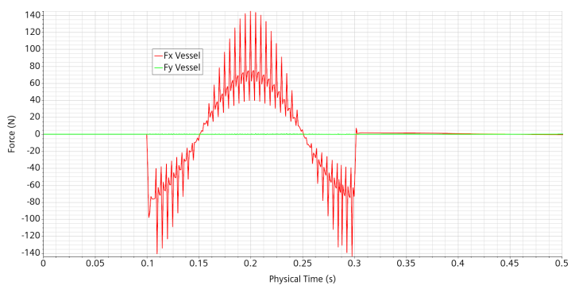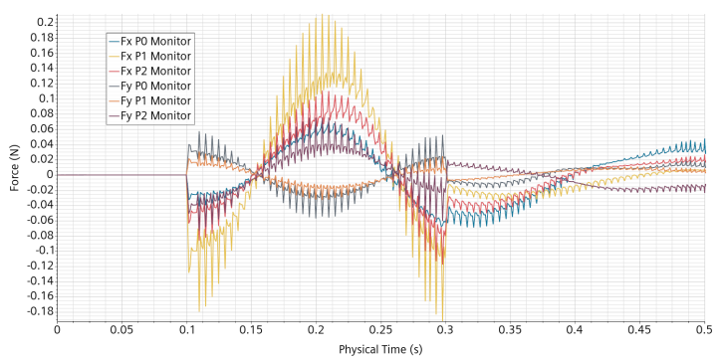
Figure 78: Pulse in direction X. Forces on the structures. Left: vessel. Right: pump pipes.

In order to interpret the force plots, a smoothing procedure of the data has been performed. A centered running average on three time steps is applied 5 times in a raw to the curve. The result is shown on Figure 79. The maximum is close to 80 N for an equivalent added mass of 32 kg, in line, while slightly lower than the 35 kg previous estimate. It is likely that the added mass increases slightly with the pulse sharpness.

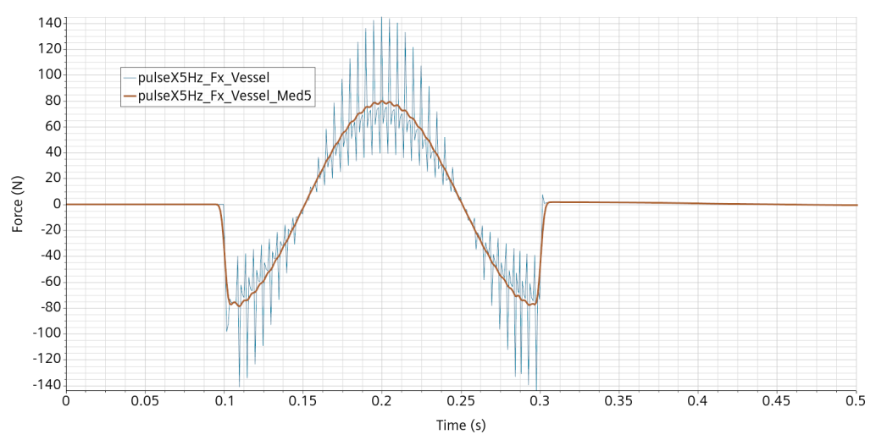
Figure 79: Pulse in direction X. Force on the vessel in direction X and its smoothed version.
This 5 time steps strong oscillation of the resultant forces is not very satisfying. Therefore, we had to look for some numerical setting adjustment to reduce its intensity and occurrence.
The simulation has been re-run switching from the second-order time discretization to the first-order one. The forces measured are now much smoother, as shown on Figure 80. This is the case for all measured forces even if some (much smaller) oscillation remains, mainly for the pump pipes, see Figure 81.
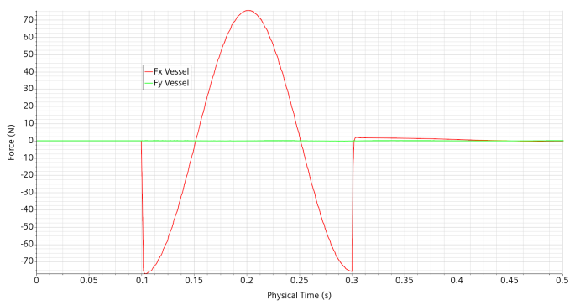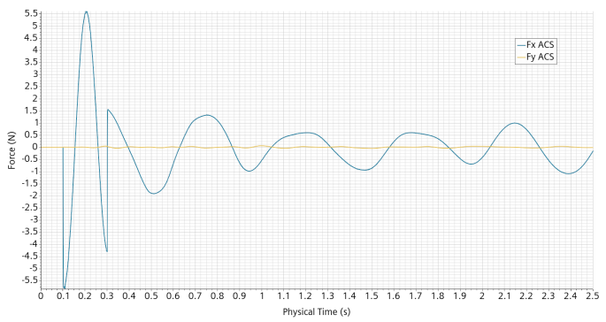
Figure 80: Pulse in direction X. Forces on the vessel and the ACS using 1st order time discretization.
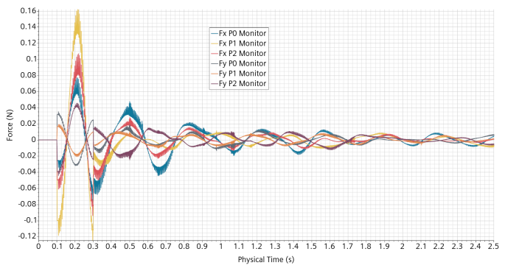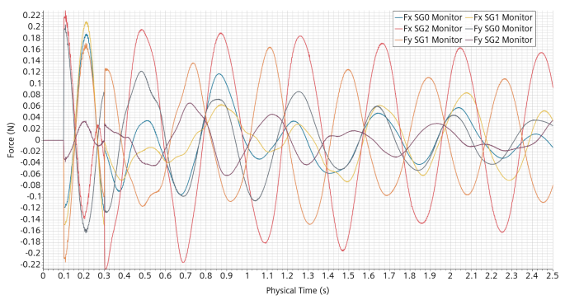
Figure 81: Pulse in direction X. Force on the pump pipes and SGs in direction X and Y using 1st order time discretization.
The forces applied to the components are much lower than those applied to the Vessel or the ACS (inner wall). Their peak value at 0.2s is given in Table 1. The position of the component has a decisive impact on the force applied. In particular, the force on SG2 is opposite to all the others, indicating that it resents largely from the mass transfer through the bottom gap. While the Y-forces on the vessel and the ACS are relatively negligible, they are of the same order as the X-forces on the components. Also, we do not retrieve exactly the total mass of water. This means that, at least for the components and for such a pulse, the added mass idea does not tell the whole story.
Part | Vessel | ACS | DHR0 | DHR1 | DHR2 | PP0 | PP1 | PP2 | SG0 | SG1 | SG2
X-Force (N) | 75.4 | 5.6 | 0.26 | 0.08 | 0.21 | 0.06 | 0.14 | 0.08 | 0.19 | 0.21 | -0.14
Added mass (kg) | 30.2 | 2.2 | 0.1 | 0.03 | 0.08 | 0.02 | 0.06 | 0.03 | 0.06 | 0.08 | -0.06
Table 1: Pulse in direction X. X-Forces on components at maximum pulse acceleration 2.5 ms⁻², time 0.2s. Equivalent added mass.

References
- Moreau V. and Profir M., D13 “Sloshing CFD modeling and validation with SHAKESPEARE first experimental campaign” PASCAL deliverable 2022
- D28 : Results of the experimental campaign with SHAKESPEARE, PASCAL project VKI deliverable (to appear)
- Luzi L., Lanzano G., Felicetta C., D’Amico M. C., Russo E., Sgobba S., Pacor, F., & ORFEUS Working Group 5 (2020). Engineering Strong Motion Database (ESM) (Version 2.0). Istituto Nazionale di Geofisica e Vulcanologia (INGV). https://doi.org/10.13127/ESM.2
- National Research Institute for Earth Science and Disaster Resilience (2019), NIED K-NET, National Research Institute for Earth Science and Disaster Resilience, doi:10.17598/NIED.0004
- https://www.ansa.it/sito/notizie/speciali/2022/08/23/sei-anni-fa-il-terremoto-che-sconvolse-il-centro-italia_f2a36ead-529c-4f3a-bf3d-faebb2bfe77c.html
- https://en.wikipedia.org/wiki/1977_Vrancea_earthquake
- https://en.wikipedia.org/wiki/2023_Turkey%E2%80%93Syria_earthquakes
- https://en.wikipedia.org/wiki/2011_T%C5%8Dhoku_earthquake_and_tsunami
- Saburoh MIDORIKAWA, Hiroyuki MIURA and Tomohiro ATSUMI, STRONG MOTION RECORDS FROM THE 2011 OFF THE PACIFIC COAST OF TOHOKU EARTHQUAKE, Proceedings of the International Symposium on Engineering Lessons Learned from the 2011 Great East Japan Earthquake, March 1-4, 2012, Tokyo, Japan.
- Hiroshi MATSUZAKI and Kazuhiko KAWASHIMA, EVALUATION OF STRONG GROUND MOTIONS OF THE 2011 GREAT EAST JAPAN EARTHQUAKE BASED ON NONLINEAR RESPONSE OF STANDARD BRIDGES, Proceedings of the International Symposium on Engineering Lessons Learned from the 2011 Great East Japan Earthquake, March 1-4, 2012, Tokyo, Japan
- Shin’ichi Miyazaki, Jeffery J. McGuire, and Paul Segall, Seismic and aseismic fault slip before and during the 2011 off the Paciﬁc coast of Tohoku Earthquake, Earth Planets Space, 63, 637–642, 2011, doi:10.5047/eps.2011.07.001
- Takuya Nishimura, Hiroshi Munekane, and Hiroshi Yarai, The 2011 off the Paciﬁc coast of Tohoku Earthquake and its aftershocks observed by GEONET, Earth Planets Space, 63, 631–636, 2011, doi:10.5047/eps.2011.06.025

